Dear Professional Colleague

ICSI OVERSEAS CENTRE, SINGAPORE

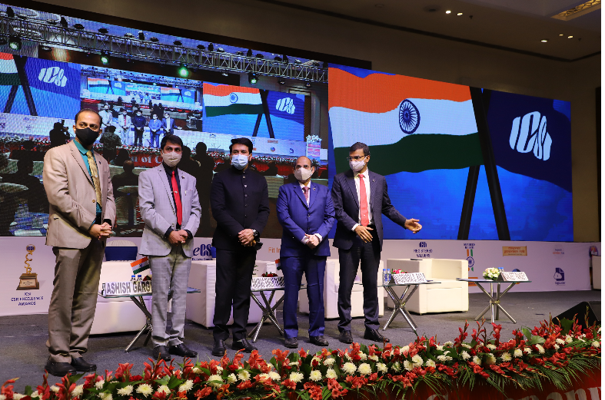

We are pleased to inform you that the Institute of Company Secretaries of India (ICSI) has inaugurated its Overseas Centre at Singapore, on 19th December 2020, during the 48th National Convention of Company Secretaries in the benign presence of Shri Om Birla Hon’ble Speaker, Lok Sabha and Shri Anurag Singh Thakur, Hon’ble Minister of State for Finance and Corporate Affairs, Government of India.

One of the main objectives of setting up the ICSI Overseas Centre at Singapore is to strengthen the global outreach of the profession while augmenting the professional opportunities for ICSI members and students internationally.

The Centre will function from the below address with the following Committee of Members:

160 Robinson Road, #20-03 Singapore Business Federation Center, Singapore 068914
Email- singaporecentre@icsi.edu

1. CS Nitish Chandan, Chairman
2. CS Dinesh Natvarlal Makani, Vice-chairman
3. CS Vandana Tiwari, Secretary
4. CS Sayali Subhash Patkar, Treasurer
5. CS Priya Mahajan, Member
6. CS Kinjal Brijesh Shah, Member
7. CS S Arthi, Member

Launch video of the ICSI Overseas Centre, Singapore is available at https://bit.ly/3pd6QlQ.

The ICSI already has its presence in UAE, USA and UK.

Regards,

CS Ashish Garg  President | CS Ranjeet Pandey  Chairman, International Affairs Committee & Immediate Past President, ICSI

