User Manual

Corporate Communication

Table of Contents
- Counsellor Registration (Guest User)
1.1 Counsellor Registration (New Application)
1.2 Status of Application of Registration for Counsellor Entities
- Chapter Admin Process flow of Registration Approval
1.1 Registration Approval
1.2 Recommend Reimbursement for Registered Student
1.3 Track Reimbursement for Registered Student
1.4 Track Incomplete Registration Request
1.5 Track/Approval of Events
1.6 Track/Approve Event Reimbursement
1.7 Reimbursement for Registered Companies through Counsellor
3. Counsellor
1.1 Bank Account Details
1.2 Create/ Track Event
1.3 Track registered Student
1.4 Track/ Apply Event Reimbursement
1.5 Track Companies Refund Request By Counsellor

Introduction
This process flow will be used by guest user who is willing to apply for appointment as ICSI Counsellor.

Counsellor Registration (New Application)
- User visit to URL: www.Smash.icsi.in
- User will go on ICSI home page and will mouse hover on menu “Counsellor Registration ” and click on “Counsellor Registration (New Application)” sub menu link .
- User will choose “New Application” from “Application Type” radio button.
- After filling all the details and upload all the mandatory documents, user will click on Submit Button.
- A confirmation message will be display and User will be notified through email/sms on successful submission of application.
(Counsellor Registration>Counsellor Registration (New Application))
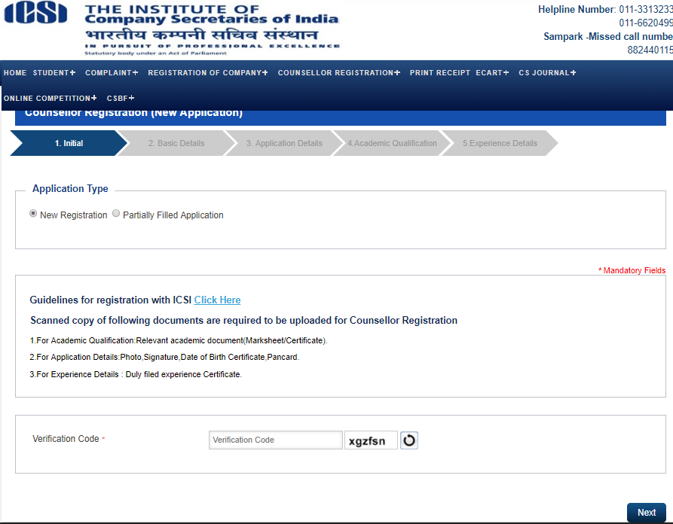
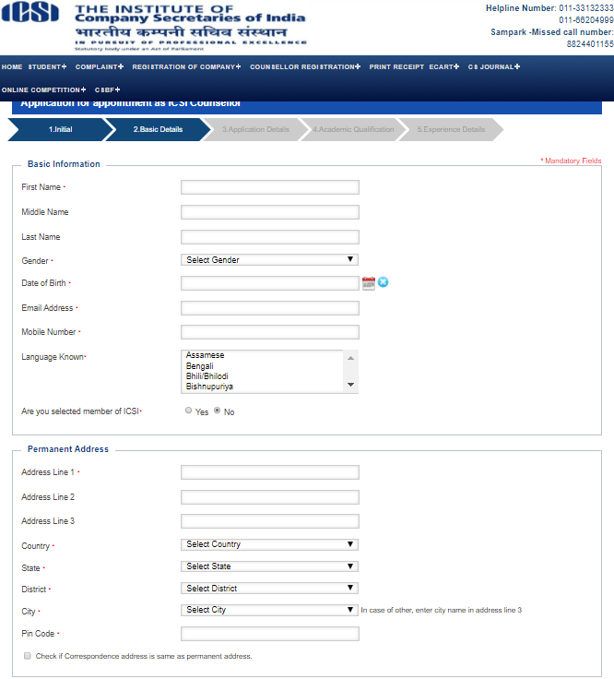
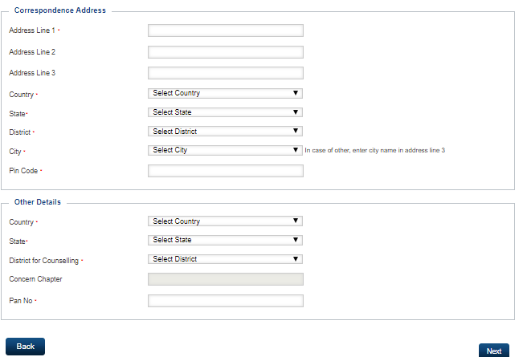
Screen: Counsellor Registration (New Application)
Screen: Counsellor Registration (New Application)

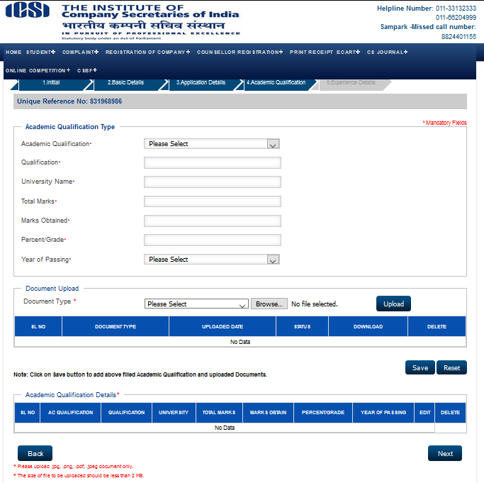

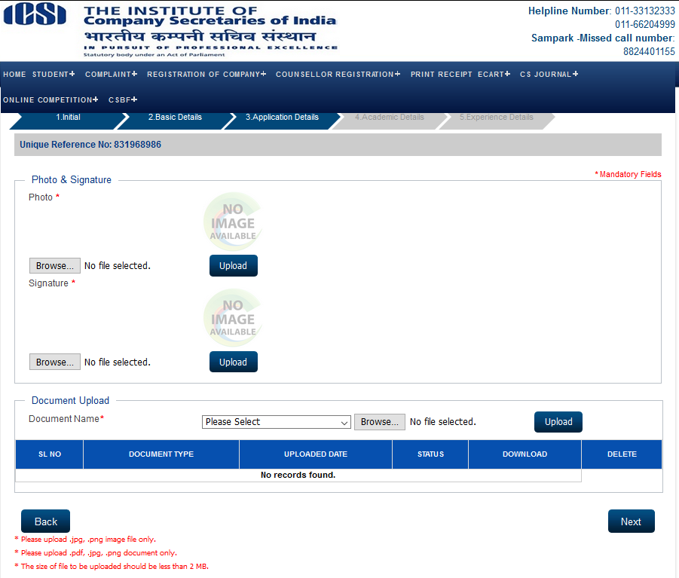

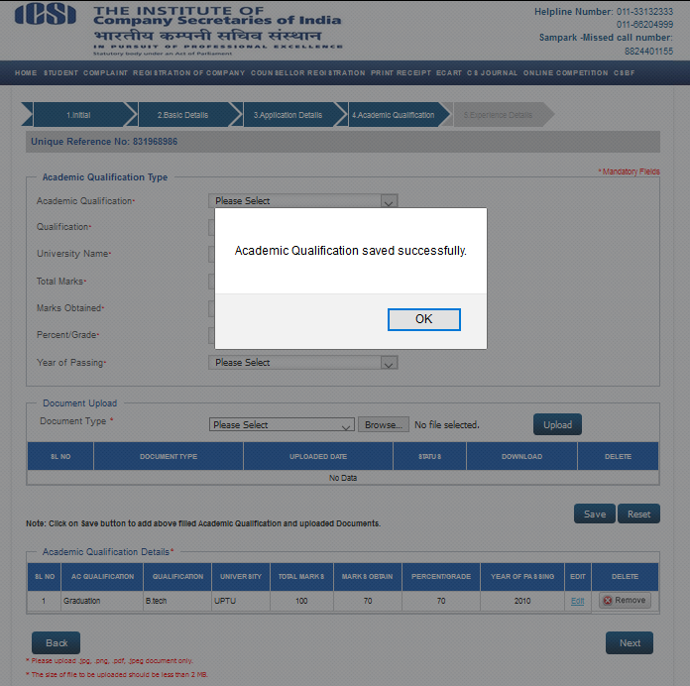

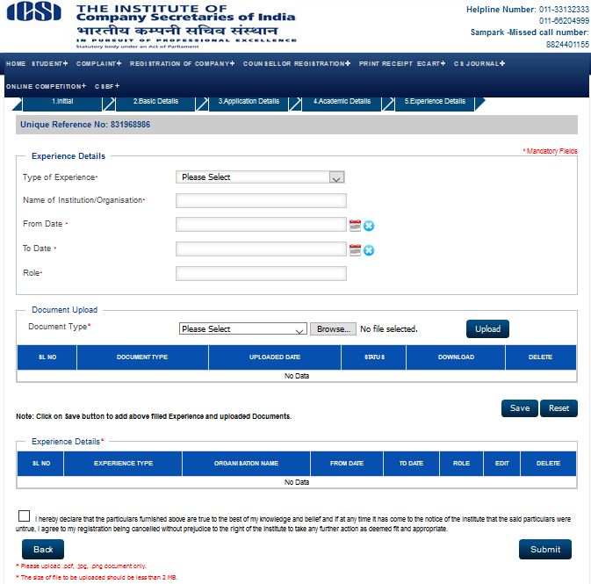

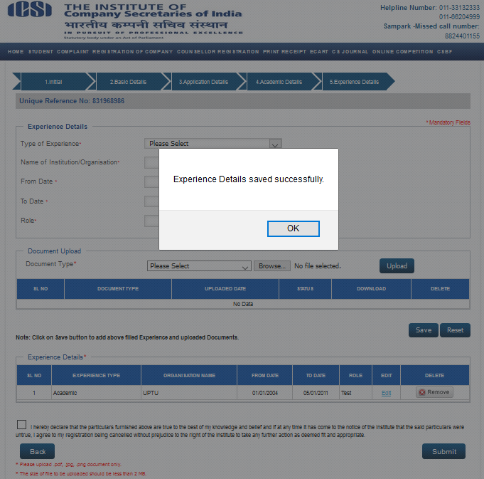

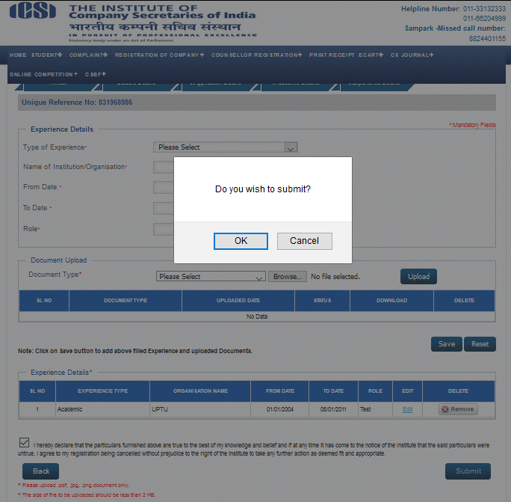

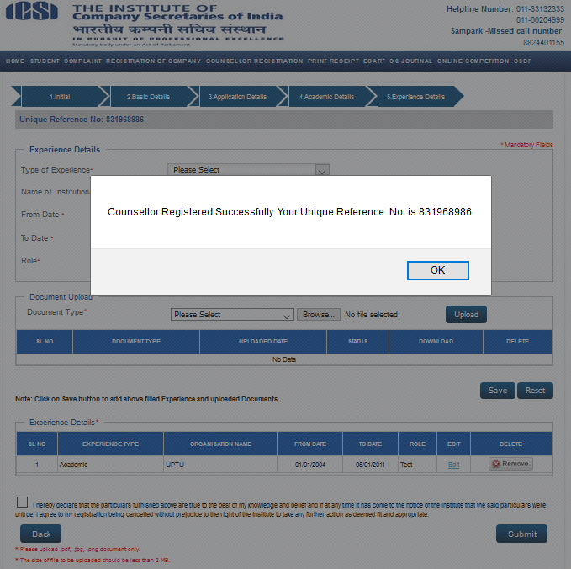

Status of Application of Registration for Counsellor Entities
1. User visit to URL: www.Smash.icsi.in
2. User will go on ICSI home page and will mouse hover on menu “Counsellor Registration ” and click on “Status of Application of Registration for Counsellor Entities” sub menu link .
3. User will enter Unique Number and Verification Code and click on Submit Button.
4. All details should be auto filled and user will Submit the request.
5. A confirmation message will be display and User will be notified through email/sms on successful submission of application.
(Counsellor Registration>Status of Application of Registration for Counsellor Entities)
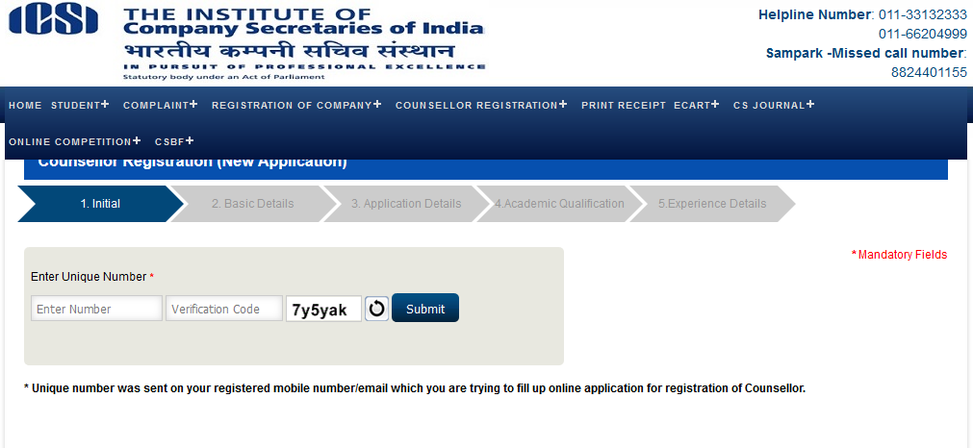

Chapter Admin Process flow of Registration Approval
Registration Approval
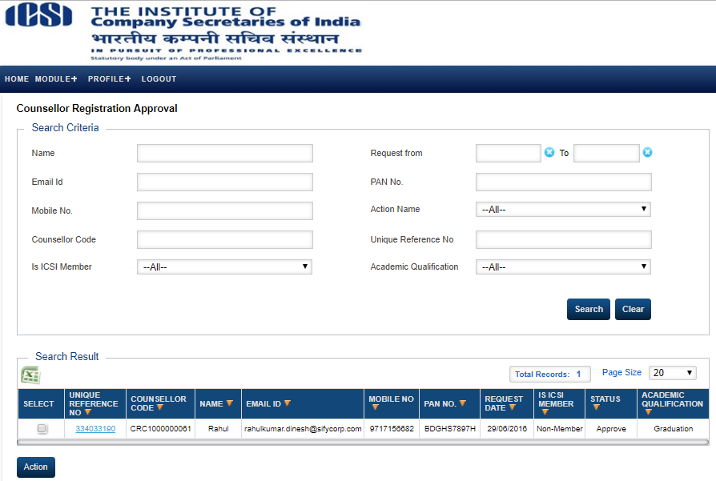
1. User visit to URL: www.Smash.icsi.in
2. User will login with Chapter Admin.
3. User will go to the Module link and mouse hover on menu “Counsellor” and click on “Registration Approval” sub menu link .
4. User will select a data and click on Action button.
5. User will approve all the uploaded documents and the approve the Registration request.
(Counsellor >Registration Approval)

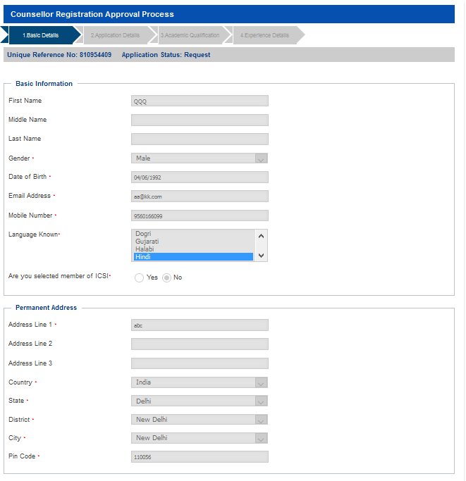
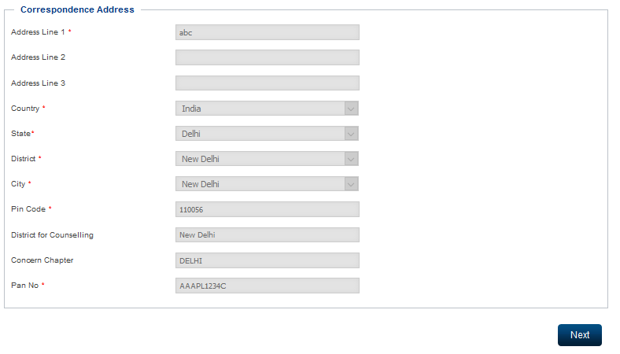

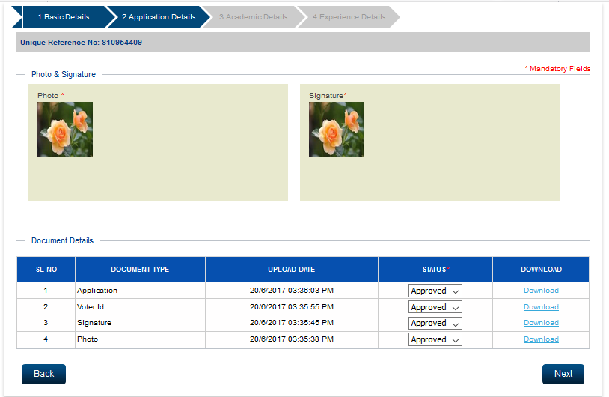
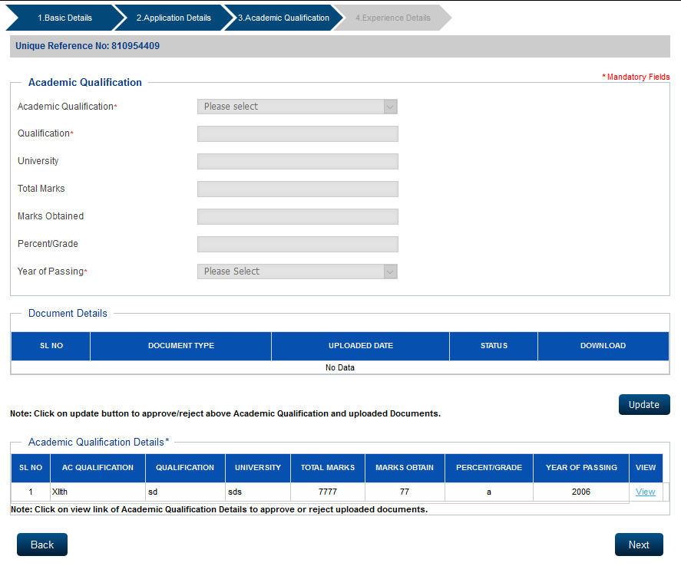

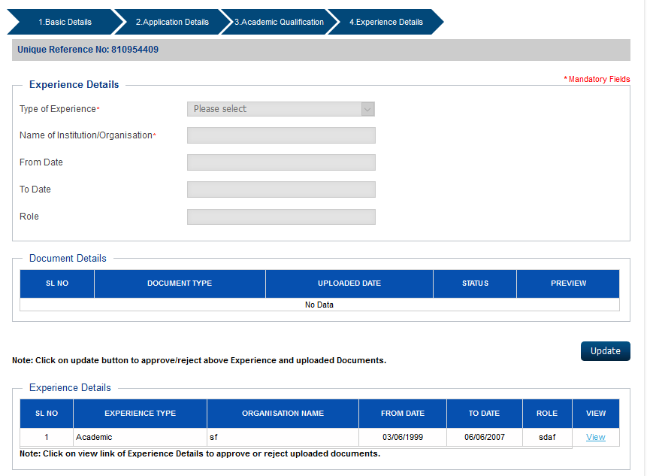

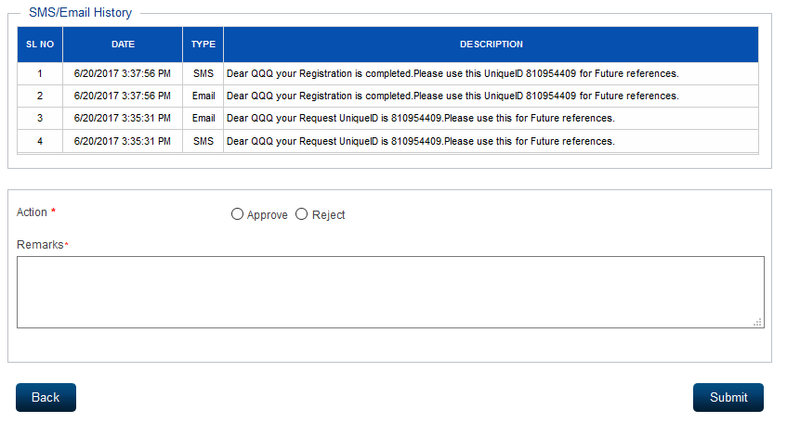

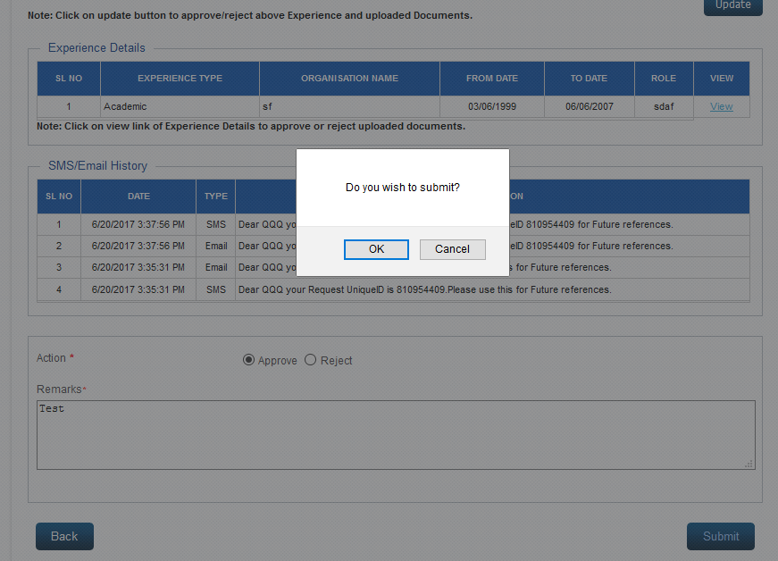
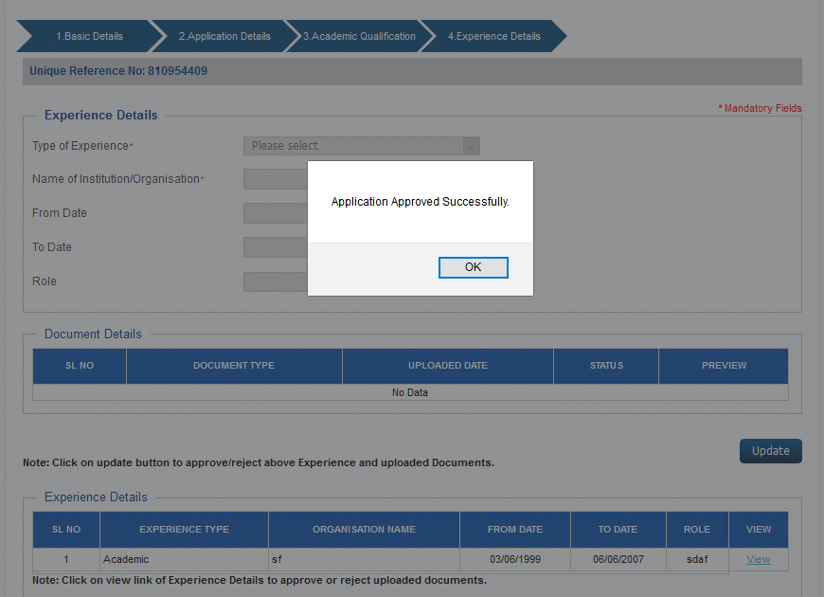
Recommend Reimbursement For Registered Student
1. User visit to URL: www.Smash.icsi.in
2. User will login with Chapter Admin.
3. User will go to the Module link and mouse hover on menu “Counsellor” and click on “Recommend Reimbursement For Registered Student ” sub menu link .
4. User will select a data and click on Recommend button.
5. User will fill all the mandatory fields and click on Submit button to submit the request of Recommend Reimbursement For Registered Student.
6. On clicking on View Student Details user will able to view Student Details Registered through Counsellor.
(Counsellor >Recommend Reimbursement For Registered Student)
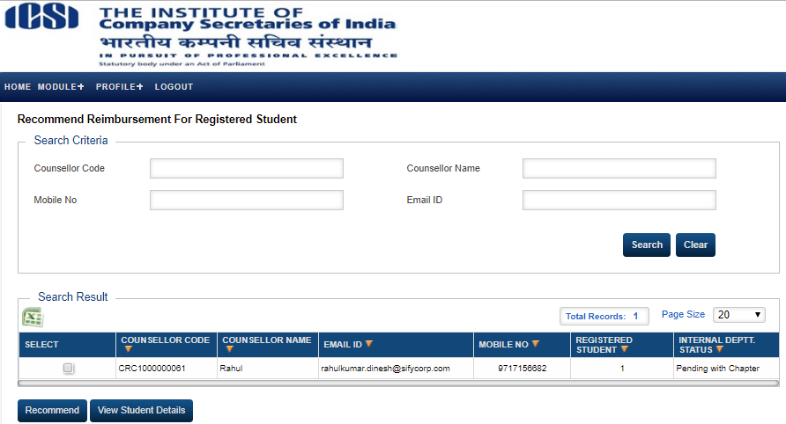

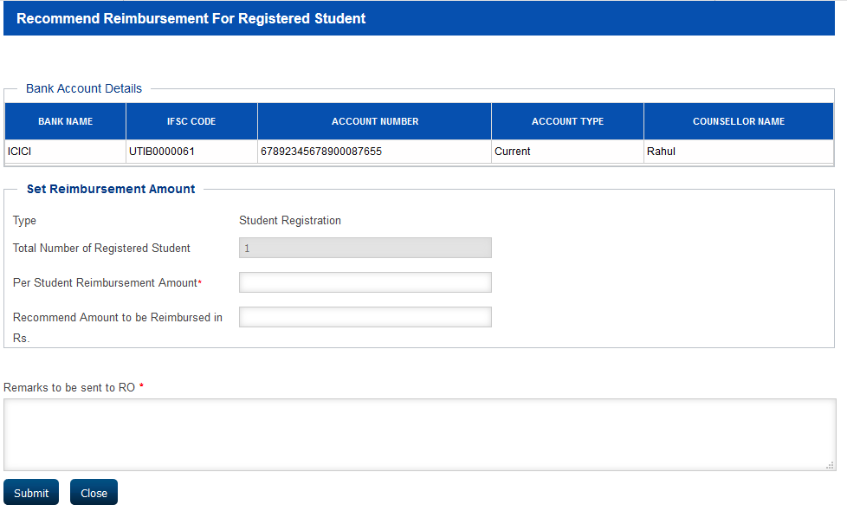
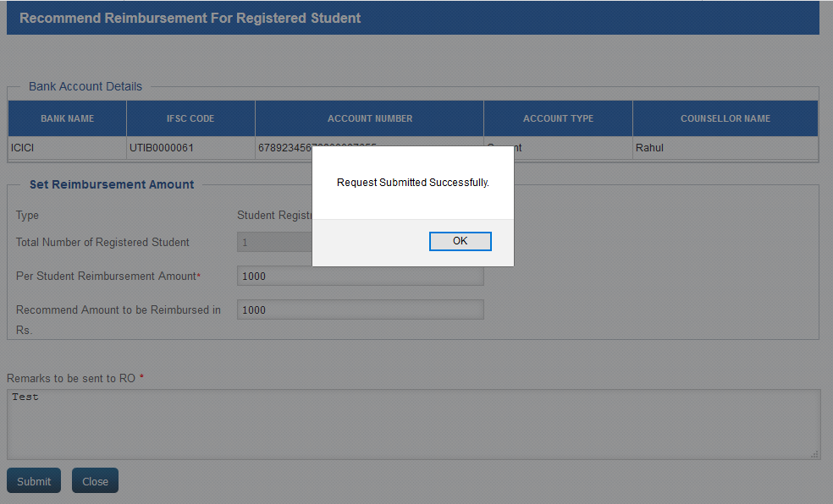
Track Reimbursement for registered students
1. User visit to URL: www.Smash.icsi.in
2. User will login with Chapter Admin.
3. User will go to the Module link and mouse hover on menu “Counsellor” and click on “Track Reimbursement for registered students ” sub menu link .
4. User will select a data and click on Refund/ Resubmit button.
5. User will fill all the mandatory fields and click on Submit button to submit the request of Reimbursement For Student Registration.
6. On clicking on View Reimbursement Details user will able to view View Reimbursement Details For Student Registration.
7. On clicking on View Student Details user will able to view Student Details Registered through Counsellor.
(Counsellor >Track Reimbursement for registered students)
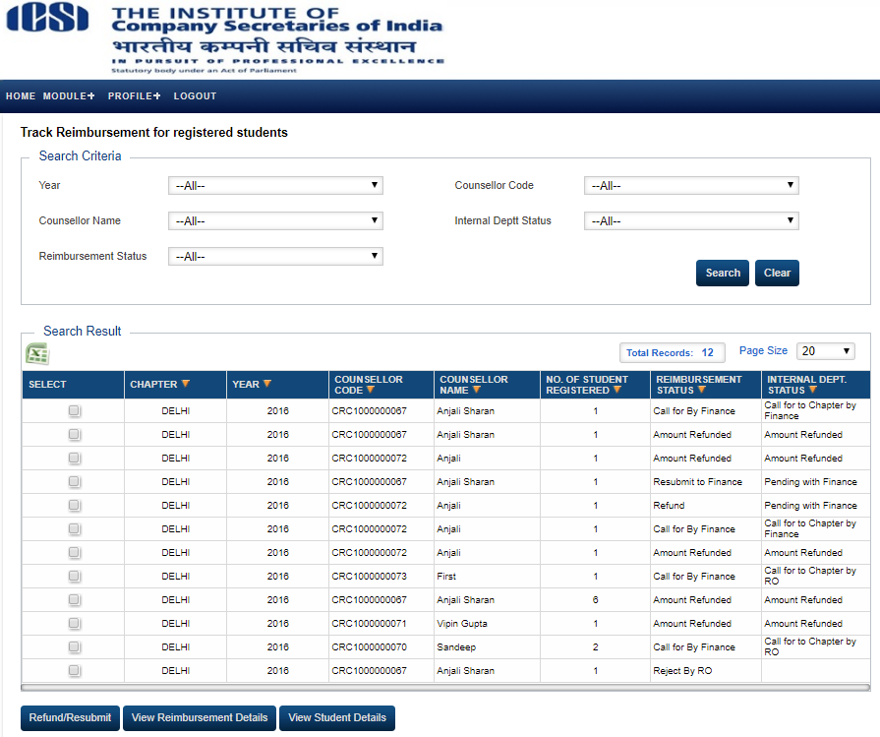
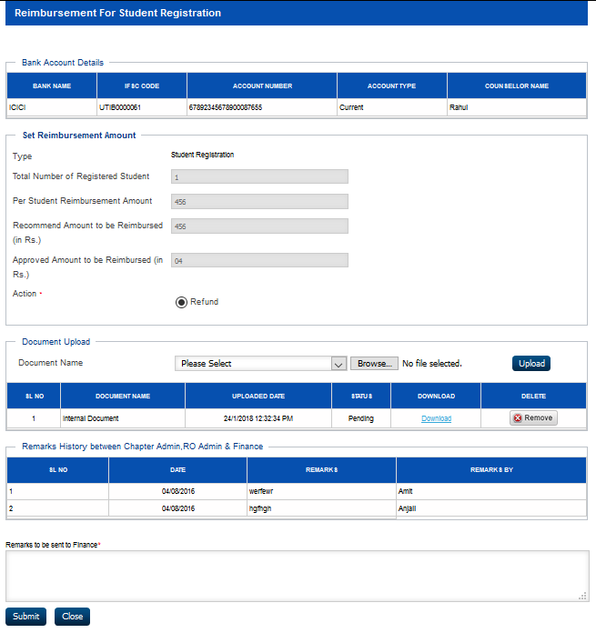

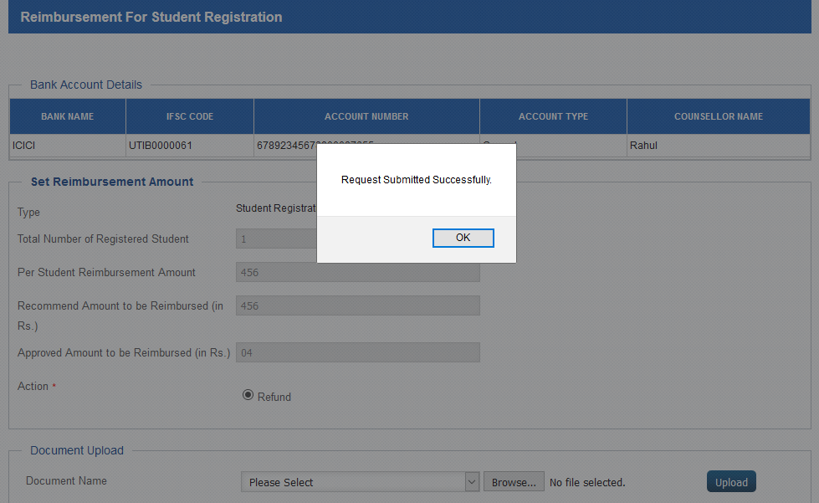

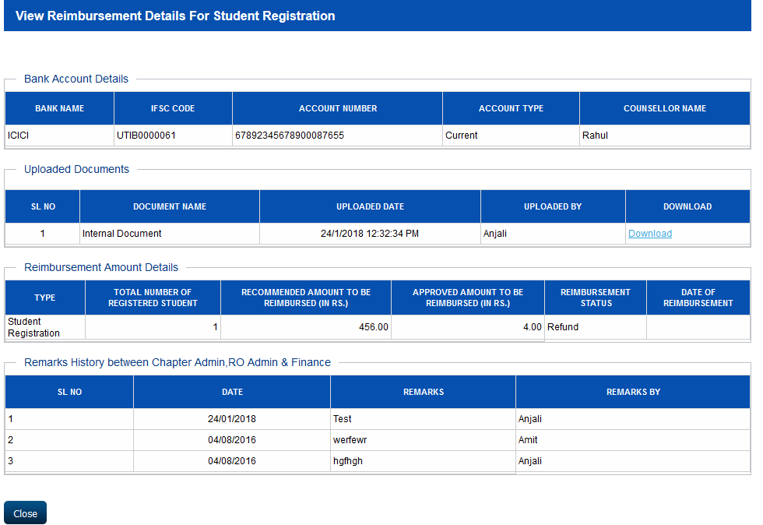

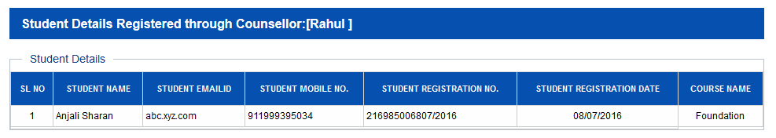
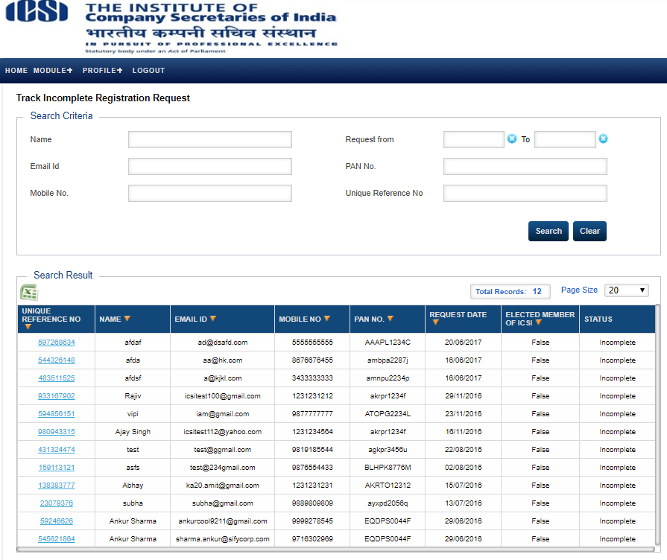
Track Incomplete Registration Request
1. User visit to URL: www.Smash.icsi.in
2. User will login with Chapter Admin.
3. User will go to the Module link and mouse hover on menu “Counsellor” and click on “Track Incomplete Registration Request ” sub menu link .
4. On click on Unique Reference No. user will be able to view Counsellor Registration Request.
(Counsellor >Track Incomplete Registration Request)

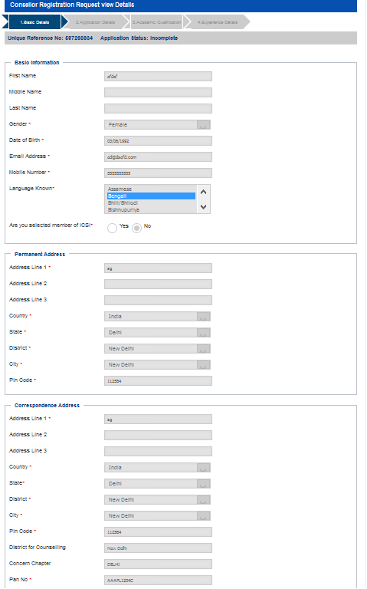

Track/Approval of Events
1. User visit to URL: www.Smash.icsi.in
2. User will login with Chapter Admin.
3. User will go to the Module link and mouse hover on menu “Counsellor” and click on “Track/Approval of Events ” sub menu link .
4. User will select a data and click on Action button.
5. User will fill all the mandatory field and then Submit the request.
6. On click on Counsellor Code, user will be able to view Event Request Detail.
(Counsellor >Track/Approval of Events)
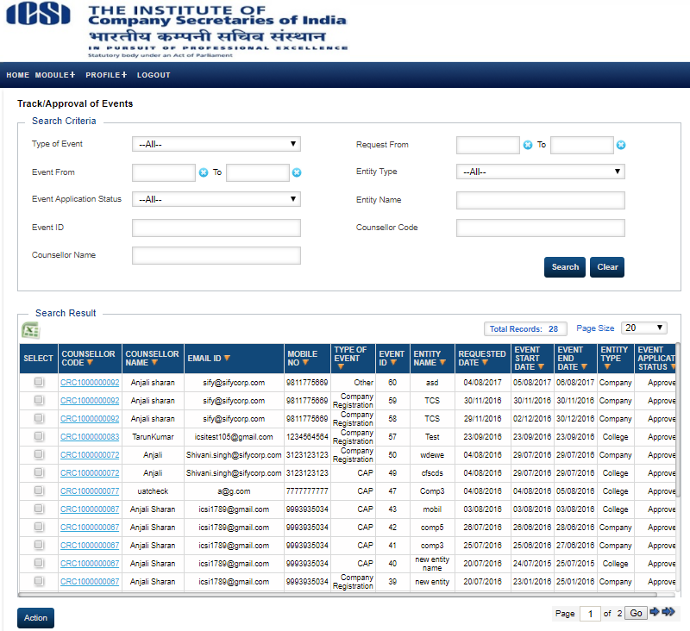

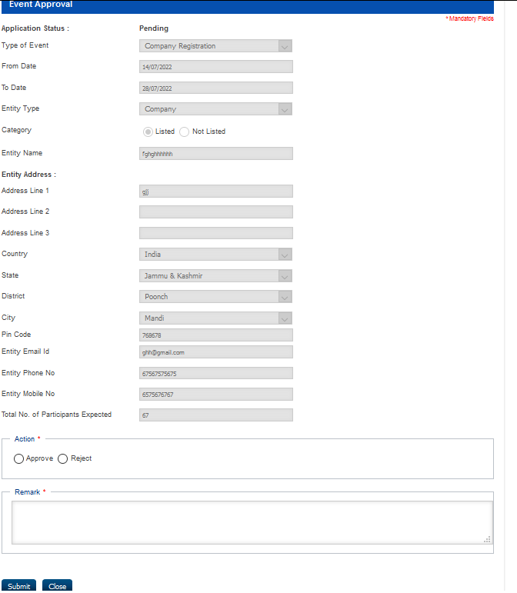
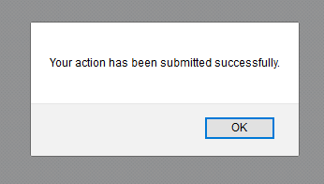
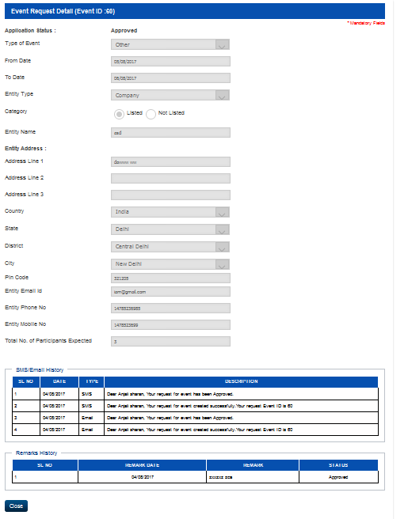
Track/Approve Event Reimbursement
1. User visit to URL: www.Smash.icsi.in
2. User will login with Chapter Admin.
3. User will go to the Module link and mouse hover on menu “Counsellor” and click on “Track/Approve Event Reimbursement ” sub menu link .
4. User will select a data and click on Click on Reimbursement button.
5. Counsellor will fill all the mandatory field and then Submit the request to the next level approval.
6. Chapter Admin will fill all the mandatory field and then Submit the request to the next level approval.
7. RO Admin will fill all the mandatory field and then Submit the request to the next level approval.
8. Finance Admin will fill all the mandatory field and then Approve/ Reject the request.
9. On clicking on Event Id user will be able to view Reimbursement Request For Registration Of Company For Imparting Training.
10. User will select a data and click on Click on Refund button.
11. Counsellor will fill all the mandatory field and then Submit the request to the next level approval.
12. Chapter Admin will fill all the mandatory field and then Submit the request to the next level approval.
13. RO Admin will fill all the mandatory field and then Submit the request to the next level approval.
14. Finance Admin will fill all the mandatory field and then Approve/ Reject the request.
(Counsellor >Track/Approve Event Reimbursement)

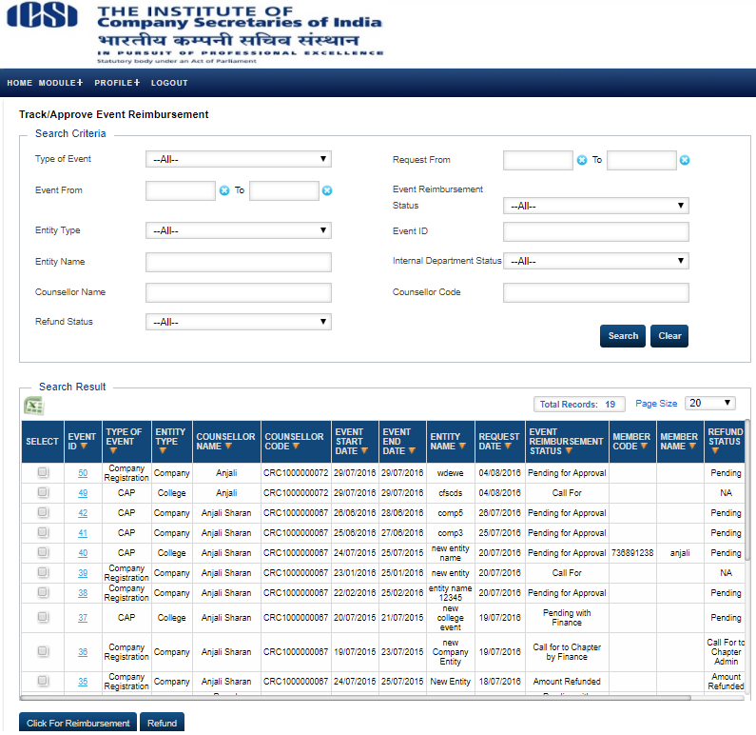

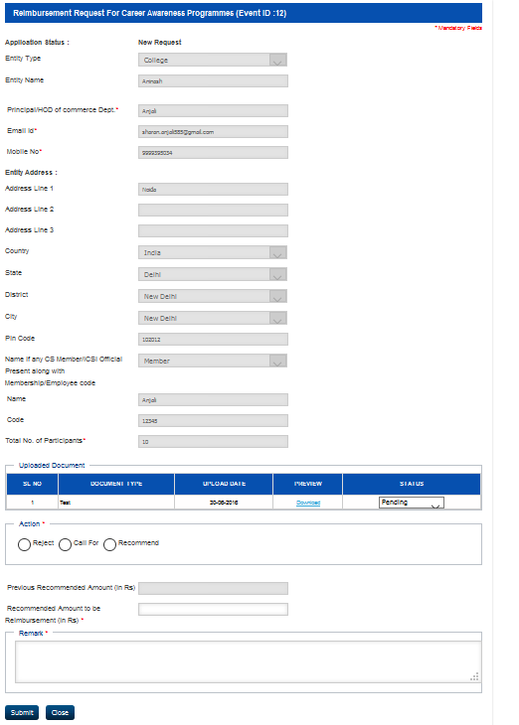

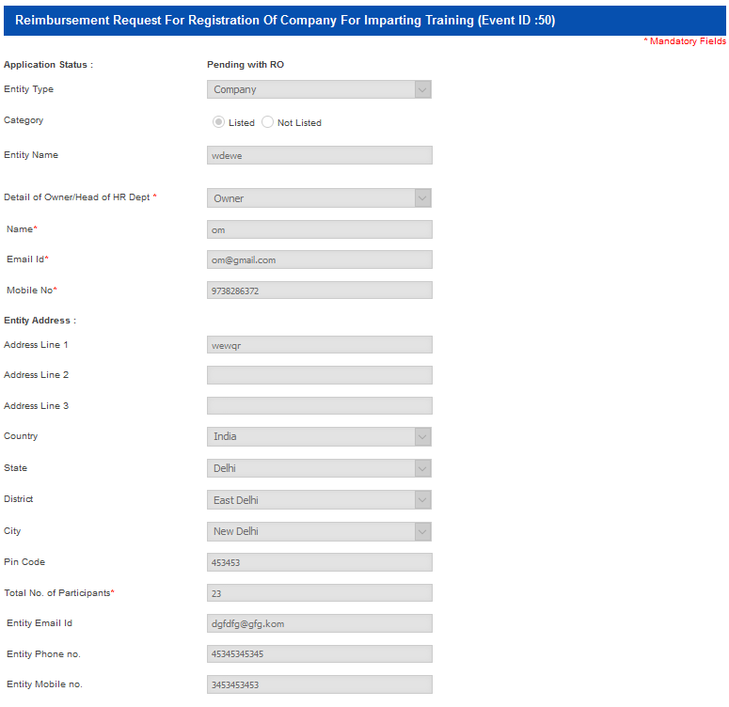

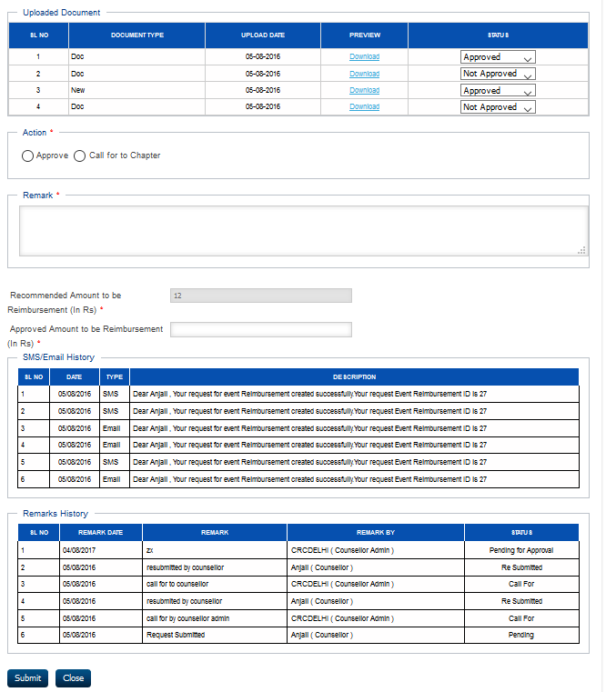

Reimbursement for Registered Companies through counsellor
1. User visit to URL: www.Smash.icsi.in
2. User will login with Chapter Admin.
3. User will go to the Module link and mouse hover on menu “Counsellor” and click on “Reimbursement for Registered Companies through counsellor” sub menu link .
4. User will select a data and click on Click on Recommend button.
5. Counsellor will fill all the mandatory field and then Submit the request to the next level approval.
6. Chapter Admin will fill all the mandatory field and then Submit the request to the next level approval.
7. RO Admin will fill all the mandatory field and then Submit the request to the next level approval.
8. Finance Admin will fill all the mandatory field and then Approve/ Reject the request.
9. On clicking on View Reimbursement Detail, user will be able to view RView Reimbursement Detail For Company Registration.
10. User will select a data and click on Click on Refund button.
11. Counsellor will fill all the mandatory field and then Submit the request to the next level approval.
12. Chapter Admin will fill all the mandatory field and then Submit the request to the next level approval.
13. RO Admin will fill all the mandatory field and then Submit the request to the next level approval.
14. Finance Admin will fill all the mandatory field and then Approve/ Reject the request.
(Counsellor >Reimbursement for Registered Companies through counsellor)
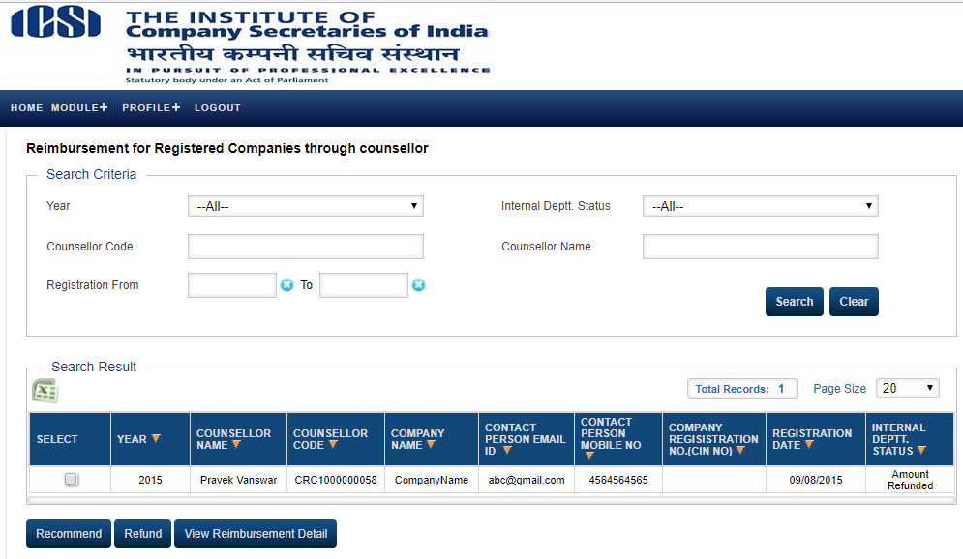
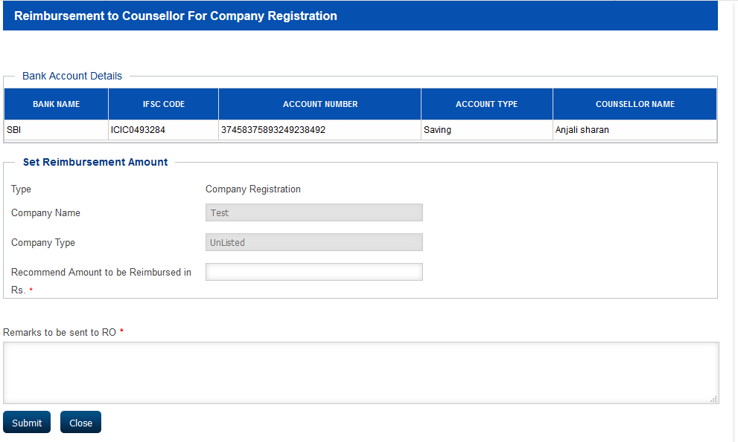

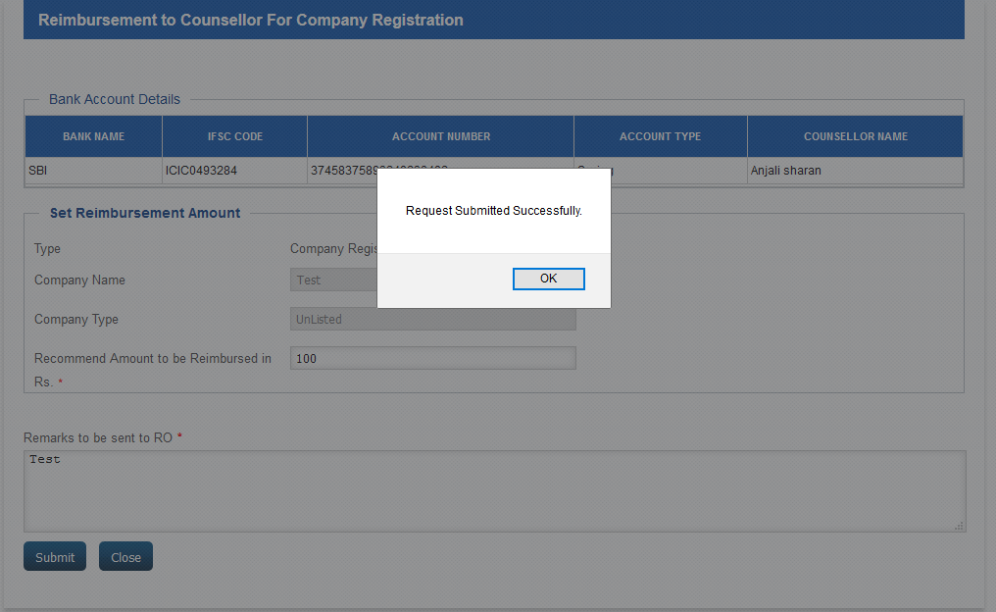
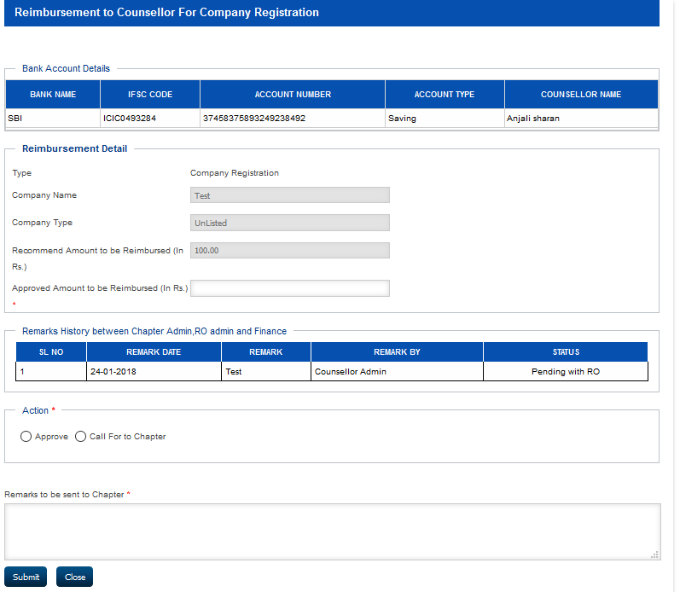

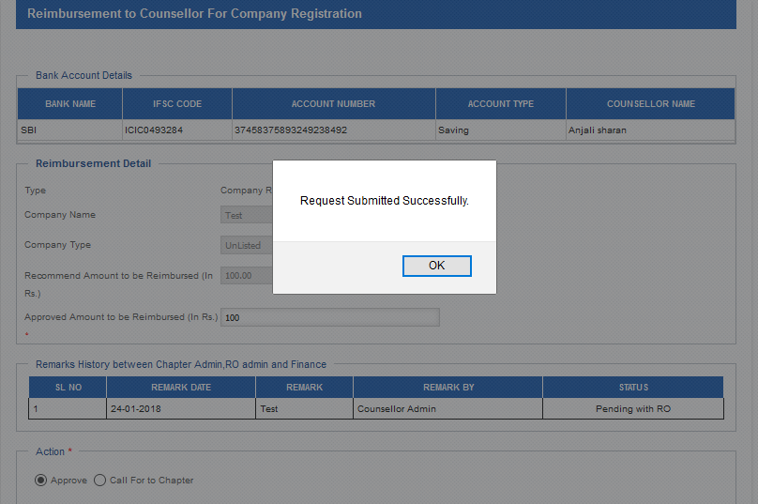

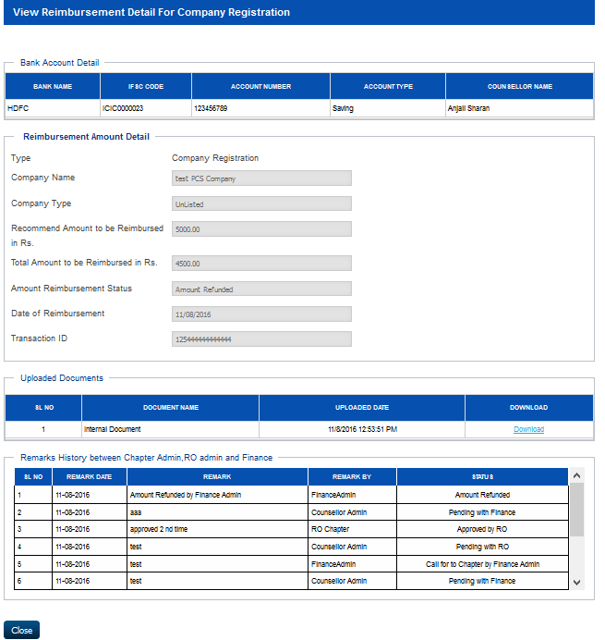

Counsellor
Bank Account Details
1. User visit to URL: www.Smash.icsi.in
2. User will login with Counsellor.
3. User will go to the Module link and mouse hover on menu “Counsellor” and click on “Bank Account Details” sub menu link .
4. User will view and update the Bank Account Details.
(Counsellor >Bank Account Details)
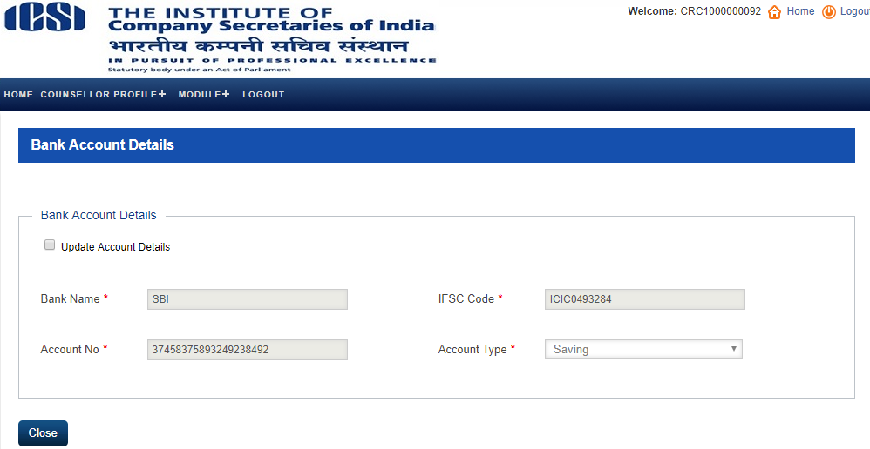
Create/Track Event
1. User visit to URL: www.Smash.icsi.in
2. User will login with Counsellor.
3. User will go to the Module link and mouse hover on menu “Counsellor” and click on “Create/ Track Event” sub menu link .
4. On clicking on Event Id, user will be able to view Event Request Detail.
5. On clicking on Create Event Button, user will fill all the mandatory details and Submit the request.
(Counsellor >Create/ Track Event)
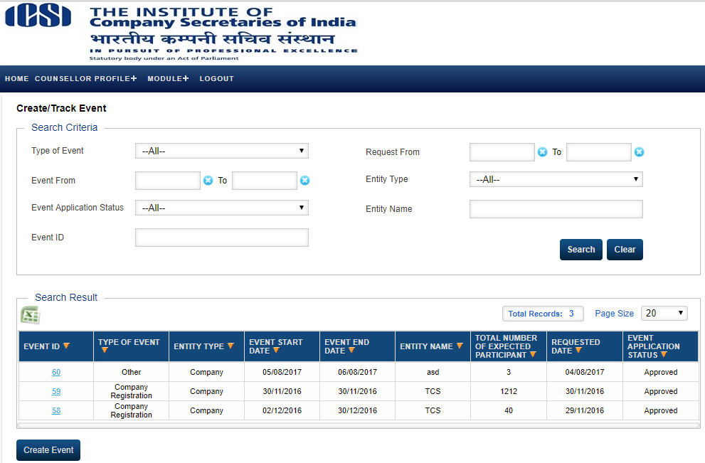
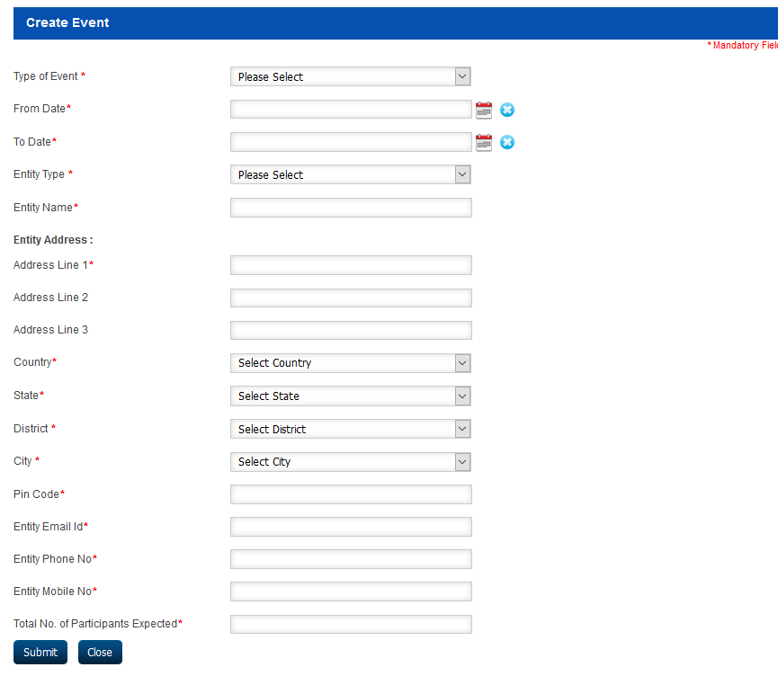

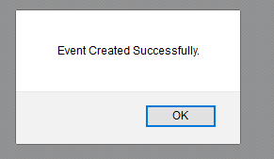
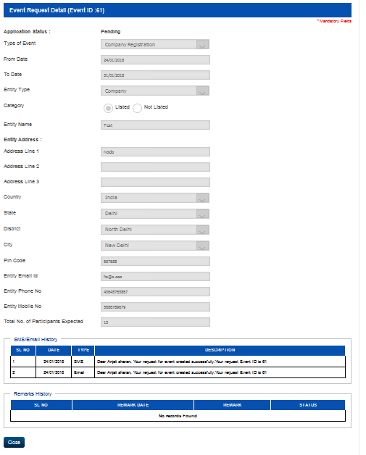

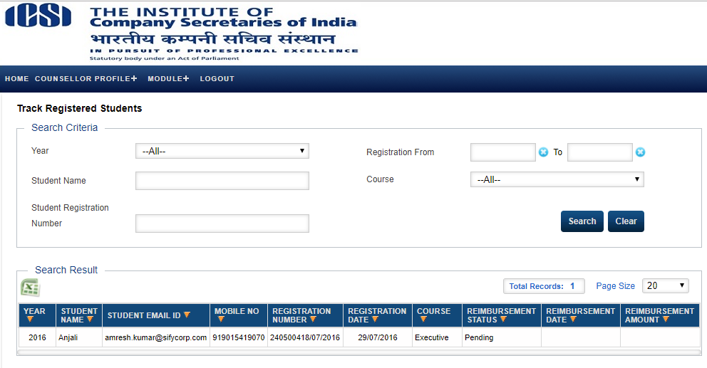
Track Registered Students
1. User visit to URL: www.Smash.icsi.in
2. User will login with Counsellor.
3. User will go to the Module link and mouse hover on menu “Counsellor” and click on “Track Registered Students ” sub menu link .
4. Data should be display on the page.
(Counsellor >Track Registered Students)
Track/Apply Event Reimbursement
1. User visit to URL: www.Smash.icsi.in
2. User will login with Counsellor.
3. User will go to the Module link and mouse hover on menu “Counsellor” and click on “Track/Apply Event Reimbursement ” sub menu link .
4. On clicking on Event Id, user will be able to view Reimbursement Request For Registration Of Company For Imparting Training.
5. On clicking on Event reimbursement Request button, user will fill all the mandatory fields and submit the request.
6. On clicking on Edit reimbursement Request button, user will be able to update the request.
(Counsellor >Track/Apply Event Reimbursement)


