

***18h January, 2019***

***Webinar for Candidates***

***of***

***Certified CSR Professional Course***

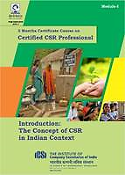 ***on***

***21st -22nd January, 2019 (Monday and Tuesday)***

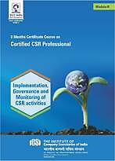

***Dear Candidate,***

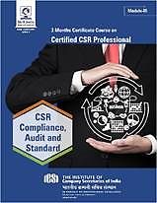 *The Institute of Company Secretaries of India is organizing a webinar for ‘****Certified CSR Professional’*** *Candidates as per the following schedule:*

***Date****:* ***21-22 January 2019 (Monday and Tuesday)***

***Time****:* ***10.30 AM onwards***

***The Candidates have to log in to the Webinar through the following Link :***

***http://www.skillpaw.com/webcast/icsi***

*The Experts/Mentors/Counsellors on CSR will highlight various issues relating to all the three Modules launched and provided to the candidates.*

*In addition to it, the Q & A session shall be there to clarify all the doubts & queries of the candidate.*

*All the Candidates are requested to participate in the Webinar for getting advantage of accessing the experts directly & putting your queries directly to the Experts for clarification.*

*Looking forward to meet you in the Webinar.*

***TEAM CSR***