User Manual
Of
Long Term Training

Table of Contents

1. INTRODUCTION..............................................................................................................................03
2. HQ ADMIN......................................................................................................................................04
2.1 Login……………………………………………………………………………………….………………………….…………………….…….05
2.2 Dashboard….…………………………………………………………………………………………………….……………………….…….05
2.3 Add New Training….…………………………………………………………………………………………………….…………….…….06
2.4 Training Request Approval (New / Balance) ….………………………………………………………………………….…….09
2.5 Quarterly Report Approval….……………………………………………….………………………………….…………………..….10
2.6 Project Report Approval….…………………………………………………………………………………………….………….…….10
2.7 Exemption Request Approval….……………………………………………………………………………………….……….…….11
2.8 Exemption Masters….……………………………………………………………………………………………………………….…….12
2.9 Training Clearance Approval….………………………………………………………………………………………………….…….14
3. TRAINER…………………….…………………................................................................................................15
3.1 Login….………………………………………………………………………………………………………………………………….….…….16
3.2 Quarterly Report Submit….……………………………………………………………………………………………………….…….16
4. STUDENT........................................................................................................................................19
4.1 Login….……………………………………………………………………………………………………………………………………….…….20
4.2 Dashboard….……………………………………………………………………………………………………………………………….…….20
4.3 Training Request….…………………………………………………………………………………………………………………………….21
4.4 Generate Pre-sponsorship Letter….……………………………………………………………………………………………….…….23
4.5 Generate Sponsorship Letter….…………………………………………………………………………………………….……….…….24
4.6 Switch Over from Earlier to Modified Training….………………………………………………………….………………….…….25
4.7 Exemption Request….…………………………………………………………………………………………………………………..…….26
4.8 Balance Training Registration….…………………………………………………………………………………………………….…….27
4.9 Training Clearance Certificate….…………………………………………………………………………………………………….…….27

Introduction

The Training module will enable the Registration of Students request for different training like Short term Training, Long term Training, Balance Training, Training exemption, 15 days specialized training etc. And the request submitted by the students can be reviewed and the respective actions like approve, reject, call for will be taken by the admins on this system.
This application will be capturing of Training data of students including sponsorship certificate details, completion certificate details, exemption details etc. with electronic-letter confirmation. Quarterly Reports and Project Report submission.
Capturing of Corporate/Companies/PCS data registered for imparting training along with their vacancies along with approval system for making them Active/Dormant. Application of Student for Full / Partial Exemption of Training.

HQ ADMIN

Login Screen
The user HQ Admin / Trainer / Student will login to training application with this login screen and after login user will be navigated to dashboard page. The URL for login to the training application is below.
URL: http://stimulate.icsi.edu
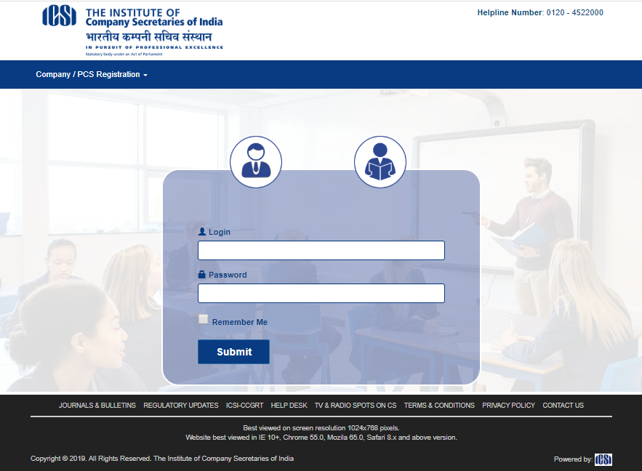

HQ Admin Dashboard
This is dashboard screen for HQ Admin user where user can do below –
- Add New Training after click on Add New Training button
- View Scheduled Training details with search criteria after click on Scheduled Trainings button
- View Feedback of Student after click on View Feedback button
- View on Going Training calendar published by RO/Chapter.
- MIS Reports Download from MIS Report Download section.
- Logout after click on Logout button in header right section.
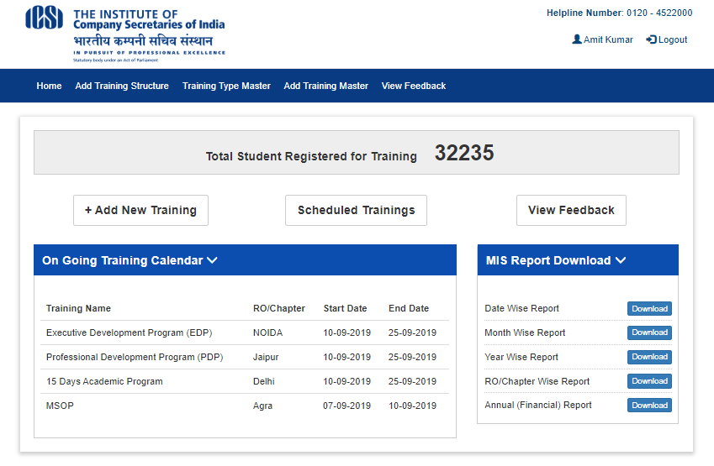

HQ Admin >> Add / Edit Training Structure
This is HQ Admin screen for creating new Training Structure like Earlier, Modified and Edit after click on Edit link in table grid. Click on Training Admin dropdown >> Training Structure link to navigate this screen.
(Refer below screen).
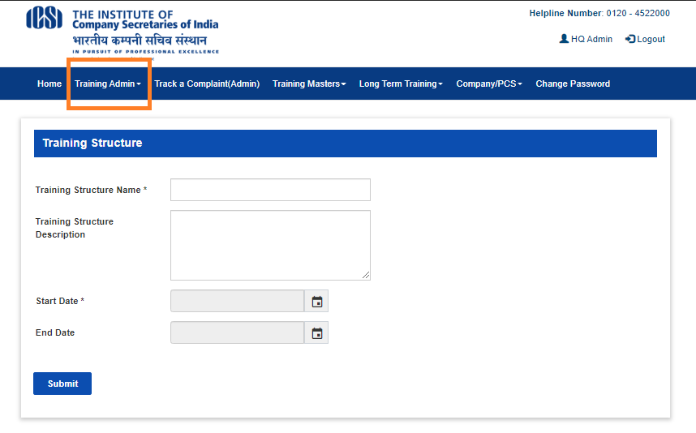

HQ Admin >> Add / Edit Training Type
This is HQ Admin screen for creating new Training Type like Short Term, Long Term and can Edit after click on Edit link in table grid. Click on Training Admin dropdown >> Training Type link to navigate this screen.
(Refer below screen).
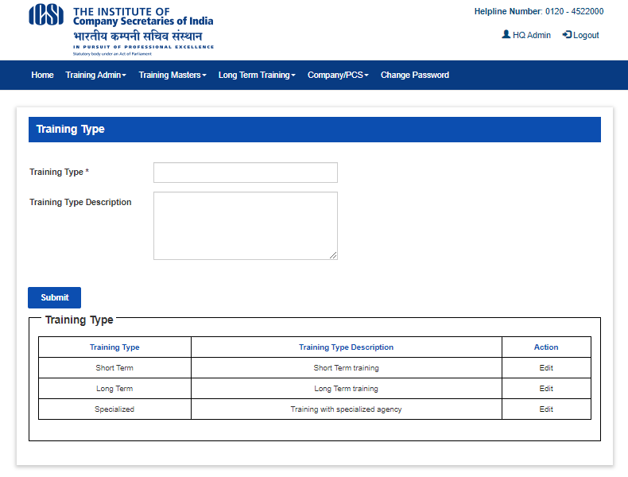

HQ Admin >> Training Master
This is HQ Admin user screen for training master with search. Click on Training Admin dropdown >> Training Master to navigate this screen. (Refer below screen).
- User can search created training with search criteria and can see search result as per search criteria.
- User can edit training details after click on Edit link in search result grid.
- User can create new training after click on Add New Button.
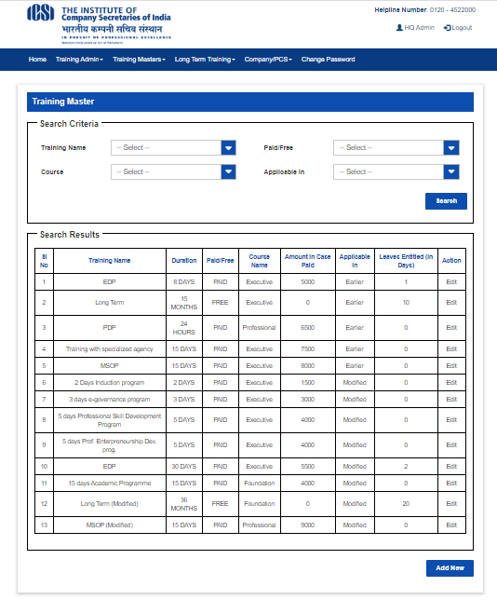

HQ Admin >> Training Master >> Add New Training
This is HQ Admin user screen for add new training. With this screen user can create new training like EDP, PDP with required details.
Click on Add New button in Training Master previous screen to navigate this screen (Refer below screen).
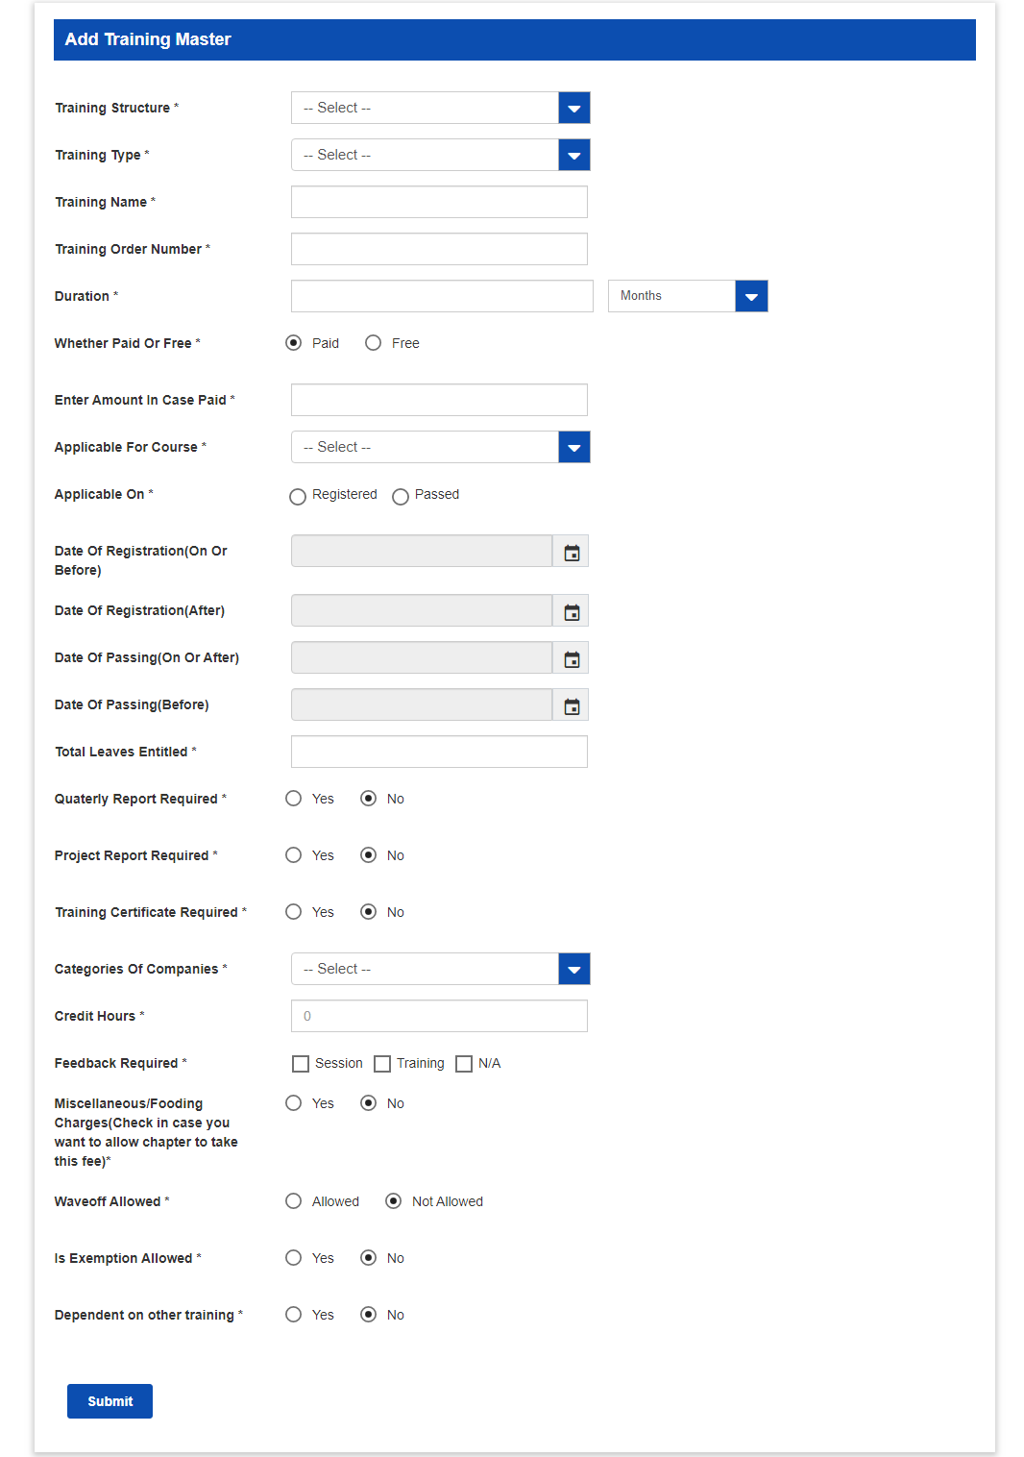

HQ Admin >> Training Request Approval
This is HQ Admin user screen for Training Request Approval. With this screen admin can do below –
- Search student list with search criteria
- Select any student from search result grid and click on Action button for approval.
Click on Long Term Training dropdown >> Training Registration Request Approval link to navigate this screen.
(Refer below screen).
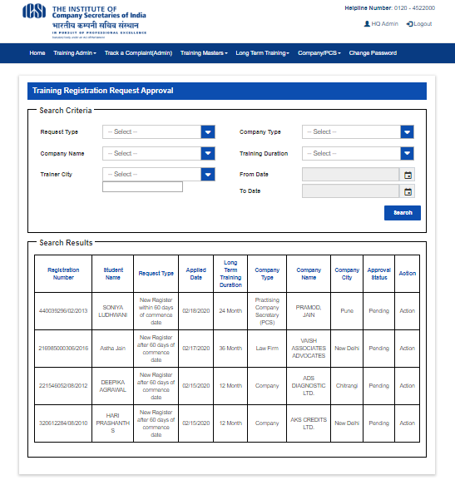

HQ Admin >> Training Request >> Approval
This is HQ Admin user screen for Training Approval. Admin can view details and Approve / Reject / Call For with remarks.
Click on Action button in search result grid on previous screen to navigate this screen. (Refer below screen).
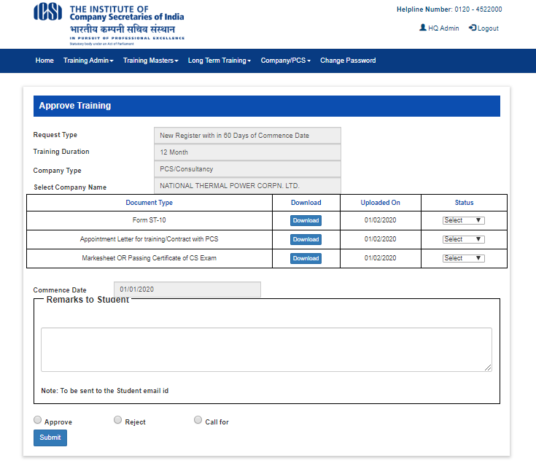

HQ Admin >> Training Report Approval
This is HQ Admin user screen for view quarterly / project report and approve / reject / call for action with remarks.
Click on Long Term Training dropdown >> Training Report Approval link to navigate this screen.
(Refer below screen).
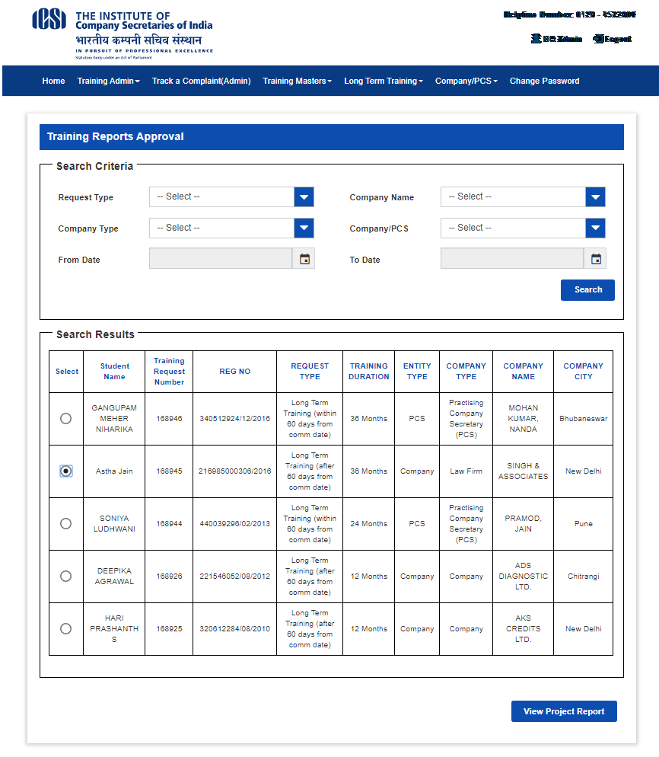

HQ Admin >> Training Report Approval >> Approval
This is HQ Admin user screen for Training Approval. Admin can view quarterly / project report and can Approve / Reject / Call For with remarks.
Click on View Project Report button in previous search result grid to navigate this screen. (Refer below screen).
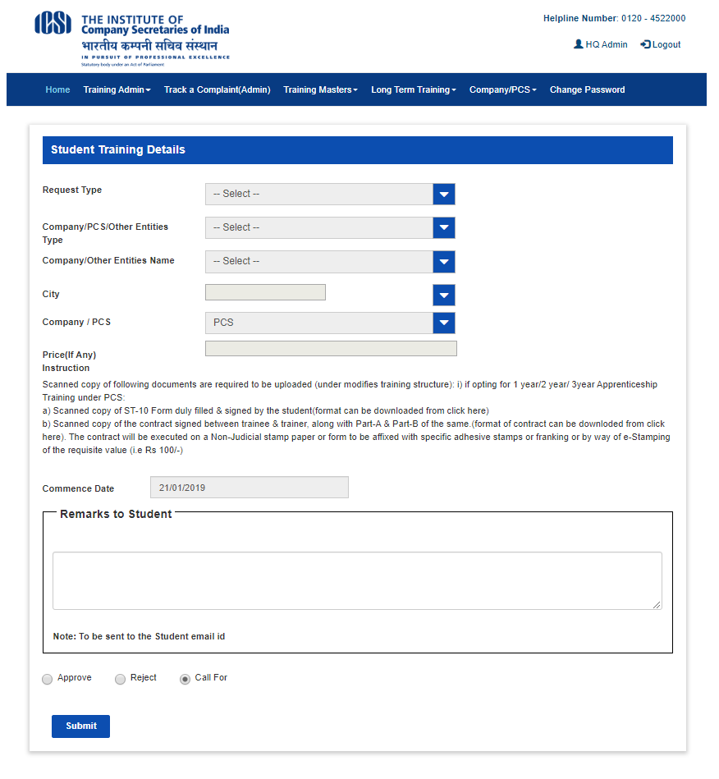

HQ Admin >> Exemption Request Approval
This is HQ Admin user screen for Approve training exemption request where admin can do below –
- Search for student list exemption request with search criteria
- Select student from search result grid and click on Approve exemption button
Click on Long Term Training dropdown >> Approve long training exemption link to navigate this screen.
(Refer below screen).
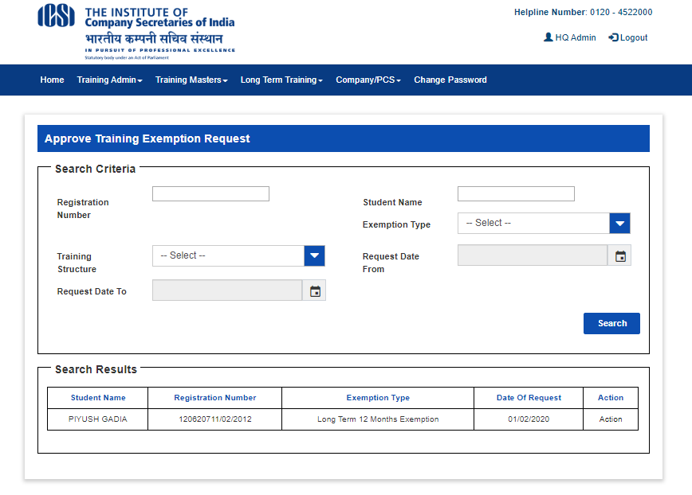

HQ Admin >> Exemption Approval
This is HQ Admin user screen for exemption approval. Click on Action button in search result grid in previous screen to navigate this screen. (Refer below screen).
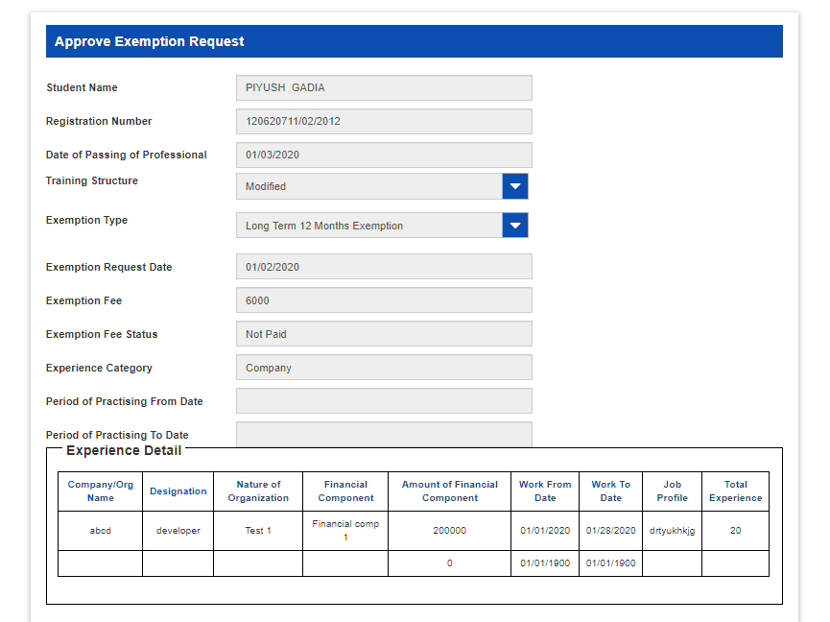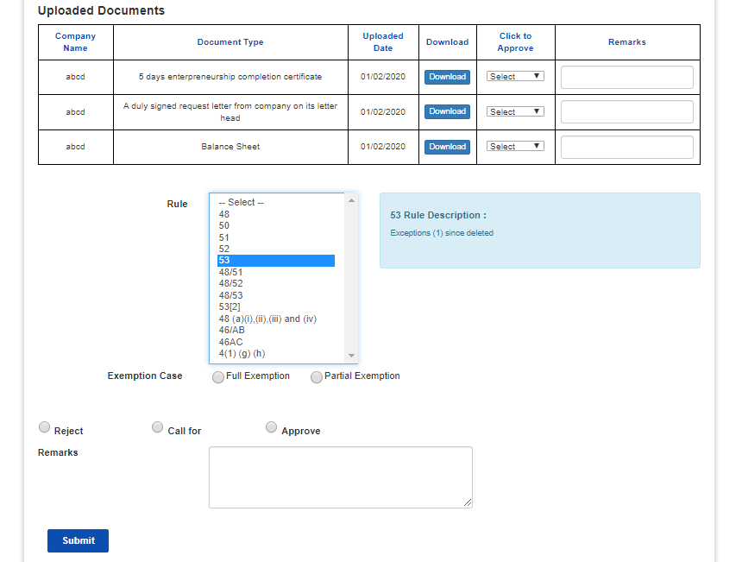

EXEMPTION MASTERS

HQ Admin >> Exemption Masters >> Define Exemption Rule
This is HQ Admin user screen for define exemption rule. With this screen user can create new rule and regulation like 45, 52(b) with description.
Click on Long Term Training dropdown >> Define Exemption Rule link to navigate this screen.
(Refer below screen).
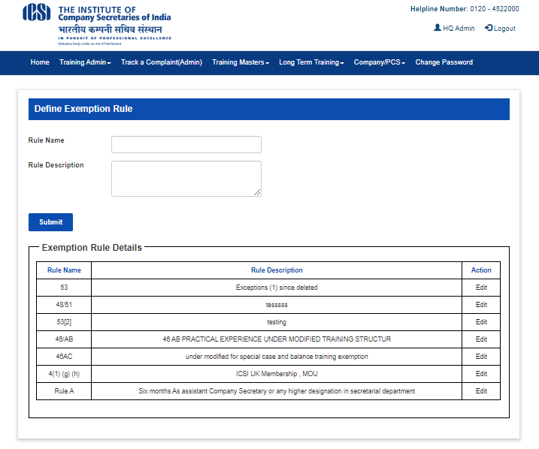

HQ Admin >> Exemption Masters >> Add Training Component
This is HQ Admin user screen for Add training component. With this screen user can create new training component like 1 month financial.
Click on Long Term Training dropdown >> Add training component link to navigate this screen.
(Refer below screen).
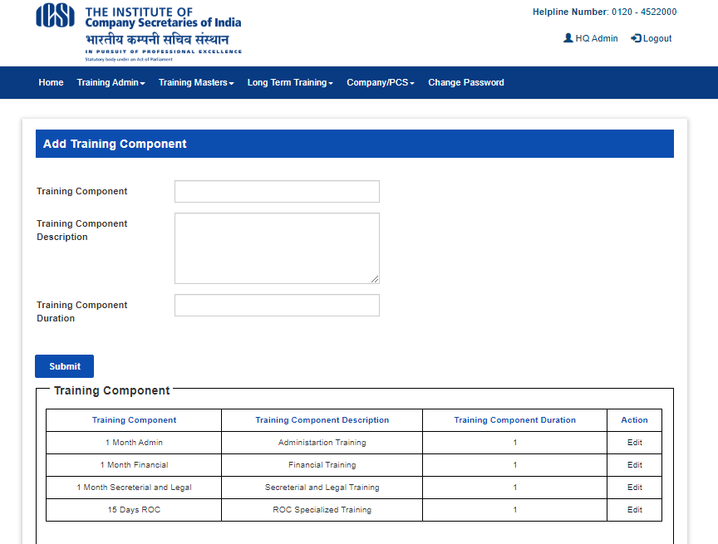

HQ Admin >> Exemption Masters >> Add Financial Component
This is HQ Admin user screen for Add financial component. With this screen user can add new financial component.
Click on Long Term Training dropdown >> Add financial component link to navigate this screen.
(Refer below screen).
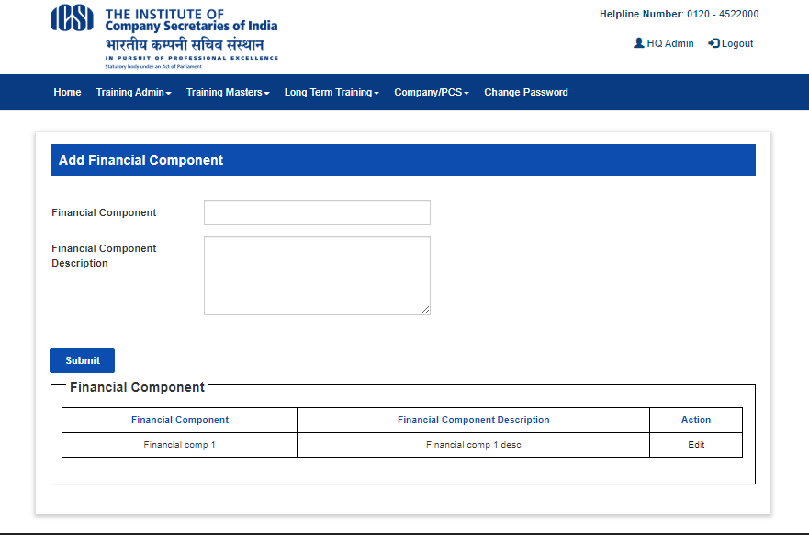

HQ Admin >> Exemption Masters >> Add Nature of Organization
This is HQ Admin user screen for Add nature of organization. With this screen user can add nature of organization.
Click on Long Term Training dropdown >> Add nature of organization link to navigate this screen.
(Refer below screen).
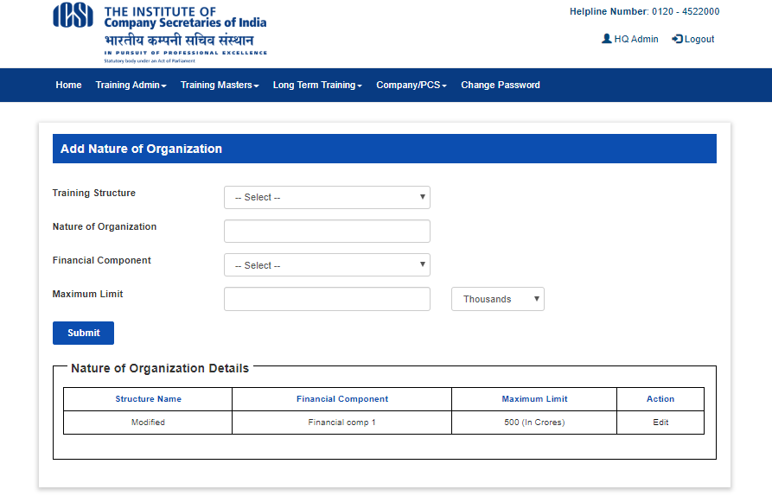

HQ Admin >> Training Clearance Approval Master
This is HQ Admin user screen for Approve student training clearance certificate.
Click on Long Term Training >> Approve final training clearance certificate link to navigate this screen.
(Refer below screen).
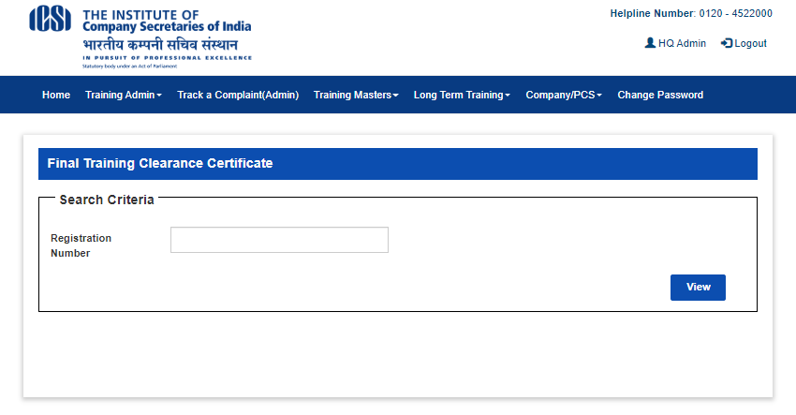

HQ Admin >> Training Clearance >> Approval
This is HQ Admin user screen for view and approve training clearance certificate.
Click on View button on previous search screen to navigate this screen. (Refer below screen).
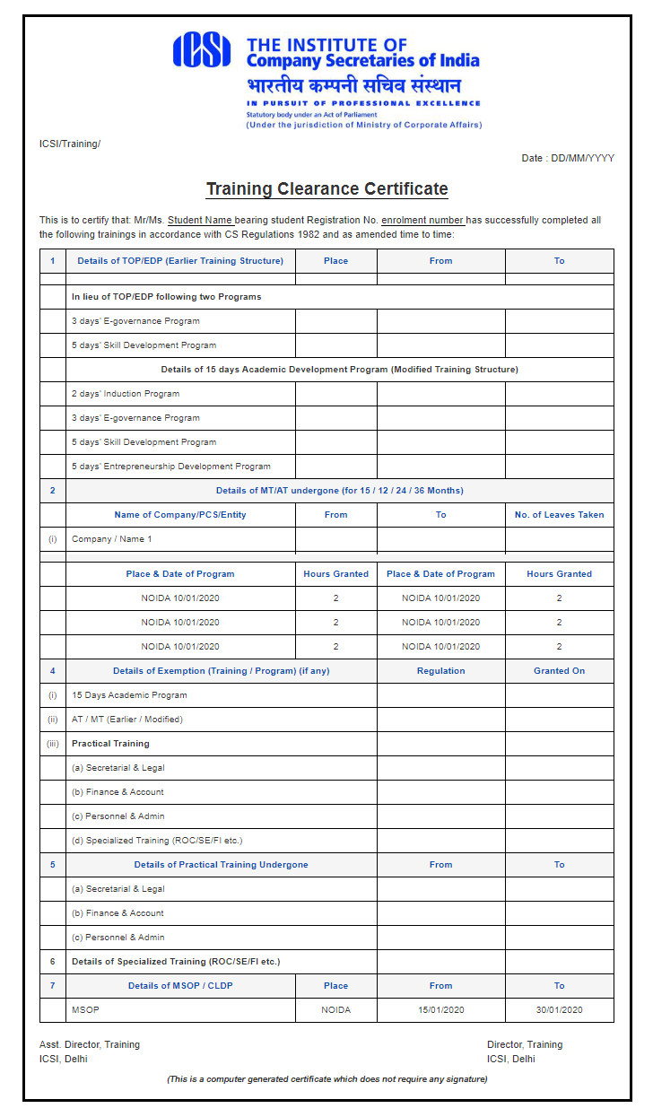

TRAINER

Login Screen
The user HQ Admin / Trainer / Student will login to training application with this login screen and after login user will be navigated to dashboard page. The URL for login to the training application is below.
URL: http://stimulate.icsi.edu

Trainer >> Submit Quarterly Report
This is Trainer user screen for Submit quarterly report with search. With this screen user can do below -
- Search student detail with search criteria.
- Select student from search result grid and click on Submit quarterly report button.
Click on Long Term Training >> Submit quarterly report link to navigate this screen. (Refer below screen).
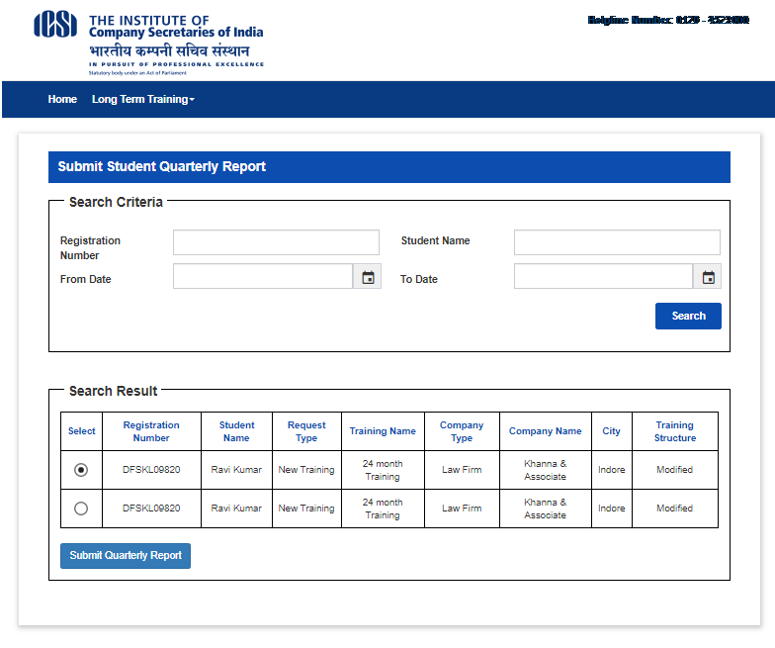

Submit quarterly report screen (Part A).
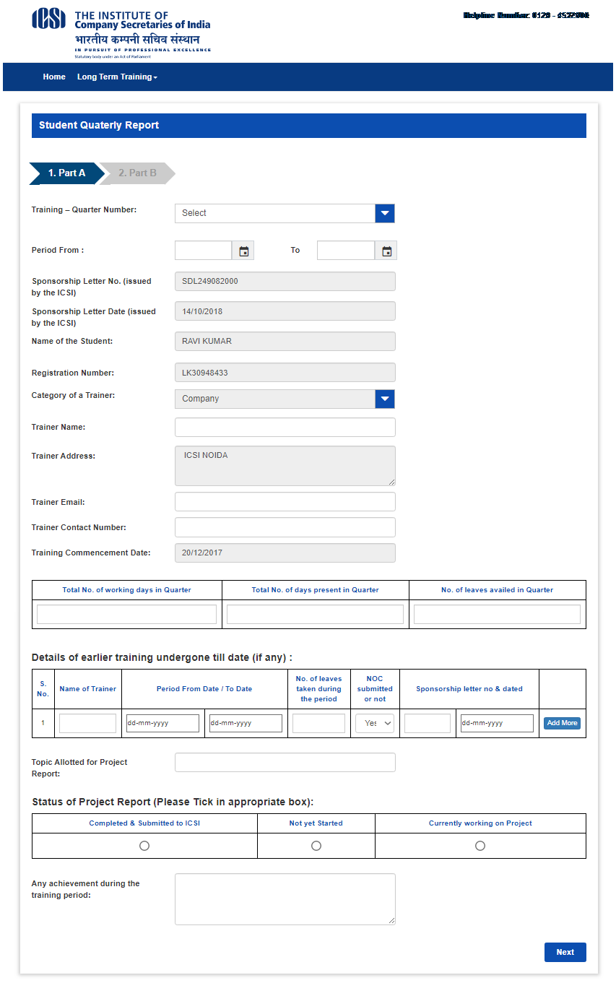

Submit quarterly report screen (Part B).
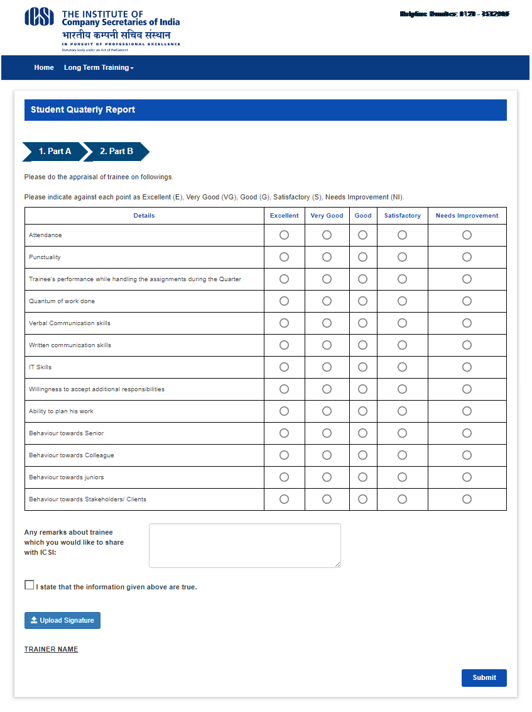

STUDENT

Login Screen
The user HQ Admin / Trainer / Student will login to training application with this login screen and after login user will be navigated to dashboard page. Student can login with SMASH login credential. The URL for login to the training application is below.
URL: http://stimulate.icsi.edu

Student Dashboard
This is dashboard screen for student user where user can do below –
- Student can View Training applicable details.
- Student can view profile detail in my profile section.
- Student can see examination status detail in examination status section.
- Logout after click on Logout button in header right section.
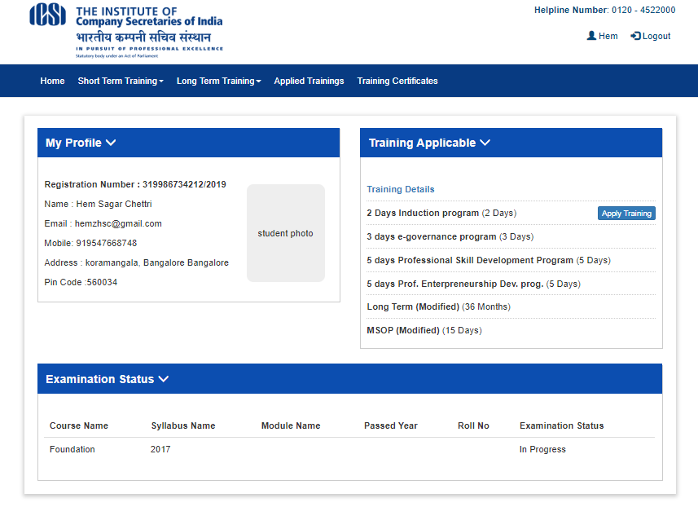

Long Term Training >> Training Request
This is Student user screen for Long term training request. With this screen student user can do below -
- Search and apply for long term training request.
- Apply for Transfer of Training after select training from search result grid and click on Transfer of training button.
- Update and view training report (quarterly / project) after select training from search result grid and click on Update training report button.
Click on Long Term Training dropdown >> Training request link to navigate this screen. (Refer below screen)
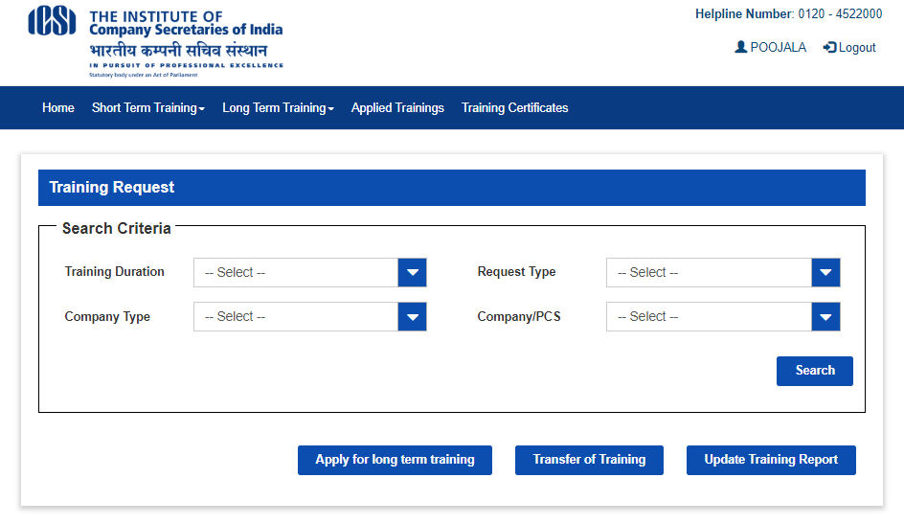

Long Term Training >> Training Request >> New Request Register
This is Student user screen for Training request new registration.
Click on Apply for long term training button after selecting training from search result grid in previous screen to navigate this screen. (Refer below screen).
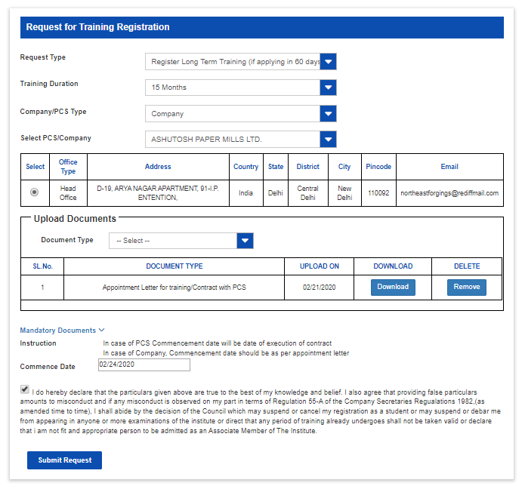

Long Term Training >> Training Request >> Transfer of Training
This is Student user screen for Transfer of training. With this screen student can request for transfer of training.
Click on Transfer of training button in previous screen after select training from search result grid to navigate this screen. (Refer below screen).
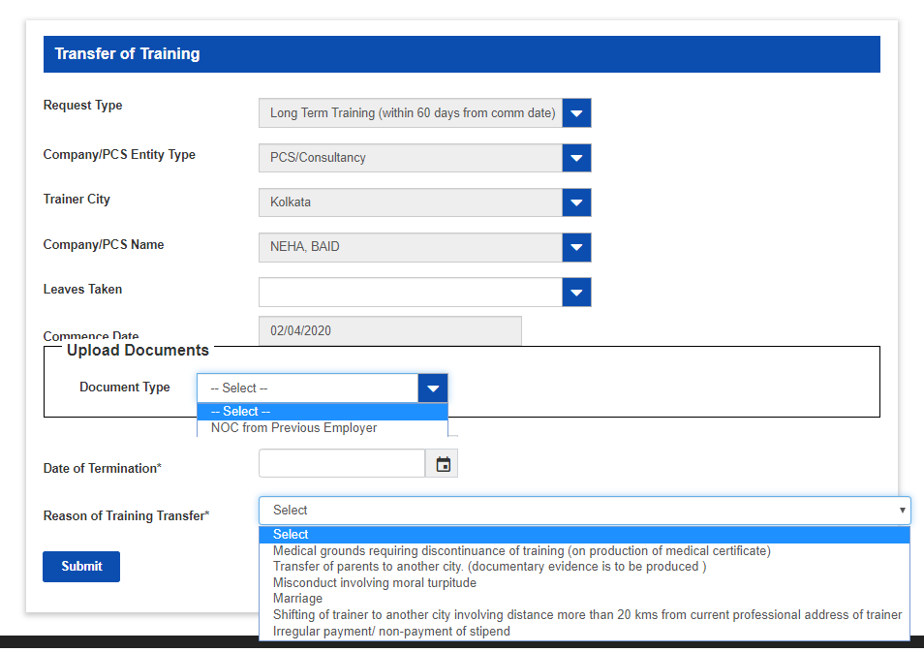

Long Term Training >> Training Request >> Update Training Report
This is Student user screen for view and update training report. With this screen student can view quarterly report status, update project report.
Click on Update training report button in previous screen after selecting training from search result grid to navigate this screen. (Refer below screen).
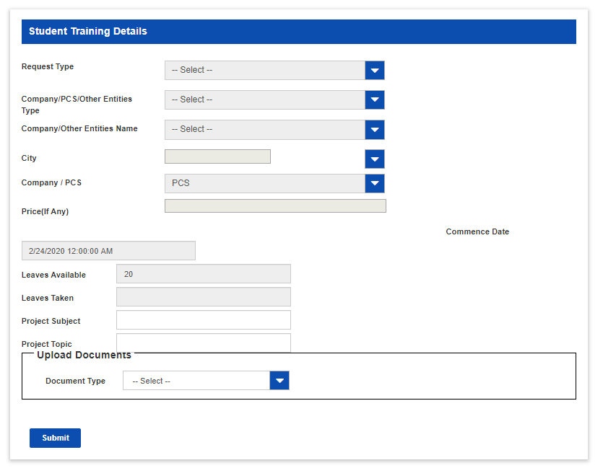

Long Term Training >> Generate Pre-sponsorship Letter
This is Student user screen for Generate Pre-sponsorship letter.
Click on Long Term Training >> Generate pre-sponsorship letter link to navigate this screen.
(Refer below screen).
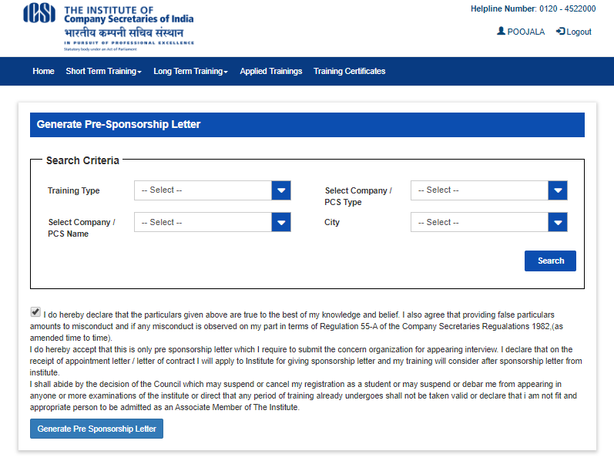

Pre-sponsorship Letter View
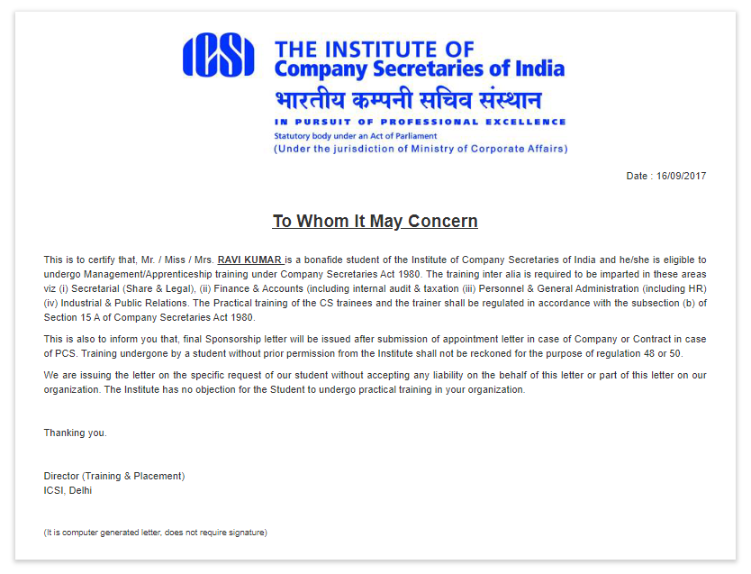

Long Term Training >> Generate Sponsorship Letter
This is Student user screen for Generate sponsorship letter.
Click on Long Term Training >> Generate sponsorship letter link to navigate this screen.
(Refer below screen).
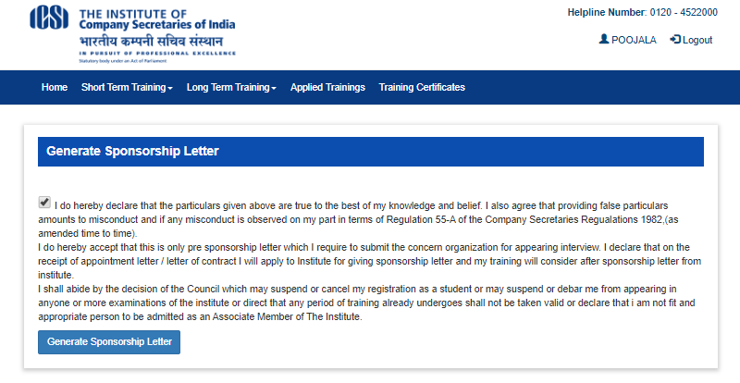

Sponsorship Letter View
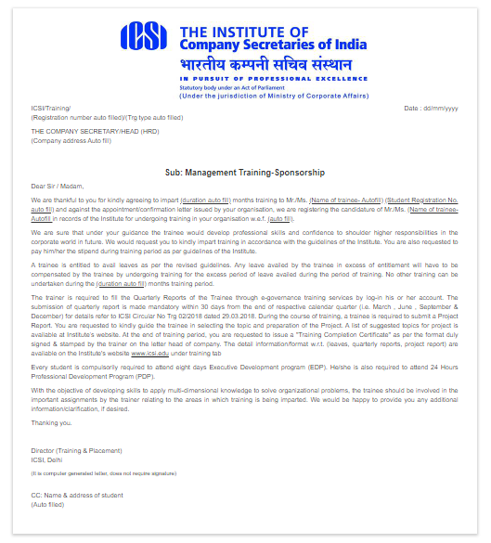

Long Term Training >> Switch over earlier to modified training
This is Student user screen for Switch over training from earlier to modified. With this screen student can switch over from earlier to modified training structure.
Click on Long Term Training >> Switch over earlier to modified training link to navigate this screen.
(Refer below screen).
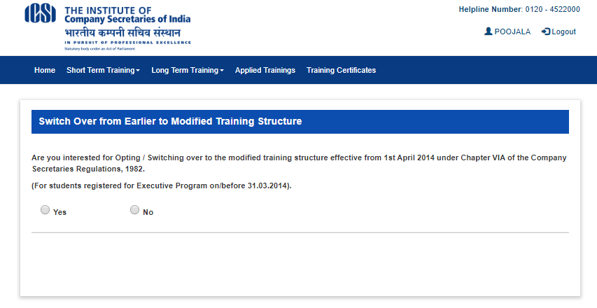
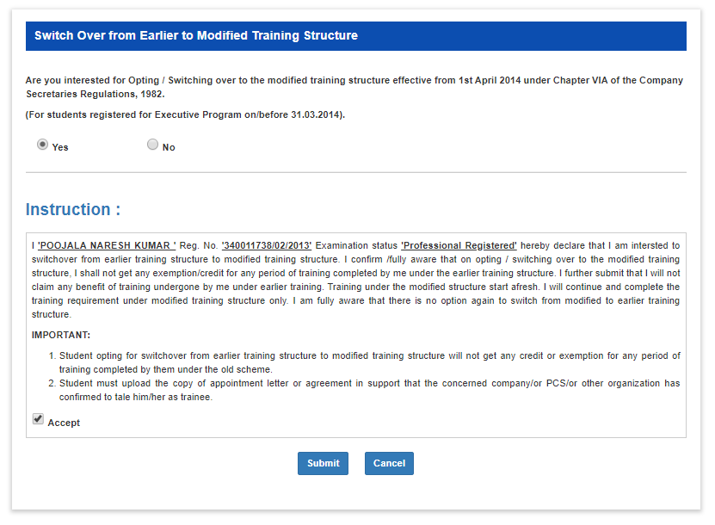
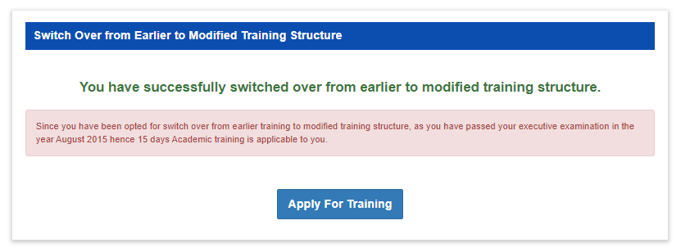

Long Term Training >> Exemption Request
This is Student user screen for Exemption request. With this screen student can apply for exemption request.
Click on Long Term Training >> Exemption request link to navigate this screen. (Refer below screen).
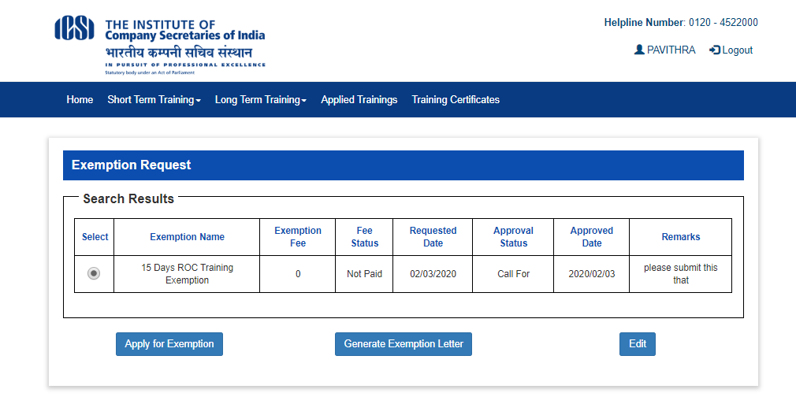

Apply for Exemption request screen after selecting training from search result grid and click on Apply for Exemption button (Refer below screen).
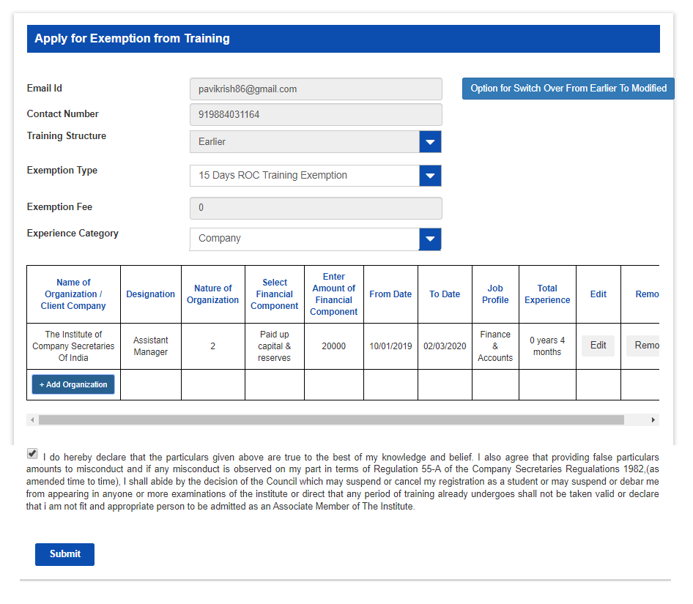

Long Term Training >> Balance Training Registration
This is Student user screen for Balance training registration. With this screen student apply for balance training in case of transfer of training and partial exemption.
Click on Long Term Training >> Balance training registration link to navigate this screen.
(Refer below screen).
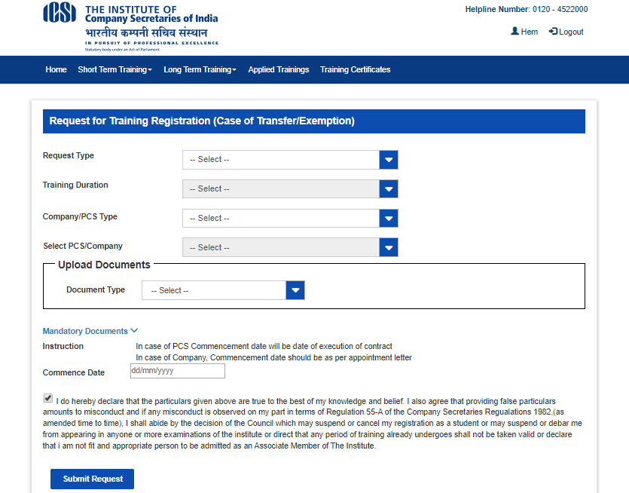

Long Term Training >> Training Clearance Certificate
This is Student user screen for Training clearance certificate. With this screen student can view and download training clearance certificate after approval from HQ admin.
Click on Long Term Training >> Training clearance certificate link to navigate this screen.
(Refer below screen).
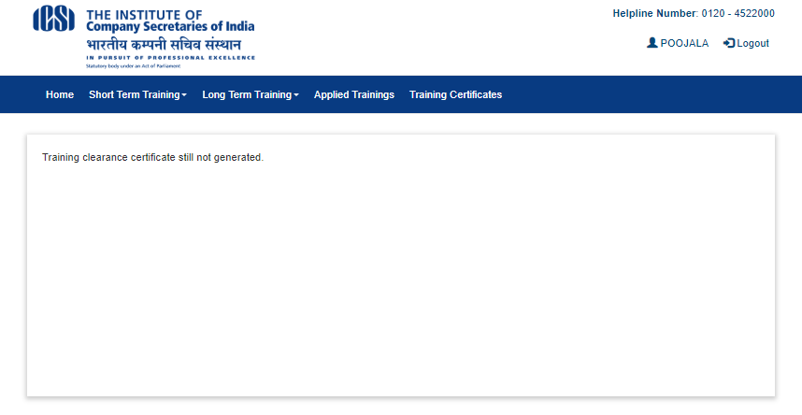

Training Clearance Certificate View if certificate approved by HQ Admin.

