ICSI E-LEARNING PORTAL USER MANUAL and FAQs

Dear Candidate,

Welcome to ICSI Elearning portal your gateway to access various courses being offered through this LMS.

- First of all please refer information given below to have an understanding of the process and technical requirements to access the courses.

Having read the entire document select the Exam Stage/Course from the link given below

https://www.icsi.edu/e-learning/
or click on the E-Learning tile as shown on the ICSI website and select the desired course and module to access.
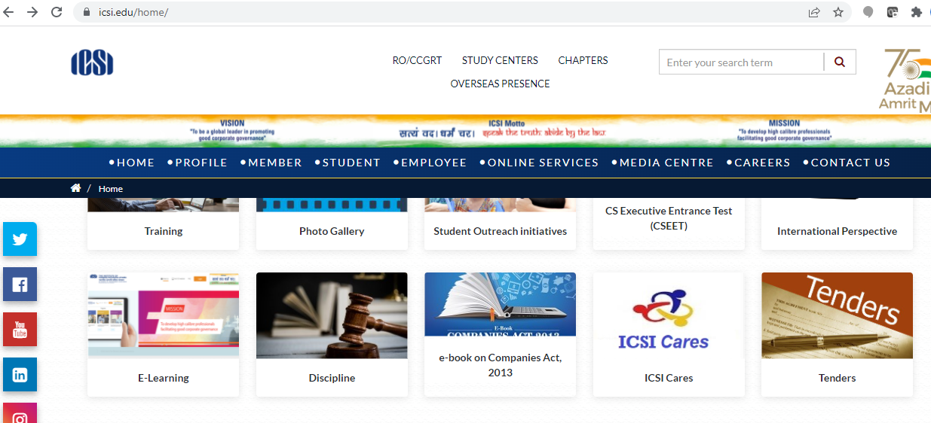
E-Learning Tile

After this the next screen will be shown as

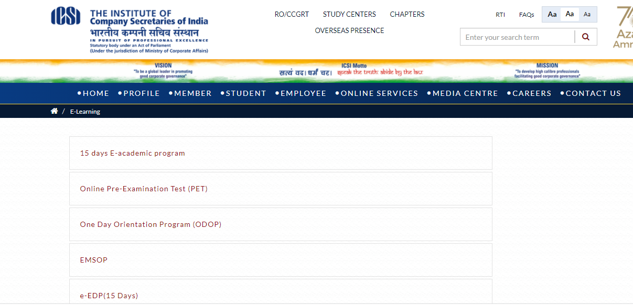

On the screen shown below please select the Exam Stage like Executive or Professional

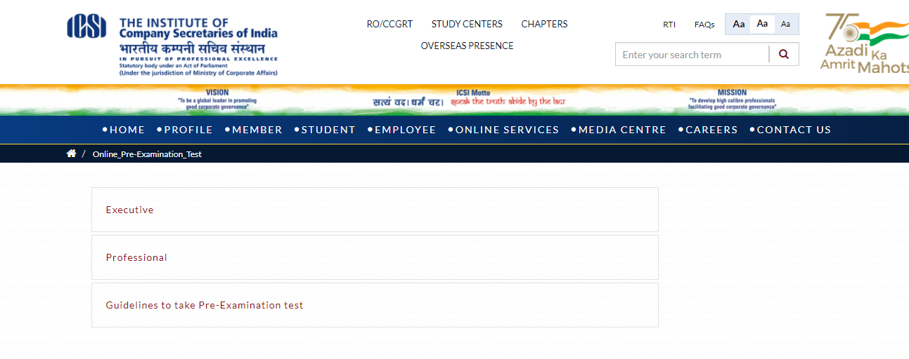

Finally you can select the Module you wish to appear

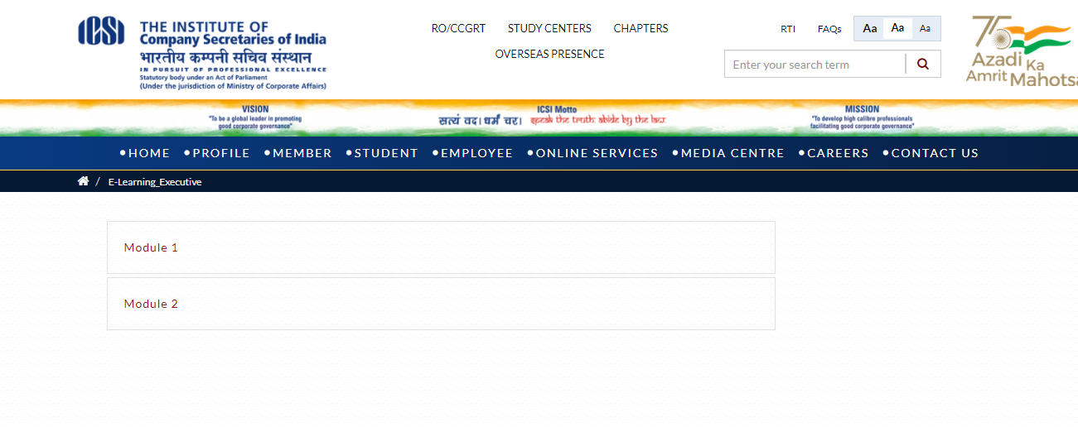
Once you select the module you will be redirected to the login page shown below

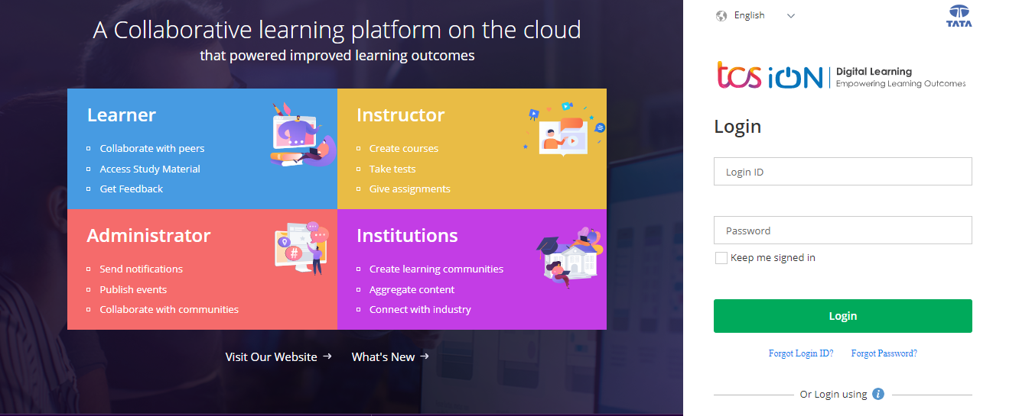

You can also reach the login page by copy paste the following link in updated Google Chrome Browser
https://www.tcsion.com/LX/login#lx

- Now use the following Login Credentials information
Learn@1234
Refer point 4 below in case you forgot password

- Your Login id is Your Registration Number (without any slash sign) suffix with @icsi.edu
For example- If your registration number is 1234567/10/2018 then your login ID will be 1234567102018@icsi.edu

2. Default password for first time login is
Learn@1234

3. Upon first login, you will be redirected to Expired password page where old password is 'Learn@1234' and then you can enter New Password to reset password. Your new password shall be like Study@3214 or Cap@99989.Once you reset the password please note it for future reference.
Learn@1234
- In case you forget password then use forgot password link:
https://www.tcsion.com/dotcom/PasswordPolicy/forget_pwd.jsp?orgFolder=TCSSMB&loginType=12NaN1
Where Login Id is your registration number without slash@icsi.edu e.g1400000072018@icsi.edu and the only option is email. Do not select OTP option. The link to reset password will be sent to your registered e-mail Id.

- After successful login please take the Pre-Examination Test and Download the certificate by following the steps at the end of this document.

- Technical Requirements for Using the LMS

a. Good Speed internet connection (4MB/s)
b. Updated version of Google Chrome/Mozilla Firefox browsers. We do not recommend Internet Explorer.
c. Preferred Screen resolution - 1366 x 768 / 1280 x 720.
d. Regular cleaning of browser cache memory
e. The preferred screen resolution is of width 1440px to 768px.

- Devices Recommended.

- We recommend to use Desktop/Laptop of Latest configuration for taking Pre-Examination or for accessing other courses being offered through the LMS.

- You can also access the e-learning platform on Tablets and Mobile handsets.

A dedicated Applicaiton “mTOP” is available for Android and IOS devices. You may download and install mTop on your mobile sets from the following link:

Android Users

https://play.google.com/store/apps/details?id=com.tcs.mobile.mtop&hl=en&IN&gl=US

IOS Users
https://apps.apple.com/in/app/mtop/id1239667765

Please DO NOT take assessments/examinations on mTOP application

- Guidelines for Online Pre-Examination Test

- Qualifying the Online Pre-examination Test will be mandatory both for examination for the Executive and Professional Programmes.
- The test will be conducted as follows :
- Online Computer Based
- The student can take the test from his home, cyber café or any other location.
- Multiple Choice Question (MCQ) type with negative marking of 25% of the allotted marks;
- The online test shall be of 100 marks.
- The duration of the test shall be 60 minutes.
- Total questions in the test shall be 50.

- The qualifying marks in each subject will be 40%.
- Students may appear in Pre-Examination Test in any specific subject thrice (three times) in a day. However there must be a gap of at least 8 Hrs between any two successive attempts in that subject.
- A student shall have to qualify in all the subjects of the Module in which he wants to appear in an Examination Session;
- The result of the Test of a subject, in which a student has qualified will remain valid for future Examinations.
- Students who have not cleared the Pre-exam test shall not be eligible to enrol for the examinations.
- After switchover into New Syllabus (2017), the students shall only be allowed to enrol for the examinations in the new syllabus after passing the Pre-Exam Test.
- After switchover, the student has to clear the pre-examination test for the subjects which are not exempted to be eligible to take the main examination.

- Steps to take Pre-Examination Test and Download Certificate

Step 1.

After login select My courses option and Search for “ Online Pre Examination Test Executive Module – 1 ” or “ Online Pre Examination Test Executive Module – 2 ”
or “ Online Pre Examination Test Executive Module – 3 ” as the case may be and click on the launch Button.
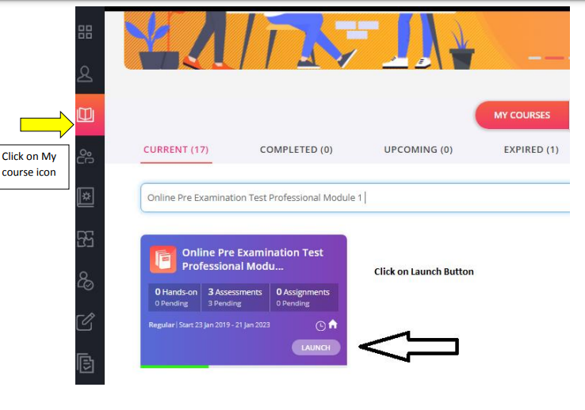

Step 2.
After click on launch button Table of content will appear, please click on the + sign to select the subject for which want to take the Pre-Examination Test and then click on LAUNCH ASSESSMENT as shown below.
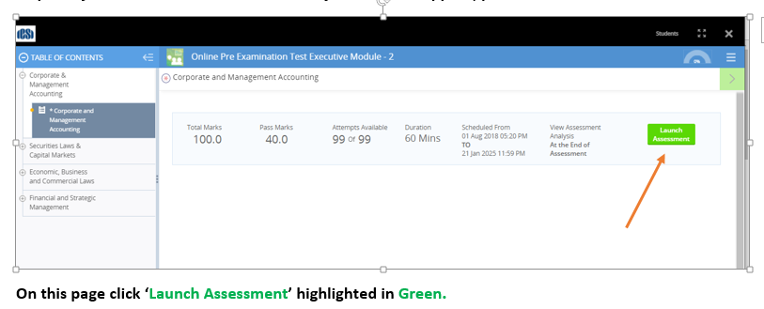
Step 3. You will be guided to Instructions page. Read the Instructions carefully.
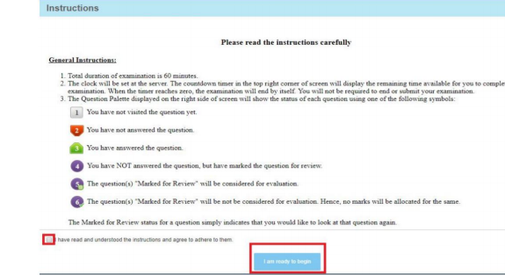

After reading the instruction,
◊ Tick the checkbox displaying (I have read and understood the instructions and agree to adhere to them).
◊ Click on “I am ready to begin”

Step 4. Assessment will start just after you click on this button. Given below is assessment screen:
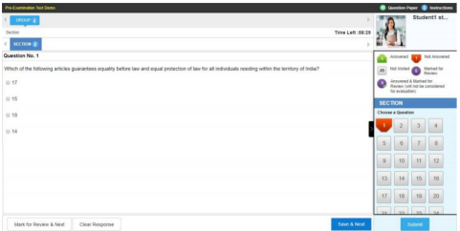

Step 5. Once the Test is completed use the SAVE and Next option and submit the test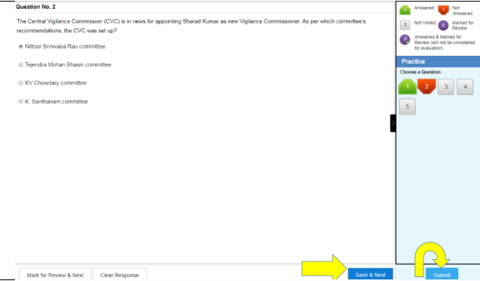
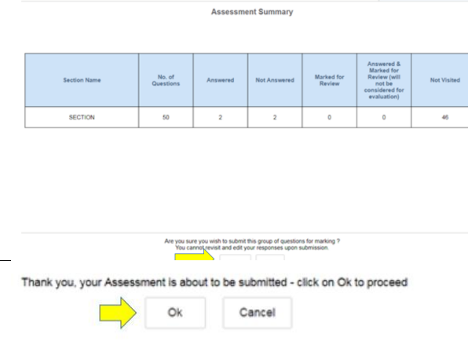

Step 6. You can download the certificate after two hours of completing the pre examination test for any module. Certificate of completion is available under completed courses section. To download certificate, click on “View certificate”.

You shall again go to my courses and click on the Module which you have completed.
- Click COMPLETED
2. Click on the Name of the module shown

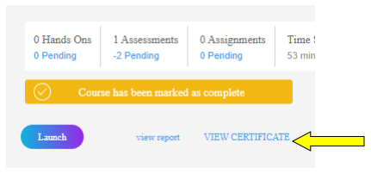
Click on the View Certificate to download the certificate.

- Pre-Exam Fee Payment (Only for students who have switch over from Old Syllabus 2012 to New Syllabus 2017): Students who have switch over from Old Syllabus 2012 to New Syllabus 2017, may remit Pre-Examination Fee via link http://www.icsi.in/PreExamFees/Login.aspx

- FAQs :Frequently asked Question

Q1. When I launch the online assessment a screen is displaying online assessment prerequisites check error in zoom level 100 –

A1. For taking pre examination test zoom level of screen should be 100%.

Q2. For students who will give the main exams in June or December, what is the cut-off date for clearing the pre-examination tests?

A2. Students may appear in Pre-Examination Test anywhere and number of times after receiving Login Credentials but they shall be able to appear in the Pre-Examination Test only ONCE every 8 hours or 480 minutes. If student closes/exits the browser by mistake it will take 70 second to launch depending on internet connectivity. Further Students shall try to clear Pre-Test well before his/her due date to fill main examination form to avoid closing days rush.

Q3. I have paid the exam fee and after that I cleared pre exam test. So where should I upload certificate?

A3 . You are not required to upload certificate after successful completion of pre examination test. Keep the record with you for reference in future.

Q4. I appeared for main exam in June or December after passing Pre-Examination Test failed. So I am going to appear in next attempt again. Do I need to pass the pre-examination test again?

A4. If your registration has not expired your pre-exam will remain valid for all successive terms. Keep the certificate with you for reference in future.

Q5. I have exemption of module 1 and module 3 of old syllabus. When I am going for pre exam it is showing all the paper?

A5: If you have module exemption then please ignore it. However, if you have subject wise exemption please launch the exempted subjects and submit the assignment without answering any question. It will mark your attendance for the pre-test of the exemption subject and the score will be processed within two/three working days.

Q6. Is there any negative marking in the online Pre-exam Test?

A6. Yes the Pre-Exam Test carries a negative marking of 1/4.

You may write to us elearning@icsi.edu in case you have any confusion about the above.

