Supporting Partner
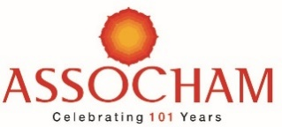
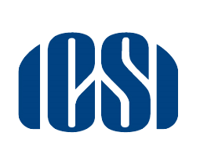
2 Unstructured CPE Credits for ICSI Members

Webinar On

“Recent Decisions of the Supreme Court/Tribunals and Appellate Tribunal and Pre-packaged Insolvency Resolution Process under IBC for MSMEs”
Saturday, May 29, 2021| 11:00 AM to 1:30 PM

Greetings from ICSI !!!
We are pleased to inform that ASSOCHAM Southern Region along with ICSI as supporting partner is organising a webinar on "Recent Decisions of the Supreme Court/Tribunals and Appellate Tribunal and Pre-packaged Insolvency Resolution Process under IBC for MSMEs" on Saturday, May 29, 2021 from 11.00 AM to 1.30 PM.
The registration is on first come first serve basis. There is no participation fee for members of ICSI.
For registration please visit link - https://bit.ly/3npe1rw

After registration, you will receive a confirmation email containing information about joining the webinar.

In case of any query regarding registration, please feel free to contact Mr. K.R. Kiran Kumar, Mob: 7899223221, Email: kiran.kumar@assocham.com

With regards,

TEAM ICSI

