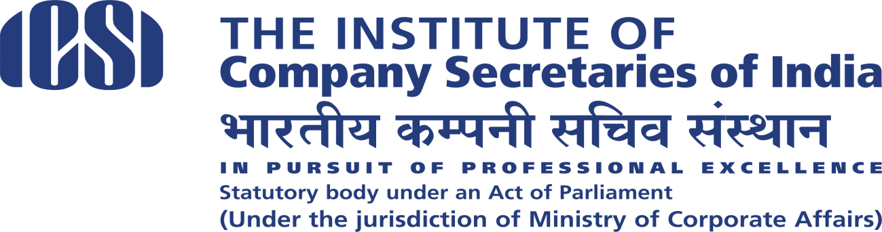

National Conference of Corporate CS
The LaLit, Mumbai | January 4-5, 2020

Accommodation arrangements for outstation Delegates

Dear Professional Colleague,

Delegate Registrations for the National Conference of Corporate CS on the theme “Governance Beyond Compliance: Expanding Horizons for Company Secretaries” scheduled to be held at The LaLit, Mumbai during January 4-5, 2020 are now open at the weblink: http://tiny.cc/9okhhz

Accommodation for outstation delegates is available at discounted rates at the venue of the Conference as per the following details:

Name & Address of Hotel | Star Category | Distance from Airport | Room Tariff per room per night with breakfast and Wi-Fi |  | Taxes | Name of contact for booking | Contact Number | E-mail
 |  |  | Single | Double
 |  |  | Occupancy
The Lalit Mumbai Sahar Airport Road Andheri East | 5 star | 0.5 km | 6000 | 7000 | 12% | Richard Haridasoham | 9004653642/8850631916 | richard.haridasoham@thelalit.com
 |  |  |  |  |  | Ninad Cheulkar | 9004307711 | mumresv@thelalit.com

The delegates may directly book their accommodation with the hotel. Limited rooms are available in the discounted category. In case the rooms are sold out, the hotel would provide the rooms in the next higher category at additional charges.

Kindly note that subject line while sending the booking should be “Booking Request – The Institute of Company Secretaries of India” so that the hotel reservation team can identify ICSI delegates and book on special rates.

Regards,

Team ICSI

