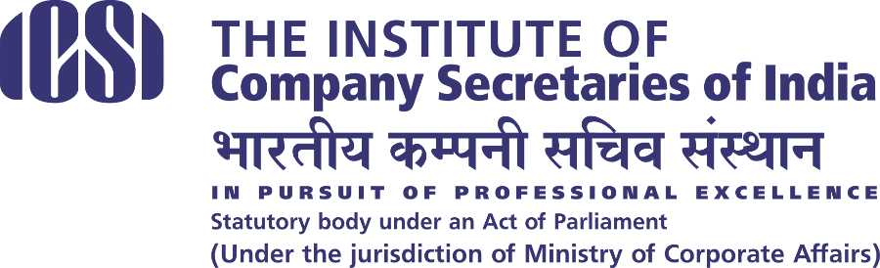

Salient Features
Online Quiz on ICSI Constitution Day & Allied Areas only – 2021

- The modalities of the online quiz will be as follows.
- The Quiz will be conducted in two Rounds.
- Eligibility: Students pursuing 11th Class / Pursuing 12th Class / Passed 12th Class/ pursuing Graduation / Pursuing Post Graduation of any stream / CS registered Students are eligible to participate in the quiz.
- Public Announcement of Online Quiz – 15th October, 2021.
- Commencement of Online Registration for Preliminary Round- 15th October 2021 at 10.00 am.
- Last date for Online Registration for Preliminary Round – 30th October 2021 at 5.00 pm.
- Preliminary Round: 14th November, 2021 at 11.00 AM – 11.20 AM.
- Registration for Final Round – 15th November, 2021 at 10.00 AM till 23rd November, 2021 at 5.00 PM
- Final Round: 26th November, 2021 at 16.00 PM – 16.20 PM.
- Existing Students of CS Course are also eligible to participate in the competition.
- Employees of ICSI and their wards and spouse are not eligible to participate in the competition
- Upper Age limit : 25 years (as on 30.09.2021)
- For any query, please contact Help Desk Number 9513850025 or write to ICSIConstitutionday@icsi.edu
- No Participation Fee.
- The Online Quiz Competition shall be in MCQ Pattern.
- Students can participate in the Quiz through Mobiles, Tablets, Laptops and Desktops which have internet connectivity. Scheduling of batches can be done for conducting of quiz, based on total participants registered.
- Syllabus for Competition : Constitution of India and Allied Areas related to Constitution of India.

Format of the Quiz

The participants who register for the competition through the online mode shall ONLY be eligible to participate in the Preliminary Round of the competition. Intimation to all the participating students will be sent through e-mail and SMS.

- Preliminary Round of the competition

This round will be conducted through an Online Competition in MCQ Pattern on 14th November, 2021 . Time of appearing shall be informed to all students as per the time of their respective batches, by email & sms. On the date of competition students may login and appear in the competition as per their allotted batch timing. Duration of the competition will be 20 Minutes during which a student is to attempt 25 questions. The window shall display the Timer during the Test and the same will automatically close at the end of stipulated time. The students who shall be scoring minimum 20 Marks out of a total of 25 Marks shall be shortlisted for the next level i.e. Semi-Final round of the Competition. A student will be allowed to appear only once in this round of the quiz. There will be no negative marking.

- Final Round of the competition

This round will also be conducted through an Online mode in MCQ Pattern on 26th November , 2021. Time of appearing shall be informed to all students as per the time of their respective batches, by email & sms. On the date of competition students may login and appear in the competition as per their allotted timings. Duration of the competition will be 20 Minutes during which a student is to attempt 25 questions. The window shall display the Timer during the Test and the same will automatically close at the end of stipulated time. A student will be allowed to appear only once in this round of quiz. There will be no negative marking.
The difficulty level of questions in the -Final Round shall be higher than Semi-Final Round.

Winners of Final Round

On the basis of score of Final round, top three Students will be shortlisted will also be given. One student is eligible to get only one prize. If any student is getting more than one award, in that case next eligible student’s name in sequence of merit will be considered.

Cash Awards to the Winners (based on scores of Final Round of Quiz only)

The All India Rank List will be prepared on the basis of performance in the final round of the competition. In case of Tie in the process of selecting top three students in final round, the same shall be decided through draw of lots / random selection methods as may be decided by the Institute. Based on the same, the Cash Awards will be given to the top performers as per the table given below:
First Prize | Cash Award of Rs.10,000/- + Commendation Certificate  (to one student only)
Second Prize | Cash Award of Rs.7,500/- + Commendation Certificate  (to one student only)
Third Prize | Cash Award of Rs.5,000/- + Commendation Certificate  (to one student only)
Mode of transferring the award money to winners will be as decided by ICSI.

Pl find the link for Preliminary round Quiz on 14th November, 2021.

Quiz Link | https://icsi-a.merittracpariksha.com/mtacs/tp/index.php?action=login
Quiz Day Helpdesk | 9513850025

-------------------------------

