Newsletter – February 2019

- Career Awareness Programme – 08-02-2019
ICSI-Kochi Chapter had conducted a Career Awareness Programme on 08.02.2019 at Deva Matha College, Kuravilangad, Kottayam District.
Company Secretary of JOSCO Jewellers, Kottayam CS Shyama Lal addressed the students. There were around 100 students who attended the program.

- One day PDP - 09.02.2019

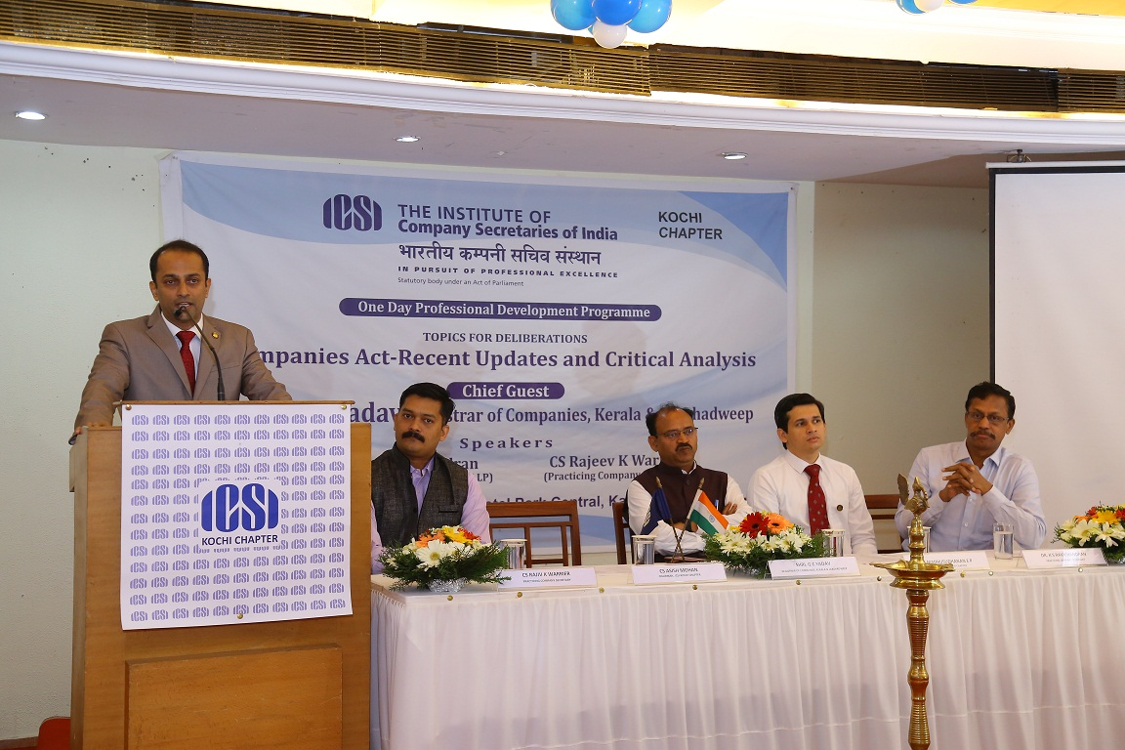

The Kochi Chapter of ICSI conducted One Day Professional Development Program on Saturday, 09 February 2019 at Hotel Park Cental, Kaloor, Ernakulam, Kerala. The theme of the program was COMPANIES ACT-RECENT UPDATES AND CRITICAL ANALYSIS.
The program was inaugurated by Shri. G C Yadav, Registrar of Companies, Kerala &Lakshadweep, various initiatives of the Kochi Chapter were launched on the day by the dignitaries including the e newsletter.
This was followed by the first technical session by CS. Rajiv K Warrier, Practicing Company Secretary, he gave an introduction to various updates on Companies Act, ordinance, latest notifications and compliance requirements. The program was lively with mixing of cine clips, and ended with an open discussion.
There was a Special Session thereafter on Indemnity Insurance-A Birds eye view, this was considering the huge request from the members. Ms. Namita Rohra, Practice Head, Liability and Specialty Lines, Aditya Birla Insurance Brokers Ltd handled the session the same was very lively.
After Lunch Dr. K S Ravichandran, Managing Partner, KSR & Co Company Secretaries LLP, made a lively presentation and Critically analysed and interpreted various company law provisions. The session ended with an open discussion and members clarified various doubts.
There was a Special Session after that during which the members had a close discussion with all the newly elected MC members and the discussions were to give further impetus to the concept and idea of Vibrant Kochi as initiated by the new MC.
The PDP was a huge success as around 140 members and 18 students attended the program. There has been an encouraging feedback received after the conduct of the said program

- Professional Entrepreneurial Development Programme (PEDP) – 18.02.2019 to 22.02.2019

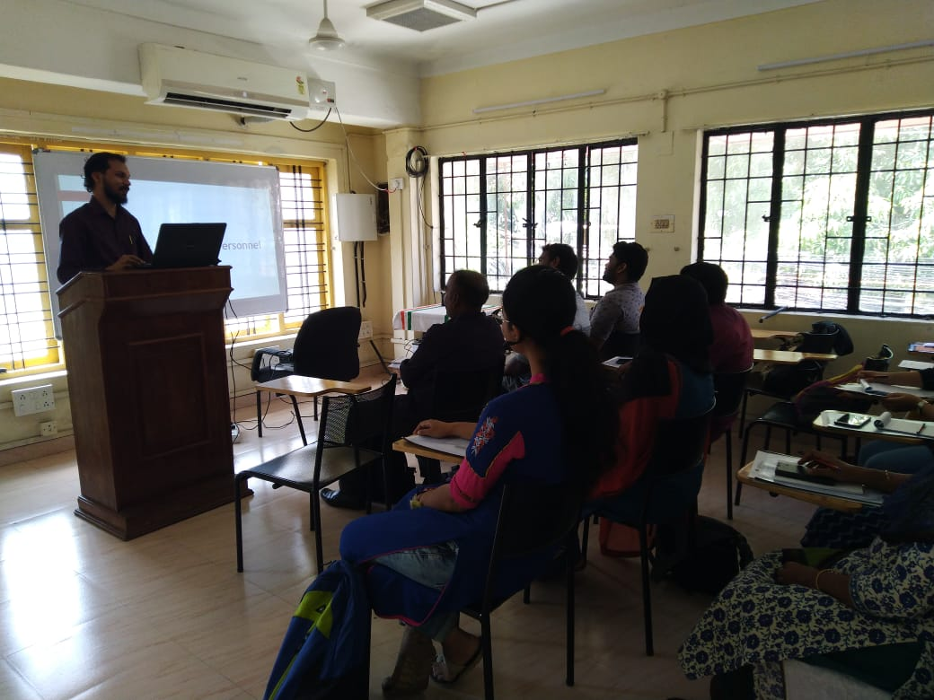

ICSI-Kochi Chapter has conducted Professional Entrepreneurial Development Programme (PEDP) at Kochi Chapter premises from 18.02.2019 to 22.02.2019 for the Executive passed students as part of their 15 days academic development programme.

Several faculties took sessions during these 5 days. A total of 13 numbers of students attended the programme.

Certificates were distributed by the CS Josmin Jose, Treasurer, ICSI-Kochi Chapter.

- Soft Skill Development Programme – 22.02.2019

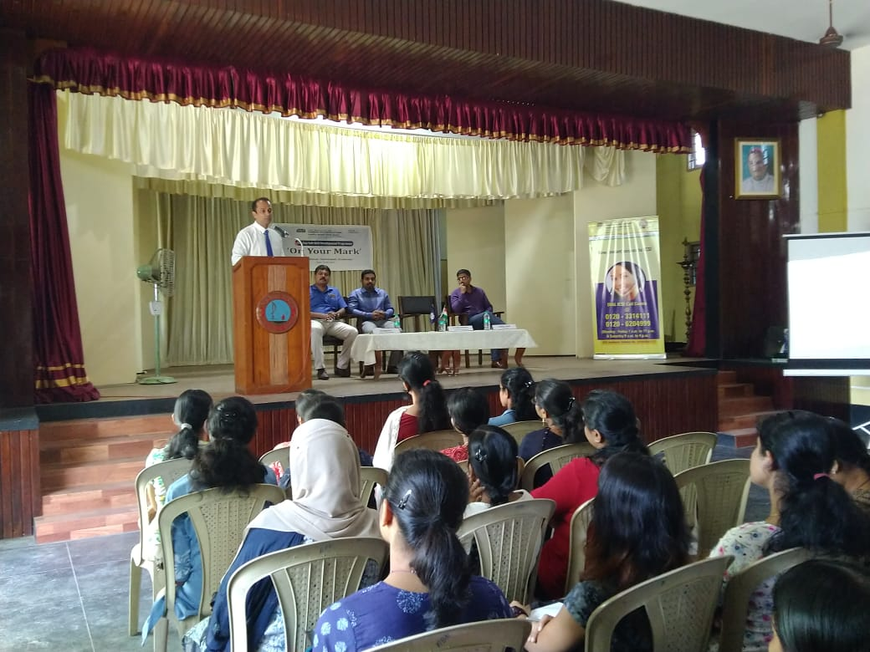

ICSI-Kochi Chapter conducted a One-day Soft Skill Development Programme for the Oral Coaching Student and other Students of Kochi Chapter of ICSI on 22.02.2019. Shri. Padmarajan E, Office In-Charge, ICSI-Kochi Chapter introduced the dignitaries to the students, CS Asish Mohan, Chairman, ICSI-Kochi Chapter inaugurated the programme. CS Sarath S, MC member, ICSI-Kochi Chapter also addressed the students. The Speaker for the programme was Shri. Sooraj Abraham, a reputed Corporate Trainer from Kochi.

The programme was very much appreciated and has been rated very well by the students who attended the same. The Program concluded with a vote of thanks by CS Josmin Jose, Treasurer, ICSI-Kochi Chapter. A total 56 students attended the programme.

- Half Day Professional Development Programme – 23.02.2019
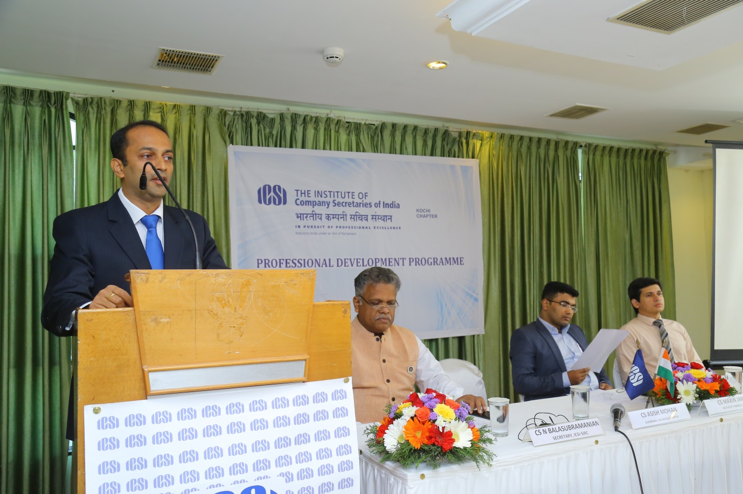

ICSI-Kochi Chapter had conducted a Half Day Professional Development Programme for the Members & Students at Hotel Central Park, Kaloor, Ernakulam on 23rd March 2019 from 2 pm to 7 pm. The Program Commenced with a Song remembering and honouring the martyrs who had been killed in the recent terror attacks.
CS Asish Mohan, Chairman, ICSI-Kochi Chapter welcomed the gathering, CS N Balasubramanian, Secretary, ICSI-SIRC, Chennai delivered the presidential speech. Vote of thanks was delivered by CS Madhusudhanan E P, Secretary, ICSI-Kochi Chapter. CS N Balasubramanian, Secretary, ICSI-SIRC was felicitated during the Session.
There were 2 technical sessions. 1st technical session was handled by CS Maxin James, Company Secretary & Compliance Officer, Muthoot Finance Limited and 2nd technical session was handled by Mr. Shibunath T Appu, Sr. Manage-Business Development, Central Depository Services (India) Limited.
Around 59 no. of Members & 6 nos. of Students participated in this programme.

- Sampark – 23.02.2019

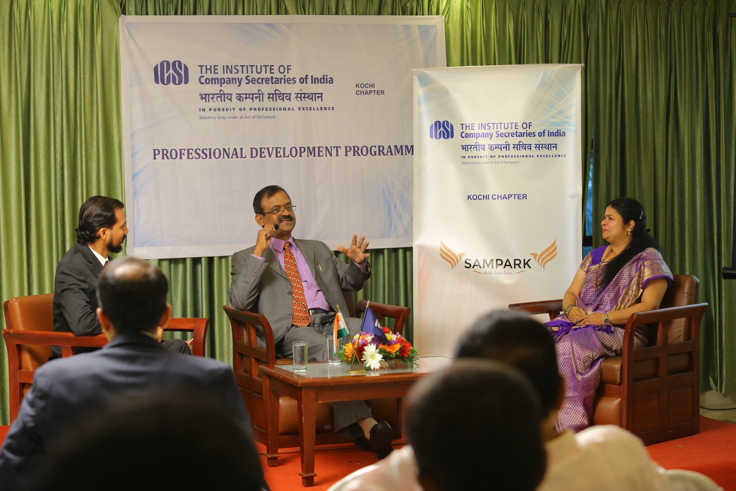

Followed by PDP, a Special Session on the theme “Sampark- Chalo Baat Kare” was also organised and CS S P Kamath, Executive Director & Company Secretary, Amalgam Group of Companies was the first guest to the program, he was also accompanied by his wife. The Program was hosted by CS Premjit Nair, this was rated as one of the outstanding programs ever conducted by the Kochi Chapter and all the members participated and enjoyed the same. The program touched upon the personal and professional life balance of the Company Secretary.
Around 59 no. of Members & 6 nos. of Students participated in this programme.

