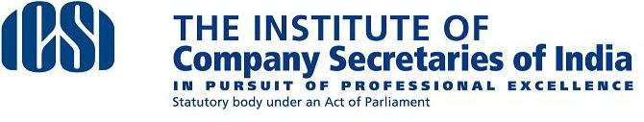

Dear Member,

The Institute (ICSI) has joined hands with Indian Merchants' Chamber as Co-Organiser for a full day seminar on **'Investment Outlook 2015’** on **Tuesday, April 28, 2015** at **BSE International Convention Hall**, Bombay Stock Exchange, Dalal Street, **Mumbai**.

The seminar will discuss the Investment Outlook for the year 2015. The five asset classes will include Debt, Equity, Commodities, Real Estate and Currencies. Each session will have a policy maker as a key note speaker and renowned panelists representing different interest groups - buyers, sellers, financiers, venture capitalists, major users, advisors, economists etc.

**Members of ICSI attending a Workshop would be eligible for grant of FOUR Programme Credit Hours (4 PCH).**

**The Participation fee for attending the Seminar is Rs 1000/- per participant.**

The registration form may be sent to Ms. Andrea Fernandes on [andrea.fernandes@Imcnet.org](mailto:andrea.fernandes@Imcnet.org) with a copy to [sudhir.saklani@icsi.edu](mailto:sudhir.saklani@icsi.edu) or call on 022-2204 6633.

Regards,

Dr. S K Dixit

Joint Secretary

ICSI