
The Chief Reporter January 11, 2010
PRESS RELEASE

Company Secretaries get together for a noble cause of benevolence

COMPANY SECRETARIES BENEVOLENT FUND (CSBF), established by the Institute of Company Secretaries of India (ICSI) organized a “CSBF Cultural Evening” on 9th January 2010 at New Delhi .

The ‘CSBF Cultural Evening’ was graced by various dignitaries including Shri Dilip Rao Saheb Deshmukh, Company Law Board Chairman, Shri S . Balasubramanian, Former Company Law Board Chairman , Shri P.D Sudhakar, Special Secretary Ministry of Corporate Affairs , Shri Jitesh Khosla ,Director General Indian Institute of Corporate Affairs, Ministry of Corporate Affairs , Her Holiness Archana Didi, Founder and Director of Amrit Path Sansthan and Shri J.D Narain, Director , Ministry of Information and Broadcasting .

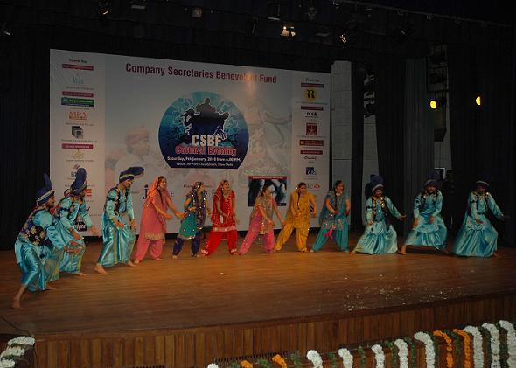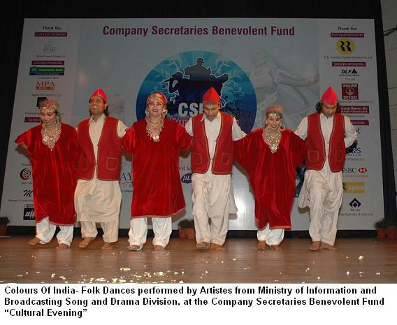
Shri Harish K. Vaid, Council Member, ICSI and Chairman, Core Group for the event, expressed that it was towards the intent and the spirit of benevolence , the Institute had, way back in 1976, set up the Company Secretaries Benevolent Fund (CSBF), to create larger security umbrella to provide comfort and security for members and their dependents in the hour of need.

Shri Datla Hanumantha Raju, President the ICSI and Chairman, Company Secretaries Benevolent Fund(CSBF), said that, the collective welfare becomes more important in times of distress and need and the Company Secretaries Benevolent Fund (CSBF) is one such collective effort towards extending much needed financial support to our brethren in times of distress.

Shri N.K Jain ,Secretary & CEO, The ICSI, said that benevolence is an integral part of civil societies and the professionals like Company Secretaries having special status in society must vigorously engage themselves in such human endeavours.

At the “CSBF Cultural Evening”, the Song and Drama Division of the Ministry of Information & Broadcasting presented ‘COLOURS OF INDIA - Folk dances from J & K, Assam, Rajasthan, Gujarat, Punjab & Maharashtra’. They also presented an invigorating display of ‘Martial Arts’ . An enlightening discourse SEEDHI BAAT BHAGWAN KE SAATH by International Society for Krishna Consciousness (ISCKON) was also one of the programme highlights.

Company Secretaries Benevolent Fund (CSBF)
The ICSI established the COMPANY SECRETARIES BENEVOLENT FUND (CSBF) in the Year 1976 which seeks to create big security umbrella and to provide comfort and security for members and their dependents.

Objective of the Fund
The fund supports the cause of :
- Benevolence
- Financial Assistance to the families of the deceased members
- Medical Assistance
- Assistance for Children Education
for the members of the of Company Secretaries Benevolent Fund.

The Institute:

The Institute of Company Secretaries of India ( ICSI) has been constituted under an Act of Parliament viz. The Company Secretaries Act,1980( Act No. 56 of 1980) and is the only professional body to develop and regulate the profession of Company Secretaries. The Institute has on its roll over 25,000 Members including 3,500 members in practice and 1,50,000 students. Out of the total membership, 6874 members are already members of CSBF.

Dr. Amita Ahuja
Senior Director (Public Relations & Corporate Communication)
Telefax- 011-24604756 ,Mob- 9717196255



