ATTENTION MEMBERS

ESTABLISHMENT OF COMPETITION COMMISSION OF INDIA

The Central Government has appointed the Chairman and Members of the Competition Commission of India.

Present Organogram of Competition Commission of India

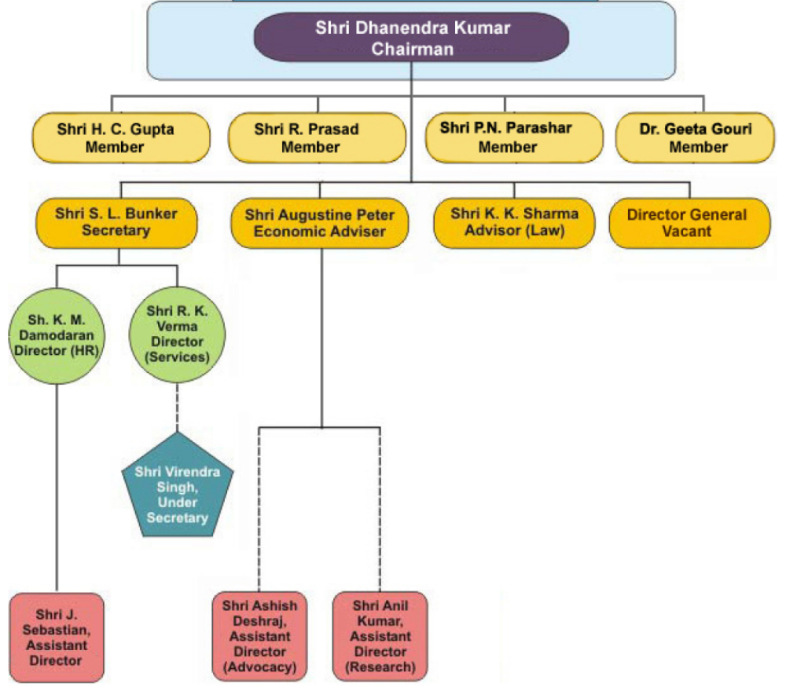

NOTIFICATION OF SECTION 3 & 4 OF COMPETITION ACT, 2002

The Central Government has notified w.e.f. 20th May, 2009, the provisions of the Competition Act, 2002 relating to anti-competitive agreements (section 3) and abuse of dominant position (section 4) along with other related and miscellaneous provisions, to enable the Competition Commission of India to enforce these provisions of the Competition Act, 2002.

ESTABLISHMENT OF COMPETITION APPELLATE TRIBUNAL

The Central Government has notified w.e.f. 20th May, 2009, the establishment of Competition Appellate Tribunal headed by Dr. Justice Arijit Pasayat, Judge (Retd.), Supreme Court of India, to deal with the appeals against the decisions of the Competition Commission of India and also adjudicate on compensation claims.

Dr. Justice Arijit Pasayat joined as Chairperson, Competition Appellate Tribunal on May 20, 2009.

THE COMPETITION COMMISSION OF INDIA NOTIFIED REGULATIONS

The Competition Commission of India notified following Regulations under the Competition Act, 2002 :
- The Competition Commission of India (Procedure for Engagement of Experts and Professionals) Regulations, 2009 (No.1 of 2009) [Notified on May 15, 2009]
- The Competition Commission of India (General) Regulations, 2009 (No. 2 of 2009) [Notified on May 21, 2009]
- The Competition Commission of India (Meeting for Transaction of Business) Regulations, 2009 (No. 3 of 2009) [Notified on May 21, 2009]
The details are available on the website of the Competition Commission of India at www.cci.gov.in

