GST HEADLINES
January 16, 2017

GST Council to meet on dual control on Monday

[Source: Business Line]

GST Council to meet on dual control on Monday
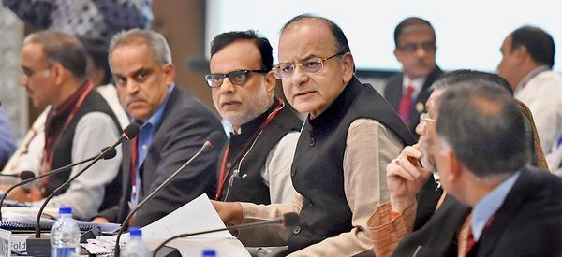
In a make-or-break meeting, the Centre and States will try and resolve the pending issues around the Goods and Services Tax (GST) on Monday to ensure its timely roll out from April 1.
The GST Council will try to reach a compromise on administrative control over businesses.
“If States get greater administrative control as has been demanded, then there is no problem with the roll out of GST,” said a State Finance Minister.
With just about a fortnight left for the presentation of the Union Budget 2017-18 (February 1), the meeting will also decide the Centre’s course of action on its policy proposals.
While Finance Minister Arun Jaitley and his team are keen to maintain control over service tax payers, States are pushing for dual control.
They have also proposed vertical division of assessees so that both the Centre and State will get a fixed number of assessees. This would ensure ease of doing business.
In contrast, States such as Kerala, Uttar Pradesh, West Bengal and Tamil Nadu are also keen on horizontal division of assessees under GST that would mean that they have exclusive control over small businesses with an annual turnover of less than ₹1.5 crore. There would be cross empowerment of officials of the Centre and States beyond this limit.
Mid-year rollout
Most States now seem to be keen on a mid-year roll out of GST from June 1 or September 1, citing the impact of demonetisation of ₹500 and ₹1,000 currency notes on the economy and the lack of time to meet the April deadline.
The GST Council had last met on January 4 but failed to resolve issues relating to administrative control and cross empowerment, taxing sea trade and cooperation of States for levy and collection on Integrated GST.
States had also sought higher compensation as many had claimed that demonetization had hurt collection of value added tax.
However, at a recent press conference Jaitley denied these claims and said that VAT collections have not been impacted.

Disclaimer: The news in the GST Corner is purely according to the information available in public domain and does not necessarily reflect the views of ICSI. Any person wishing to act on the basis of this document should do so only after cross checking with the original source.

