GST HEADLINES
October 06, 2016

A GST Secretariat is Needed in Every State

[Source : Business Line]

States Start Looking for Consultants for GST

[Source : The Times Of India]

A GST Secretariat is Needed in Every State
A GST Secretariat is needed in every State to address the day-to-day issues relating to the implementation Goods and Services Tax.
“There is an institutional void at the State level. State GST secretariats will bring together central government and state government offices in one place. It should be a registered body under the Society’s Act,” VS Krishnan, Advisor, Tax Policy, EY and a former member (service tax and GST), Central Board of Excise and Customs, told BusinessLine.
A seamless and efficient transition without people being forced to run to GST Council should be possible. But “there is no mechanism to address the day-to-day implementation issues. You need a body or institution in the State. So, one of the things we are advocating is GST Secretariat in every State,” he said.
Asserting that GST wouldn’t have any impact on the poor, Krishnan exuded confidence that GST would lead to greater compliance. “Cheating will come down. Long-awaited transformation of transactions coming into the open will happen, which is a good thing,” he stated.
In the medium-to-long term it would create market expansion and unleash a new entrepreneurial wave. “More people will want to become entrepreneurs and participate in the economic gains because they would know there are no inter-State barriers,” he said while highlighting how such policy triggers in India and other countries in the past expanded the market.
With the implementation of GST, inter-State check posts would vanish and efficiency of the road sector will improve significantly. In the US, a truck carrying goods travels 820 km a day as against 210 km in India. In the short haulage category railways will see more competition from roadways, he said.
Krishnan pointed out that technology would be the biggest challenge for the companies. They will have to ensure that their vendors are ready and may have to go to bigger vendors to achieve compliance.

States Start Looking for Consultants for GST
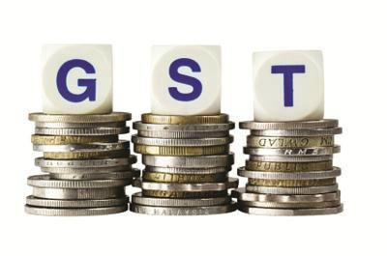

NEW DELHI: States have started scouting for tax consultants to advise them on technical aspects of the goods and services tax (GST), which is planned to be rolled out from April next year.
With the Centre moving on to the fast track to meet the April 2017 deadline, the Punjabgovernment has initiated the process of appointing consultant to help it successfully implement the new tax regime, which will subsume various state levies like octroi and sales tax.
According to sources, other states may also go in for consultants to assist the administration in the preparatory work for GST.
While the Punjab government is looking to appoint a consultant for two years, sources said other states too would be looking at a similar timeline as the hurdles in implementation of GST are expected to come down in 1-2 years.
Among other things, the consultants will be required to suggest organisation structure of the department in the GST regime, strategy for transition period and ways to mitigate risks and checklist of tasks that need to be completed before introduction of GST.
Also, the consultant will be required to frame a communication strategy for administration vis-a-vis stakeholders such as industry and traders.
Also, the consultant will be imparting training on provisions of the GST Act/Rules and processes to officers of the department.
Besides, the entity will calculate the impact of GST implementation on state revenues keeping in view the present rate of tax in the state and the proposed rate of tax under GST.
Touted as the biggest tax reform since Independence, the GST will subsume excise, service tax, cess, VAT and other local levies and create a uniform market for seamless transfer of goods and services.
The GST draft rules on payment, returns and refund have been finalised and the all-powerfulGST Council will decide on the tax rate by October 20.

Disclaimer : The news in the GST Corner is purely according to the information available in public domain and does not necessarily reflect the views of ICSI. Any person wishing to act on the basis of this document should do so only after cross checking with the original source.

