SHe-Box
Online Complaint Management System

WHAT’S SHe-BOX?
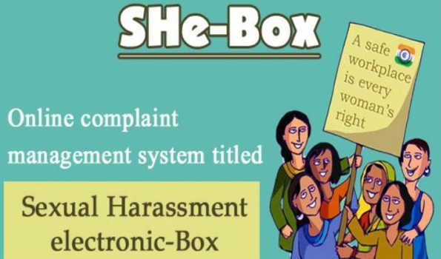
- The Indian Ministry of Women and Child Development (“WCD”) had launched an online complaint platform named “SHe-Box”, which stands for “Sexual Harassment Electronic Box” for reporting complaints of sexual harassment arising at the workplace.
- The SHe-Box facility can be used by both government and private sector employees.
- ‘SHe-box’, which can be accessed at www.shebox.nic.in, seeks to ensure effective implementation of India’s Sexual Harassment of Women at Workplace (Prevention, Prohibition and Redressal) Act, 2013 (“Anti-Harassment Law”).
- It aims at providing speedy redressal of sexual harassment complaints. Progress of the investigation can be monitored by both the complainant and the Ministry of Women and Child Development.
- In the event that a formal complaint is lodged with SHe-Box, based on an assessment of the complaint, the WCD will direct such complaint to the employer’s Internal Complaints Committee (“ICC”) or the Local Complaints Committee set up by the government at each district (“LCC”), as the case may be.
- The WCD also proposes to actively monitor the progress of inquiry conducted by the ICC / LCC and keep the complainant updated.
- SHe-Box also proposes to work as a repository providing information related to dealing with workplace sexual harassment complaints.
- The users are free to access the resources available on SHe-Box for creating awareness.
- . The WCD promises to ensure that the identity of the aggrieved women / complainant is kept confidential.

HOW TO REGISTER A COMPLAINT IN SHe-Box

Click on the link
http://www.shebox.nic.in/

Click on ‘Register Your Complaint’ Tab

In case you are Government Employee, select whether you are working with:
- Central Government
- State Government

Choose the Category to which you
belong :
- Government Employees
- Private Employees

Fill all the fields of the registration
form and press the ‘submit’ button.

A confirmation message will be sent
to your email address provided in the registration form.

Click on the link Confirm my email and create my account! » provided in the confirmation email, to generate password.

View Status of the Complaint by submitting your email id and password so generated.

