GST HEADLINES
August 31, 2016

Telangana Assembly Unanimously Ratifies GST Bill

[Source : Firstpost]

Mizoram Assembly Becomes 13th State To Ratify GST

[Source : The Indian Express]

Sikkim Assembly Ratifies GST Bill

[Source : The Indian Express]

Telangana Assembly unanimously ratifies GST Bill

Hyderabad: The Telangana state legislature on Tuesday ratified the Goods and Services Tax (GST) Bill passed by the Parliament early this month.
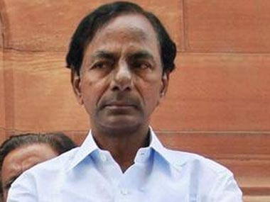
File image of K Chandrasekhar Rao. PTI
Both the houses unanimously passed a resolution ratifying the GST Bill (122nd Constitution Amendment Bill, 2014).
In the state assembly, Chief Minister K Chandrasekhar Rao hailed the passing of unanimous resolution and said this would set a good precedent.
As soon as the House met for the special session to ratify the bill, the Chief Minister moved the resolution.
He said the bill need to be ratified by the legislatures of half of the states before it is presented to the President for his assent.
He told the House that nine states had already ratified the bill, which will introduce a uniform tax system for the entire country as is being followed in 150 countries.
Rao said no state was ready to let go its tax revenue and all states had urged the Centre to protect their interests. He told the members that the Centre has assured that it will compensate the states for any revenue loss caused to them on account of implementation of GST for a period of five years.
The Chief Minister said the services sector would expand with the implementation of GST and the state would benefit from this as it will have 50 percent share in service tax.
"Currently the service tax is under the central government. With GST, the state will get 50 percent share. This will benefit the state which is ahead in sectors like e-commerce and software exports. The service tax in the state is growing at 35 percent," he said.
The Chief Minister also informed the House that the passing of constitutional amendment bill was just the beginning of the process as the GST council will have to formulate modalities and prepare tax structure in consultation with all states and only then it will go to Parliament in the form of a bill for its approval.
Members of ruling Telangana Rashtra Samithi (TRS), opposition Congress party, Bharatiya Janata Party (BJP) and others supported the resolution.
In legislative council, Deputy Chief Minister Kadiam Srihari moved the resolution, which was unanimously passed after members cutting across party lines supported it.

Mizoram Assembly becomes 13th state to ratify GST
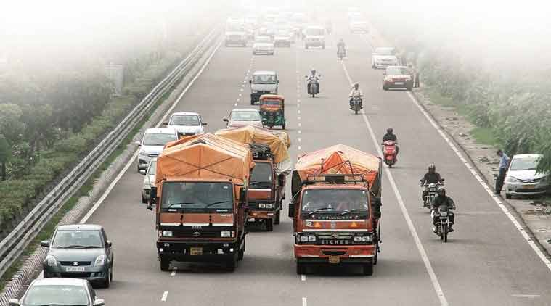
A revenue-neutral rate is a single rate at which there will be no revenue loss to the Centre and states in the GST regime, while the standard rate will be levied on most goods and all services.
Mizoram Assembly today ratified the Goods and Services Tax (GST) Constitutional Amendment bill by adopting an official resolution, becoming 13th state to have approved the legislation. The state legislature unanimously adopted the official resolution moved by Finance and Taxation Minister Lalsawta after deliberations on the first day of the Assembly.
Participants of the discussion, irrespective of party affiliations, expressed hope that the GST Act would not only streamline the tax regime in the country, but also benefit states like Mizoram.
Earlier, the Telangana Legislature on Tuesday unanimously ratified the Goods and Services Tax Constitutional Amendment Bill. Both Houses of the Legislature met for a special one-day session to approve the Constitution (122nd Amendment) (Goods and Services Tax) Bill, passed by Parliament earlier in August.
Although the bill was passed unanimously by both houses of the Parliament,16 states have to ratify the Constitution amendment after which it has to receive a notification form the President. It is only after this that the GST council would be formed which decides the rates. The ratification of the bill by Mizoram and Telangana means that thus far, 13 states have approved the legislation. These states include Assam, Bihar, Jharkhand, Himachal Pradesh, Chhattisgarh, Gujarat, Madhya Pradesh, Delhi, Nagaland, Mahrashtra and Haryana.
GST aims to do away with multiple-tax regime on goods and services and bring them under one rate. It will alter the present system of production-based taxation to a consumption-based one. While manufactured consumer goods will become cheaper as the incidence of excise duty and VAT will come down from 25-26 per cent at present, the cost of services would by and large go up from the present 15 per cent levels.

Sikkim Assembly ratifies GST Bill

Sikkim: In a special sitting of the Sikkim Assembly, the resolution on ratification of the GST bill was moved by R B Subba, state Minister for Law, Legislative and Parliamentary Affairs and passed by the House.
The Government of India has set April 1, 2017 as target for rolling out GST, considered as the biggest tax reform. (Representational image)
Sikkim on Tuesday ratified the Constitution Amendment Bill on Goods and Services Tax (GST). Thirteen states – Assam, Bihar, Chhattisgarh, Delhi, Gujarat, Haryana, Himachal Pradesh, Jharkhand, Madhya Pradesh, Maharashtra, Nagaland, Telangana and Mizoram have already ratified the Bill.
In a special sitting of the Sikkim Assembly, the resolution on ratification of the GST bill was moved by R B Subba, state Minister for Law, Legislative and Parliamentary Affairs and passed by the House.
Chief Minister Pawan Kumar Chamling thanked the Speaker and all the members of the Sikkim Assembly for conducting the special session and for passing the resolution. The session concluded with a vote of thanks by the Assembly Speaker K N Rai.
The Constitution (122nd Amendment) Bill, 2014 on GST was passed by Parliament recently and it needs to be ratified by at least 15 state legislatures before the President can notify the GST Council which will decide the new tax rate and other issues. The government has set April 1, 2017 as target for rolling out GST, considered as the biggest tax reform.

Disclaimer : The news in the GST Corner is purely according to the information available in public domain and does not necessarily reflect the views of ICSI. Any person wishing to act on the basis of this document should do so only after cross checking with the original source.

