GST HEADLINES
August 30, 2016

Maharashtra Ratifies GST Constitutional Amendment Bill

[Source :Livemint]

Haryana Assembly Ratifies GST Bill

[Source : The Indian Express]

Panel To Evolve Consensus On GST Rollout With Industry

[Source : The Hindu]

Maharashtra ratifies GST constitutional amendment bill

All parties in the Maharashtra legislature supported the bill moved by the BJP-Shiv Sena government
Maharashtra would particularly benefit from the GST regime as it was the leading manufacturing, consuming, and also service sector state, state finance minister Sudhir Mungantiwar said.

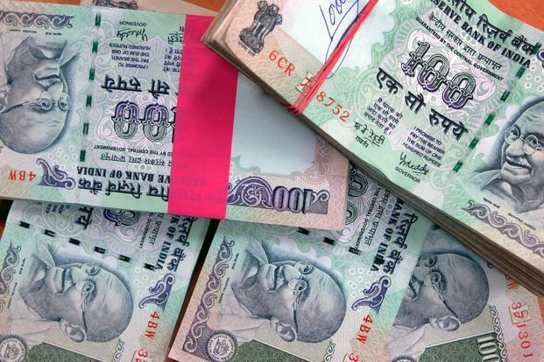
Photo: Bloomberg
Mumbai: Maharashtra on Monday became the tenth state to ratify the Goods and Services Tax (GST) constitutional amendment bill passed by the parliament. All parties in the state legislature supported the bill moved by the Bharatiya Janata Party-Shiv Sena government. The bill was passed by voice vote in both houses of the state legislature.
Moving the resolution to seek ratification of the GST constitutional amendment bill in the assembly, Maharashtra finance minister Sudhir Mungantiwar said the GST would not only support the Make in India programme but would also make “India one” as a market. He said the revolutionary tax reform would end the cut-throat competition among states to offer discretionary and variable tax rates.
Maharashtra would particularly benefit from the GST regime as it was the leading manufacturing, consuming, and also service sector state, Mungantiwar said. “Maharashtra accounts for 19.62% of the national service sector,” Mungantiwar pointed out. He admitted that people had doubts about the eventual rate of tax.
Mungantiwar said Maharashtra’s 17 taxes would be subsumed in GST. “This includes value added tax, central sales tax, lottery tax, sugar purchase tax, octroi, various miscellaneous taxes and surcharges etc. At the same time, the GST regime would not take away Maharashtra’s right to levy tax on liquor, stamp duty, and electricity duty.” he said.

Haryana Assembly ratifies GST Bill

In the 90-member Haryana assembly House, BJP has 47 MLAs, INLD 19, Congress 17 (after HJC merged with Congress), BSP one, SAD one and five are Independents.

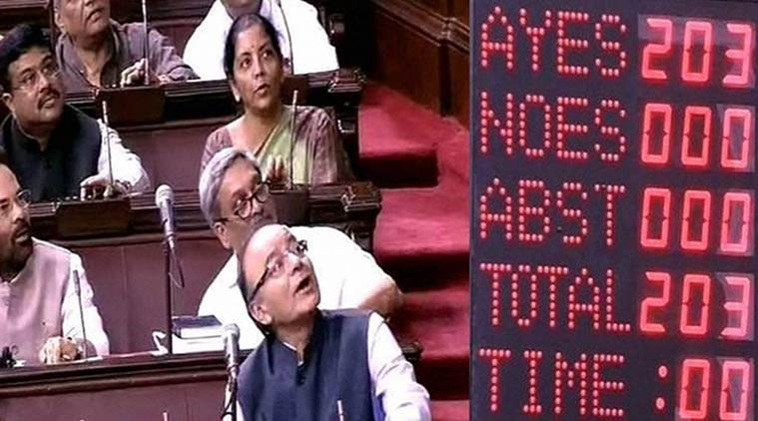
The GST Bill being passed in the Lok Sabha.

On the second day of the Monsoon session, the Haryana Assembly today unanimously ratified the Constitution Amendment Bill on Goods and Services Tax (GST). The bill was introduced by state Finance Minister Capt Abhimanyu and passed after a brief debate.

Participating in the discussion on the resolution regarding ratification of the 122nd Constitution Amendment Bill, Congress Legislature Party (CLP) leader Kiran Chaudhary asked the government to take care of the interests of small and medium business enterprises who may be impacted after the implementation of GST, a new regime of indirect taxes. She suggested that the threshold limit to levy tax be enhanced from Rs 20 lakh to Rs 25 lakh in GST.
“GST Bill is a Congress’s baby and it is a simplified tax. But it has a lot of clauses,” she said. Chaudhary said the state might face revenue loss of Rs 9,000 crore because of GST and asked the government how it will ensure to neutralize the same.

Congress MLA Karan Dalal said GST is a “destination tax”.He said the government should clarify which authority would resolve any issue arising out of inter-state dispute. Dalal said there is a 40 per cent tax on tobacco and the party supports it. But the government should also keep in mind that a lot of people smoke ‘Hukas’ in Haryana, he said.

In the 90-member Haryana assembly House, BJP has 47 MLAs, INLD 19, Congress 17 (after HJC merged with Congress), BSP one, SAD one and five are Independents.

The Assemblies of Himachal Pradesh, Bihar, Jharkhand and Assam have already ratified the bill.

The Constitution (122nd Amendment) Bill, 2014 on GST was passed by Parliament recently and it needs to be ratified by at least 15 state legislatures before the President can notify the GST Council which will decide the new tax rate and other issues.

The government has set April 1, 2017 as target for rolling out GST, considered as the biggest tax reform.

Panel to evolve consensus on GST rollout with industry

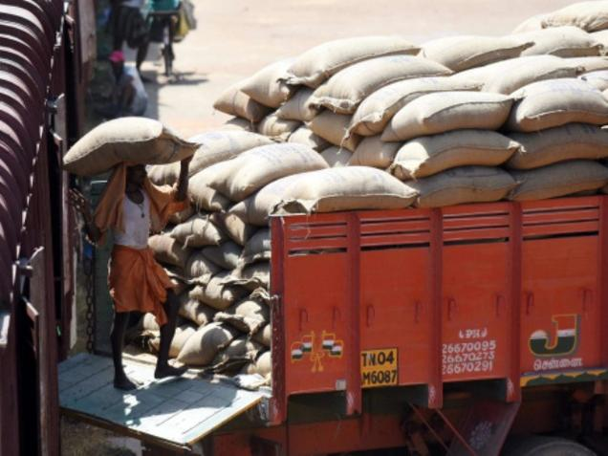

Trade representatives to meet committee of state finance minsters today
Industry and trade representatives are set to impress upon the empowered committee of state finance ministers about the need to keep the Goods and Services Tax rate at reasonable levels, if not 18 per cent. The issue will be taken up at a day-long interaction with the committee on Tuesday, when industry as well as the accounting fraternity, will air concerns of various sectors about the implementation of the new indirect tax regime with state FMs.
The finance ministers’ deliberations with industry, trade and professional groups are scheduled after the committee’s own meeting on the rollout of the GST regime, that is expected to last for an hour in the morning, a senior government official told The Hindu.
Seven more
Eight state assemblies have already cleared the GST Constitutional amendment Bill out of the minimum 15 states required before the Bill can be sent to the President for his approval.
A GST Council would then be constituted to set tax rates.
The finance ministry, which is pushing for an April 2017 rollout of the new tax, has already held detailed parleys with industry chambers and trade associations over the past fortnight, where concerns were raised by firms across sectors.
“This will be the first meeting of the empowered committee of state FMs since the Constitutional amendment Bill was passed by Parliament,” the official said requesting anonymity.
“While the political rollout is moving through state assemblies, we want to evolve a consensus on the implementation plan as well so industry chambers, trade bodies and professional groups have been asked to share their concerns about the nitty-gritty of the tax with state finance ministers,” the official said.
Five representatives have been invited for the meeting from each of the apex professional bodies that represent chartered accountants, cost accountants and company secretaries. Similarly, trade organisations, Confederation of All India Traders, Federation of All India Traders Associations and the Bharatiya Udyog Vyapar Mandal have been asked to make a presentation on GST.
Six invited
Six chambers of industry and commerce have been invited, including software lobby group Nasscom, exporters’ body FIEO, Assocham, FICCI, the Confederation of Indian Industry and the Confederation of All India Micro and Small Scale Industries.
Industry honchos, during talks with Revenue Secretary Hasmukh Adhia earlier this month, had already raised concerns about the distortions that may be caused by the proposed tax treatment in sectors such as electricity, petroleum and real estate and also red-flagged provisions in the model GST law.
FICCI, for instance, had questioned the wide discretionary powers to tax authorities and provisions that mandate taxes be deposited for filing appeals, saying such provisions may lead to disputes in future.

Disclaimer : The news in the GST Corner is purely according to the information available in public domain and does not necessarily reflect the views of ICSI. Any person wishing to act on the basis of this document should do so only after cross checking with the original source.

