GST HEADLINES
August 29, 2016

50% of States Expected to Approve GST by Early September

[Source : The Times Of India]

Daylong Session of State in Maharashtra Assembly Today for GST

[Source : The Indian Express]

50% of states expected to approve GST by early September

HIGHLIGHTS
- 50% of states are likely to give nod to GST Bill by early September
- Govt is now moving to the next stage — deciding on fixing the rates
- The bill needs to be ratified by at least half the 29 states
- Govt is planning to put this reform initiative in place by April next year
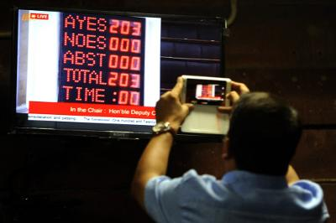
A journalist takes the voting number picture from a TV during the voting on the GST Bill at Rajya Sabha. (TOI photo)

NEW DELHI: With half the state legislatures expected to ratify the Constitution amendment bill to roll out goods and services tax (GST) by early September, the Centre is now moving to the next stage — deciding on the contentious issue of fixing the rates — so that the ambitious reform initiative is in place by April.
Sources said the finance ministry is set to hold consultations on the GST rate - which several states suggest should be upwards of 20% to protect their revenue - as well as the other legislations which need to be cleared by Parliament during the winter session for the new tax regime to kick in from April.
Depending on the progress in setting up the GST council and an agreement on the contentious issue of rates, the winter session of Parliament might be brought forward to early November. But government sources emphasised that the rate and related issues would need to be ironed out.
Apart from the politically crucial discussions on the rate, some of the other contentious issues, such as the cut-off turnover under which state authorities will have jurisdiction over entities, will pave the way for states to enact their own GST legislations.
Once 16 states ratify the Constitution amendment, and the President notifies it, the stage will be set for formation of the GST council, which will be the authority on deciding rates. Once the rates are decided, the upper limit will be included in the bill that will be moved in the Centre.
At least eight states have already shown the green flag to the Constitution amendment bill that was approved by Parliament. To ensure implementation of GST, the bill needs to be ratified by at least half the 29 state assemblies. It is set to cross the halfway mark comfortably despite the lukewarm response from some non-NDA ruled states. Several states have convened special sessions of their state legislatures to discuss the Constitution amendment bill on GST. Rajasthan is expected to give its nod during the assembly session that has been convened from September 1.
The proposed levy will be a single tax that will cover all levies at the Centre and state levels, including entry tax. It is a value-added tax, which means a levy at each stage of production, sale or consumption will be set off against taxes paid in the previous stage. It is expected to benefit consumers and help government revenues and add to overall economic growth.
Three non-NDA ruled states — Himachal Pradesh, Bihar and Delhi — have approved the bill. Kerala and Uttarakhand have convened special sessions to give the go-ahead. NDA-ruled Maharashtra too is expected to join the list of approvers at the one-day session on August 29. The government has discussed the issue with all parties to ensure smooth passage and with the Shiv Sena on board, the bill is expected to be approved.
Telangana has called for a special session on August 30 to get the bill approved.

Daylong session of state in Maharashtra Assembly today for GST

The Centre has set a deadline of April 2017 for its rollout. Assam was the first state to ratify the Bill, followed by Bihar

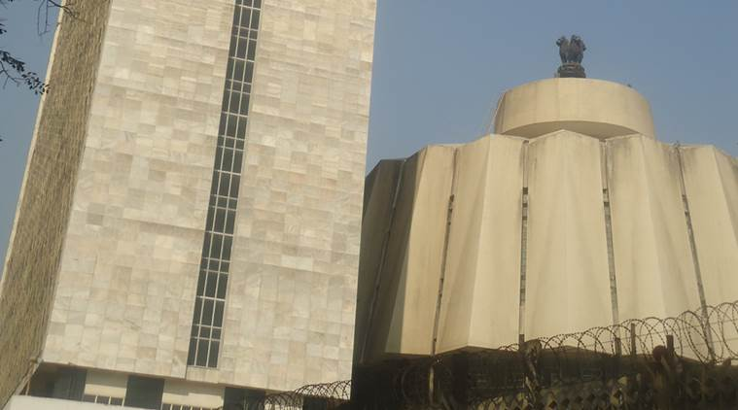Maharashtra Assembly. (File)

The state will hold a daylong session of the Maharashtra Assembly on Monday to ratify the Goods and Services Tax (GST) Bill.
The Constitution (122nd Amendment) Bill, 2014, on GST has already been passed by the Lok Sabha and the Rajya Sabha. The Bill, seen as the biggest tax reform in a long time, needs to be ratified by at least 15 state legislatures before the President can notify the GST Council, which will decide the new tax rate and other issues.
×
The Centre has set a deadline of April 2017 for its rollout. Assam was the first state to ratify the Bill, followed by Bihar. Seven other states — Jharkhand, Himachal Pradesh, Chhattisgarh, Gujarat, Madhya Pradesh, Delhi and Nagaland — have now ratified it.

Maharashtra, Uttar Pradesh and Haryana are expected to do it on Monday.

GST aims to do away with the multiple-tax regime on goods and services and bring them under one rate. It will alter the present system of production-based taxation to a consumption-based one. While manufactured consumer goods will become cheaper as excise duty and VAT will come down from 25-26 per cent at present, the cost of services would by and large, go up from the present 15 per cent levels.
Maharashtra, India’s most industrialised state, will have to find new ways to repay debt and interest with the Goods and Services Tax (GST) estimated to dent the state’s own tax revenue by an estimated Rs 20,000 crore in the initial years.

Seven taxes imposed in the state – Value Added Tax, Entertainment Tax, Central Sales Tax, Luxury Tax, Sugar Purchase Tax, Tax on Lotteries, and Octroi (in Mumbai) – will be replaced by the GST. These would be in addition to the state’s share in some Central taxes and duties, including Central Excise, Additional Excise Duty, Service Tax, Special Additional Duty on Customs, Surcharges, and Cess.
In Maharashtra, about 66 per cent of revenue is collected from the state’s own taxes, the highest in the country.

Disclaimer : The news in the GST Corner is purely according to the information available in public domain and does not necessarily reflect the views of ICSI. Any person wishing to act on the basis of this document should do so only after cross checking with the original source.

