**GST HEADLINES**

**November 28, 2016**

# E- Commerce Players Amazon, Flipkart Need to Register in each State under GST

# *[Source: The Economic Times]*

**GST Law to have Anti-Profiteering Clause, Rate capped at 28%**

# *[Source: Hindustan Times]*

**Securities excluded from GST Ambit in Revised Bill**

# *[Source: Business Standard]*

# 

# GST law to have anti-profiteering clause, rate capped at 28%

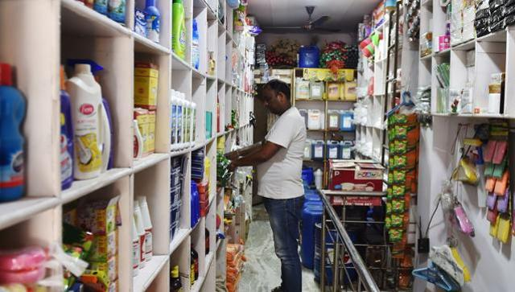

**The goods and services tax (GST) will replace a patchwork of central and state levies on goods and services and is one of Prime Minister Narendra Modi's biggest reforms since taking power in May 2014. (AFP Photo)**

In order to prevent any rise in price of commodities after goods and service tax (GST) implementation, the Centre has proposed an ‘anti-profiteering’ measure to ensure that trade and industry pass the benefits of reduction in tax rates to consumers.

The draft model GST law, which is to be finalised by the GST Council on December 2-3, has also specified that the highest tax slab will not exceed 28% in the GST regime, thus accepting the key demand of Congress.

As per the draft, the central government will constitute an authority or entrust the task to an existing authority to examine that the input tax credits or reduction in tax rates are passed by registered tax payers to consumers.

The Centre on Friday released three drafts -- model GST law, IGST law and Compensation law -- which have to be approved by the Centre and state legislatures for roll out of GST.

Under the new GST regime, which is likely to kick in from April 1, all traders and industries have to be registered with the GST network to pay taxes, file return and claim refunds.

“Enabling provisions have been made for introduction of anti-profiteering measure, wherein a mechanism may be established to monitor whether the benefit arising to industry on account of GST is passed on to the consumers,” said Pratik Jain, partner and leader Indirect Tax at Pricewaterhouse Coopers.

The draft Integrated GST (IGST) law which has to be adopted by Centre as well as the states, says that Centre will notify the GST rate on the recommendations of the GST Council but it would not exceed 28%.

The GST Council, headed by finance minister Arun Jaitley and having state representatives, has already decided on a 4-tier GST tax structure of 5, 12, 18 and 28 per cents. Luxury items and demerit goods would be taxed at the highest rate and would also attract a cess to create an Rs 50,000 crore corpus for compensating states for loss of revenue.

Parliament will have to approve all these legislations in the ongoing winter session to meet the April deadline.

# Securities excluded from GST ambit in revised Bill

## Revised draft plans anti-profiteering authority, introduces composite and mixed supply concept

**9089**

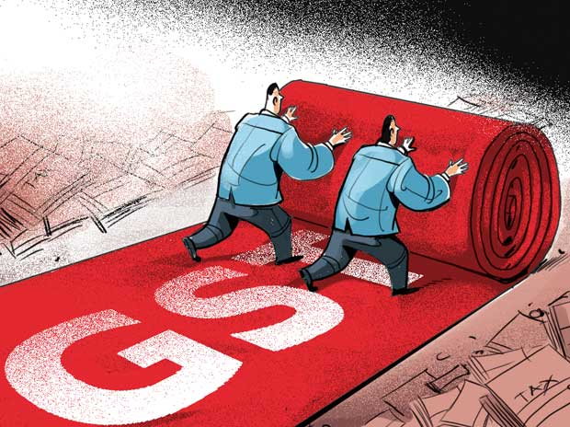

In a significant relief for stock markets, brokers, banks, and mutual funds, the government has excluded securities from the definition of ‘goods’ in the revised draft Model Goods and Services Tax Law.

Section 2(49) of the revised draft model law states that “goods’’ means every kind of movable property other than money and securities. The previous draft of the Model GST bill had included ‘securities’ in the definition of goods, raising concerns on whether transactions in securities would attract GST.

The government released revised drafts of the Model GST Law, Integrated GST Law and GST Compensation Law on Saturday in a bid to introduce the goods and services tax (GST) and compensation Bills in the current winter session of Parliament.

According to the revised drafts, an 'anti-profiteering' measure has been proposed to ensure that trade and industry pass the benefits of reduction in tax rates to consumers. An anti-profiteering authority is likely to be set up for this.

The Bills have also introduced new concepts of “mixed” and “composite” goods as well as anti-profiteering measures.

The Bills will now be taken up by the GST Council, comprising the Union finance minister, the minister of state for finance and representatives of states, on December 2 and 3. The aim would be to introduce the Central GST (CGST), integrated GST (IGST) and compensation Bills in Parliament.

If passed, the government would be able to introduce GST from the targeted date of April 1, 2017. State GST Bills would have to be passed by respective state Assemblies.

The draft Bills do not have GST rates. Earlier, the GST Council had approved different tax slabs — zero per cent, five per cent, 12 per cent, 18 per cent, 28 per cent and a cess on sin and luxury goods. The exact segment-wise rates are yet to be worked out.

The government will, however, have to woo the Opposition over demonetisation as Parliament proceedings remained stalled last week, and politically settle the issue of turf between the central and state officials over administering assessees under GST.

The revised draft GST Bills outlines “mixed” and “composite” goods, which was not there in the earlier draft.

“Mixed” goods mean a seller may give different goods to a buyer, without a dominant price.

For instance, one may go to a restaurant and order a “thali”, comprising rice, roti, vegetables, pulses and a sweet dish. Some of these, such as rice, may be exempt from GST, but others such as the sweet dish may attract a rate, say 12 per cent. In such a case, the “thali” would attract the highest rate, that is, 12 per cent.

Another concept is “composite” of goods, where one dominant good is sold.

For instance, one may go to a mall and purchase a mobile handset. Along with it, the seller may give the buyer a bag for it. The bag might be exempt from GST but the mobile handset might attract 18-per cent tax. In this case, the rate applicable for the dominant good, that is the mobile handset, would apply.

Arguing that one had purchased a good that did not attract GST will not work.

“In a case of composite supply, wherein a supply is made comprising of multiple supplies of goods or services, out of which, one supply is predominant and others are naturally bundled with it, it will be treated as a supply of the predominant one. In a case of mixed supply, which involves multiple individual supplies of goods or services for a single price without any predominant supply, it will be treated as a supply of goods or services which attract highest rate of tax,” said Pratik Jain, leader, indirect tax, PricewaterhouseCoopers (PwC) India.

Jain, however, said it would be a challenge to implement these measures as it was difficult to ascertain if lower GST rate could cut the prices of a good or services, as a corresponding increase in the costs of inputs might affect it.

Asked about Malaysia, which had also introduced this measure, the expert said there were a number of litigations in the country over this.

The Bills also provided for staggering input-tax reimbursements, called input-tax credit in technical language, over a period of three years for goods such as telecom towers and pipelines.

In earlier drafts, intangibles were taken as services, but in the new drafts, this provision has been removed. There was a lot of confusion as to why some intangibles, particularly in the software sector, should be taken as services. One has to wait for exact rules on tangibles to see whether this problem has been resolved.

The new draft has also addressed concerns of stock markets, brokers and mutual funds as securities have been taken out from the definition of goods. This implies transactions — selling and buying — in these papers would not attract GST.

Along with GST Bills, a draft compensation Bill was also made public. This is the first draft as the GST Council decided only last month to have a separate compensation law. The Bill says that a tax revenue growth rate of 14 per cent would be assumed for states with the base year of 2015-16.

The Centre will give full compensation to states in case of revenue loss because of GST for the first five years of the introduction of the new indirect tax system. This would be given at the end of every quarter, says the draft Bill.

Earlier, the meeting of GST Council was scheduled for November 25, but it was put off to December 2 and 3 as a technical committee of officers were yet to finalise these drafts.

*Disclaimer: The news in the GST Corner is purely according to the information available in public domain and does not necessarily reflect the views of ICSI. Any person wishing to act on the basis of this document should do so only after cross checking with the original source.*