**GST HEADLINES**

**October 27, 2016**

**FM Defends Multiple Slabs for GST, Cess for Compensating States**

***[Source: The Financial Express]***

# Realty may Attract 18% GST; Impact on Housing Prices Neutral: ICRA

***[Source: The Economic Times]***

|  |  |
| --- | --- |
|  |  |
|  |  |
|  |  |
|  | |

# FM defends multiple slabs for GST, cess for compensating states

## Finance minister Arun Jaitley on Wednesday strongly defended the multiple-rate structure proposed by the Centre for the Goods and Services Tax (GST) saying, “different items used by different segments of society have to be taxed differently”.

|  |  |
| --- | --- |
|  |  |

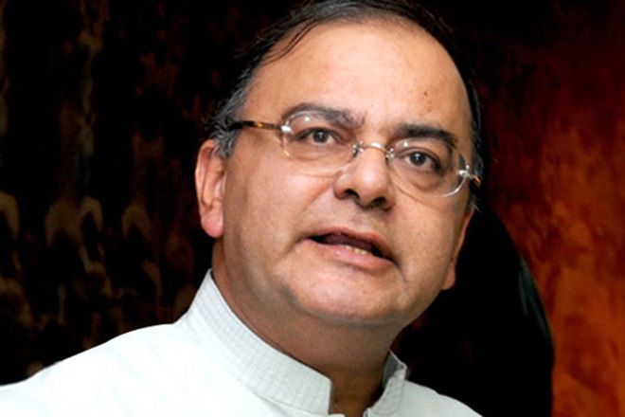

Countering criticism from many quarters, including former finance minister P Chidambaram against levy of GST at many rates, Jaitley cited examples of countries with 3-4 slab GST/VATs, even as some rich countries keep fewer slabs. Multiple rates, the finance minister said, are “inevitable” for India.

Finance minister Arun Jaitley on Wednesday strongly defended the multiple-rate structure proposed by the Centre for the Goods and Services Tax (GST) saying, “different items used by different segments of society have to be taxed differently”.

Countering criticism from many quarters, including former finance minister P Chidambaram against levy of GST at many rates, Jaitley cited examples of countries with 3-4 slab GST/VATs, even as some rich countries keep fewer slabs. Multiple rates, the finance minister said, are “inevitable” for India.

In a blog post, the finance minister also pitched for continuing some existing levies for a period of five years as cesses in order to raise the resources for compensating, as constitutionally provided, the states for any revenue loss. “This would include clean energy cess and cesses on luxury items and tobacco products, which in any case, currently also pay levy higher than 26%,” he wrote. In the GST council meeting here last week, several states had opposed the idea of new cesses to fund compensation, even though there was a convergence of views on not subsuming the clean energy cess and the imposts on tobacco in GST. This proved to be a sticking point in the Centre-state confabulations.

Explaining the rationale behind the proposal to use cess proceeds for compensation rather than a higher demerit GST rate, he wrote: “Assuming that the compensation is R50,000 crore for the first year, the total impact of funding (it) through a tax would be abnormally high… R1.72 lakh crore tax would have to be imposed (because). Out of every 100 rupees collected (through) GST, only 29 rupees remains with the Centre.”

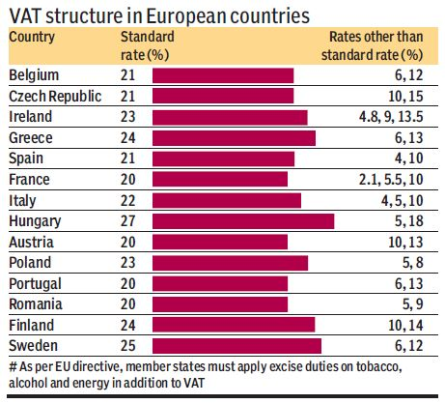

The cess mooted by the Centre is meant to apply on items currently being taxed at rates higher than the highest proposed slab of 26%. The rate of cess will be equal to the difference between the current tax incidence on these items and 26%. The cess proceeds, the Centre said, would create a fund, which would be used exclusively for compensating states’ revenue losses in the GST regime, in regard to their taxes to be subsumed in GST. According to Jaitley, the cess proposal would ensure that no additional burden is imposed on taxpayers.

**

**

*Disclaimer: The news in the GST Corner is purely according to the information available in public domain and does not necessarily reflect the views of ICSI. Any person wishing to act on the basis of this document should do so only after cross checking with the original source.*