GST HEADLINES
September 27, 2016

Govt Issues Draft GST Procedural Rules, Council to Finalise them on Friday
[Source : Business Standard]

Tripura Assembly Ratifies GST Bill
[Source : The Times Of India]

Govt Favours E-Payment of GST over ₹10,000

CBEC will take up 50% Posts in GST Secretariat, says Najib Shah
[Source : Business Line]

Govt Issues Draft GST Procedural Rules, Council to Finalise them on Friday

Experts fear e-commerce companies mat end up with multiple registrations because of some provisions
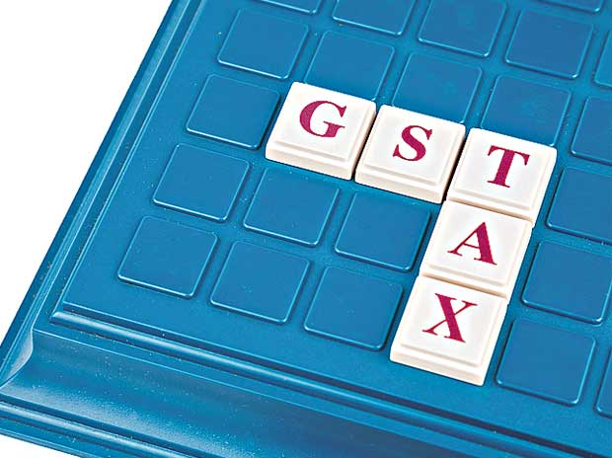
The businesses within India may get online registration within three days of submission of application under the proposed Goods and Services Tax (GST) regime, according to draft rules floated for registration, invoice and payments for the new indirect tax regime by the indirect tax department.
The non-residents, who will come under the purview of GST, will be required to electronically submit the application for registration at least five days prior to the commencement of business and deposit full tax liability in advance, according to these rules.
Experts fear that e-commerce companies mat end up with multiple registrations because of some provisions.
The draft rules were a swift move by the Central Board of Excise and Customs (CBEC) with an eye on the April 1, 2017, roll-out of the new indirect tax regime. The rules, on which comments are sought by Wednesday, are likely to be finalised by the GST Council on Friday.
"We intend to have these rules approved by the GST Council in its meeting on September 30 so that business systems can be modified by all," Revenue Secretary Hasmukh Adhia tweeted.
The draft rules also provide that if a tax official fails to take action on the registration application within a stipulated time frame, the application for grant of registration shall be deemed to have been approved.
The rules also provide for suo motu registration of persons who are liable but have failed to apply for registration.
The draft rules came just three days after end of the first meeting of the GST Council.
According to the draft norms, the applicant seeking registration will have to submit PAN, mobile number and email address on the common portal or through a facilitation centre.
The tax authorities will use the PAN, one-time password and Aadhaar number to verify the details of the applicant.
In case all documents are in order, the tax official will approve GST registration in three working days from the date of submission of the application.
If there are defects in the GST registration application, the applicant has to be intimated within three working days and after receiving clarification, s/he will be granted registration within seven days from the date of receiving the reply.
There will also be a provision to grant separate registrations for business verticals of the same organisation.
The rules also provide for physical verification of business premises after the grant of registration.
Nangia & Co Director Rajat Mohan said, "The government is working enthusiastically and is moving with lightning speed in hitting the bullseye for April 2017."
In all, the CBEC has come out with 17 rules and 26 forms for registration, five rules and one form for invoice and four rules and seven forms for payment.
Invoice rules prima facie prescribed that the number of details should be mentioned in an invoice e.g. description of goods, HSN code of each good supplied, quantity of goods, rate (per item), discount offered, freight, amount of tax (under reverse charge), electronic reference number etc.
These rules also prescribe the transporter need not carry any invoice if the supplier provides invoice reference number to the transporter.
Divyesh Lapsiwala, tax partner, EY India, said some of the provisions such as electronic authentication for registrations, special application for non-resident dealers, and self-updation of non-core details without needing an approval are positive changes.
"Further, it appears that e-commerce companies may end up with multiple registrations due to TCS (tax collected at source) provisions," he said.
THE RULES
- Online registration by residents should be done within 3 days of submission of the application
- Non-residents will be required to electronically submit applications for registration 5 days prior to the commencement of business and deposit full tax liability in advance
- If a tax official fails to take action on registration application within a stipulated time frame, the application shall be deemed to have been approved
- The applicant will have to submit PAN, mobile number, email address on the common portal or through a facilitation centre

Tripura Assembly Ratifies GST Bill
PTI | Updated: Sep 26, 2016, 09.24 PM IST
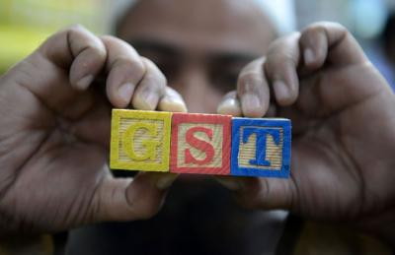
AGARTALA: Tripura assembly on Monday unanimously ratified the Constitutional Amendment Bill on Goods and Services Tax (GST).
State finance minister Bhanulal Saha moved a resolution to ratify the Constitution (122 Amendment) Bill, 2014, which was passed without any opposition.
No legislators from Left Front, Trinamool Congress(TMC) or Indian National Congress raised any question on the GST Bill.
President Pranab Mukherjee gave assent to the Constitution Amendment Bill on GST on September 8 after it was passed in the both Houses of Parliament and was ratified by requisite number of state assemblies.

Govt favours E-Payment of GST over ₹10,000
CBEC’s draft rules suggest online registration, invoicing; steps to prevent evasion
NEW DELHI, SEPTEMBER 26:
To make tax payments less cumbersome for taxpayers, the government has proposed that over-the-counter cash payments of ₹10,000 and above as tax by private companies and traders will not be allowed under the goods and services tax (GST) regime.
The draft payment rules, released by the Central Board of Excise and Customs (CBEC), have instead recommended that all tax payments under GST be done electronically through Internet banking, debit/credit card or NEFT/RTGS.
Only outstanding dues and funds seized during investigation or recovery by notified persons, officers or government departments may be deposited over-the-counter in cash, according to the draft rules.
The CBEC has also issued draft rules for registration and invoices under the GST, both of which depend on electronic interface through the GST network (GSTN) portal.
Seeking public comments on the three sets of draft rules by September 28, the CBEC said, “Corresponding changes in the Model GST Law are being carried out separately.” Rules on other issues such as returns are still awaited.
The draft rules and formats will be taken up for finalisation by the GST Council when it meets again on September 30.
The draft rules state that all persons who are already registered as assessees under an “earlier law” such as Central Excise or service tax and having a Permanent Account Number (PAN) will be given a provisional registration, and the GST Identification Number (GSTIN) would be available on the GSTN portal.
Plugging tax evasion
To prevent tax evasion, the PAN details of each applicant will be verified before giving them a GSTIN.

New applicants would be expected to provide details of their PAN, mobile number and e-mail address and the application would be verified in three working days. Non-resident applicants would be mandated to seek registration at least five days before they start their business activities in the country.
The draft rules have prescribed the maintenance of an electronic ledger by each registered taxable person “for crediting the amount deposited and debiting the payment towards tax, interest, penalty, fee or any other amount”.
Invoicing procedures
For supply of goods, all invoices should be made in triplicate. In case of exports, the invoice shall carry an endorsement stating that it is meant for export on payment of Integrated GST.
Tax experts welcomed the draft rules and said it would lower the chances of harassment as most processes have to be done online.
“It is a good development as a lot of detailing of GST by companies would be contingent on the rules,” said Pratik Jain, Leader, Indirect Tax, PwC India.

CBEC will take up 50% Posts in GST Secretariat, says Najib Shah
CBEC Chairman asks his officers to welcome the new tax, and play a lead in its rollout
NEW DELHI, SEPTEMBER 26:
The Central Board of Excise and Customs (CBEC) has said the department will take up 50 per cent of the posts in the Secretariat of the GST Council and will also depute officers in the GST Network (GSTN).
This was stated by CBEC Chairman Najib Shah in a recent letter to his officers, where he also urged them to “welcome” the Goods and Services Tax.
“As a Central service, CBEC will continue to collect the Central GST and integrated GST...We are in the process of encardering 50 per cent of all posts in the GST Council Secretariat for CBEC,” he said, adding that the department has also called for willing officers to take up some more posts in the GSTN.
The GST Secretariat, located here, will be the administrative headquarters of the GST Council that will decide on all key issues related to the tax.
“The Directorate of Systems is in the process of being strengthened, the IT infrastructure is being revamped and upgraded to meet the requirement of GST. The GSTN already has CBEC officers on deputation,” he said.
Shah also expressed dismay at concerns being expressed in some quarters and asked his officials to “rise up to the challenges” to ensure the success of the indirect tax reform. “We are at the cusp of the most historic change in the indirect tax structure and should welcome the opportunity,” he said.
An association representing officers of the Indian Revenue Service (IRS) had written to Finance Minister Arun Jaitley, seeking the transfer of the management of GSTN to the Directorate General Systems of CBEC.
Shah also noted that petroleum and tobacco products, which account for substantial revenues, will continue to attract Central excise duty and will be out of the ambit of GST.
The CBEC is in the process of restructuring its central excise and service tax commissionerates for the rollout of GST from April 1, 2017, under which there will be a single uniform levy replacing the two Central levies, State value added tax and other local cesses and levies.
The CBEC is also likely to be renamed as the Central Board of Indirect Taxes.
In this context, the CBEC Chairman said the changes must be embraced and the officials must take the lead in the restructuring. “Change management will be of paramount importance. We will have to provide a lead role in meeting the implementation challenges, training the officials and trade and industry, holding workshops, acquiring and imparting necessary IT skills.”
He further said that about 60,000 tax officials of both the Centre and the States will be trained in the next few months on GST law.

Disclaimer : The news in the GST Corner is purely according to the information available in public domain and does not necessarily reflect the views of ICSI. Any person wishing to act on the basis of this document should do so only after cross checking with the original source.

