GST HEADLINES
December 26, 2016

GST Council Approves Primary Drafts of Central GST & State GST Laws

[Source:The Indian Awaaz]

About 75 per cent of targeted 60,000 officers trained for GST

[Source:The Indian Express]

GST Council Approves Primary Drafts of Central GST & State GST Laws
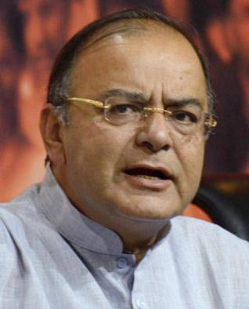
The Goods and Services Tax Council on Friday approved the primary drafts of Central GST and State GST laws but issues related to cross-empowerment and dual control remained to be sorted out.
The meeting chaired by Finance Minister Arun Jaitley, approved 197 provisions and five schedules in the CGST and GST draft laws.
Briefing reporters after the end of 7th meeting of GST Council in New Delhi, the finance minister said the CGST is to be approved by Parliament while the SGST to be approved by States legislative Assemblies.
Jaitley also said, during its two day meeting, the council also cleared basic draft of compensation law.
He said, the states will be fully compensated for any loss of revenue for five years due to the implementation of GST.
He also said, the compensation to the states will be paid in every two month. FM also said, the key issues related to Integrated GST and dual control and the legally vetted language will be taken up in the next meeting of the GST Council on 3rd and 4th of January, 2017.

About 75 per cent of targeted 60,000 officers trained for GST
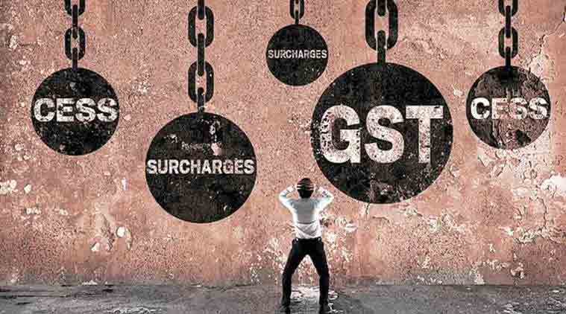
As per the latest data of NACEN, 44,259 field officers have been trained.

Uncertainty over the rollout date of Goods and Services Tax (GST) notwithstanding, the National Academy of Customs, Excise and Narcotics (NACEN) has already trained about three-fourth of the targeted 60,000 field officials who would be instrumental in implementing the new indirect tax regime. NACEN has been tasked with the mammoth training target of 60,000 officials of both the Centre and states.

As per the latest data (up to December 17) of NACEN, 44,259 field officers have been trained. The government intends to roll out the GST regime from April, but there are apprehensions that the date would be missed because the all powerful GST Council is yet to iron out several vexed issues, including jurisdiction of Centre and state governments over tax payers.

The Council, headed by Union Finance Minister Arun Jaitley and comprising state finance minister, has so far met seven times after Parliament amended the Constitution for implementation of GST. The next meeting is scheduled for January 3 and 4 to decide on the contentious issue of dual control over assessees and the legislation on IGST.
NACEN data further stated that 2,060 ‘trainers’ have been trained against the target of 1,600. Similarly 310 ‘master trainers’ have been skilled, thus surpassing the target of 300. As many as 36 officers from the Comptroller and Auditor General (CAG) to have been imparted the necessary training.

CBEC officials have already been deputed to the GST Network, the IT backbone of the new indirect tax regime.

Disclaimer: The news in the GST Corner is purely according to the information available in public domain and does not necessarily reflect the views of ICSI. Any person wishing to act on the basis of this document should do so only after cross checking with the original source.

