GST HEADLINES
October 26, 2016

Revenue Neutral Rate Structure of GST to be finalised Next Month

[Source: NDTV]

Govt Sources Say Cess is a Better Option than High Tax Rate

[Source: Business Standard]

Revenue Neutral Rate Structure of GST to be finalised Next Month
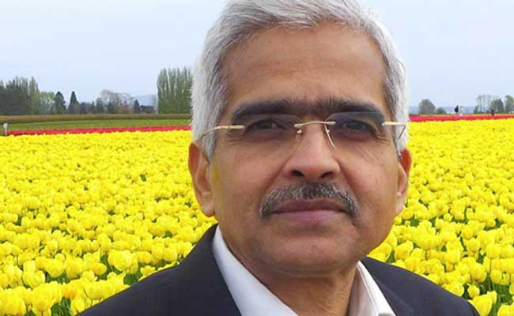
Shaktikanta Das expressed confidence that revenue neutral rate structure will be decided next month
NEW DELHI: Asserting that the government is determined to implement GST from the next fiscal, Economic Affairs Secretary Shaktikanta Das on Tuesday expressed confidence that the revenue neutral rate structure will be decided the next month.
"The rate structure on which there is a lot of discussion going on at the moment with the GST Council and also in the public domain... will get resolved in the next meeting of GST Council in the first week of November. Maybe, one or two sittings, it should come to a conclusion," Mr. Das said at an Assocham event here.
Dismissing criticisms, he said the rate structure has been prepared based on "a very practical basis".

"The rate has to be necessarily revenue neutral. You cannot have a rate structure where governments run into huge deficit. Therefore, GST rates are worked out in such a manner that bulks of commodities are under the standard rate, which is 18 per cent," he said.
The items which are very important, which are of use to a large cross-section of people and common man are pegged at 6 per cent, he said, adding that 6 per cent, 12 per cent, 18 per cent and a higher rate for demerit goods has been proposed.
Former finance minister P Chidambaram on Monday criticised the proposed multiple-rate GST structure as "disastrous".
"We sincerely hope that we do not misinterpret the design of standard, standard minus and plus rates of GST. We can have 20 rates. It will be disastrous and that cannot be GST, it will be fooling the country," Mr. Chidambaram had said.
Emphasizing that the bankruptcy law together with GST will bring in a lot of dynamism into Indian economy, Mr. Das said the government is determined to implement GST from April 1, 2017.
"Whatever preparedness is required, it is in place. The state governments are also equally committed to introducing it from April 1," he added.
Earlier this month, the Centre and states failed to decide the tax rate under the GST regime even though they "converged towards a consensus" on levying a cess in addition to the highest rate of tax on luxury and sin goods.
A four-slab tax structure of 6, 12, 18 and 26 per cent with lower tariff for essential items and the highest bracket for luxury goods found favour with them, but a decision was put off to the next meeting on November 3-4.

Govt sources say cess is a better option than high tax rate

The other option could have been to raise direct taxes, which did not find favour with the Centre

Just a week before the next Goods and Service Tax (GST) Council meeting on November 3 and 4, the view of states being compensated through a cess rather than a hike in the proposed GST rate has gained strength, with the Centre telling them that an increase in the tax rate has to yield around Rs 1.72 lakh crore. On the other hand, a cess which will yield Rs 50,000 crore a year would be enough to compensate states.
The Centre has proposed a four-slab structure — 6 per cent, 12 per cent, 18 per cent and 26 per cent— under the proposed GST and a cess beyond 26 per cent on luxury and sin goods. States are expected to lose around Rs 50,000 crore a year, which would be compensated by the Centre in full for the first five years. If the GST rates are raised beyond 26 per cent on luxury and sin goods, it must yield Rs 1.72 lakh crore to the states and the Centre, government sources said. This is so because half of this would be state GST, and of the remaining half— Rs 86,000 crore — 42 per cent, or around Rs 36,000 crore would go to states. This would leave Rs 50,000 crore in the Centre’s hands to compensate states.
The other option could have been to raise direct taxes, which did not find favour with the Centre, sources said.
While there has been demand from various quarters to have a maximum rate of 18 per cent, the government sources said it would have meant a Rs 1 lakh crore revenue loss to the Centre's exchequer. This would have to be offset from increasing tax rates on items consumed by the poor, they said.
On the other hand, a 26 per cent peak tax rate would be mainly on consumer durable goods such as refrigerators which already are taxed at the combined rate of 25 per cent. So, there is not much of the difference between existing rate and the one proposed under the GST regime.
Moreover, there is no cascading and leakages under the GST regime which would save another 2-4 per cent on taxes, which should also be taken into account while comparing the present structure with the proposed peak GST rate.
The proposed GST, including a cess, would lead to a total of Rs 9.32 lakh crore to the Centre’s kitty.
The sources said that one can argue that the proposed GST is not an ideal one, but the government's hands were tight.
While many experts have criticised the multiple tax rates proposed by the Centre for GST, the sources said even in Europe there are specific rates for products. While Luxembourg has four rates, other countries in the European Union have three slabs. Former finance secretary Vijay Kelkar who headed the 13th Finance Commission that gave recommendations on GST recently said the proposal was disappointing as it would rob the GST of its efficiency enhancing potential.
He had said the impact of the tax rate proposals on the economy would be only one fourth of the high potential impact that the 13th Finance Commission had estimated.
The next GST Council meeting’s agenda will be a packed one as it is expected to decide on the much-awaited GST rates. Also, the issue of administrative control over tax assesses or dual control — claimed to have been settled earlier — has been cropped up and it will be decided upon at the meeting slated for November 3-4. In the last meeting on October 19, the Centre and states did manage to reach a broad agreement on the formula for compensation to loss-incurring states and a cess over the peak rate to fund the compensation.
The details of these, however, would be worked out at the next meeting, before tax rates can be fixed.

Disclaimer: The news in the GST Corner is purely according to the information available in public domain and does not necessarily reflect the views of ICSI. Any person wishing to act on the basis of this document should do so only after cross checking with the original source.

