GST HEADLINES
September 26, 2016

Congress Asks its CMs to Insist on 18% GST Rate
[Source : The Times Of India]

GST Council sets Exemption Threshold for Tax at Rs.20 lakh
[Source : The Hindu]

GST Council Additional Secretary Appointed
[Source : NDTV]

Congress asks its CMs to Insist on 18% GST Rate
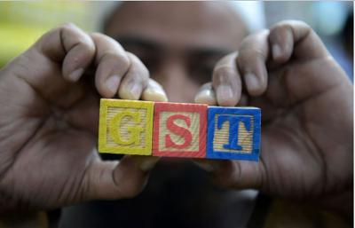
NEW DELHI:

Congress has asked its chief ministers to demand 18% cap on the GST rate when the GST Council meets for a three-day brainstorming session starting October 17.
In a recent note, the party asked its state governments to argue that a rate higher than 18% would burden the common man and undo GST's stated purpose of creating a common market to reduce the tax burden of both producers and consumers.
The GST Council will decide the rate after its discussions. Congress had refused to support the GST bill for over a year, insisting that the government agree to its three demands -abolition of 1% surcharge, establishment of a dispute redressal mechanism and legal ring fencing of GST rate.

GST Council sets Exemption Threshold for Tax at Rs.20 lakh

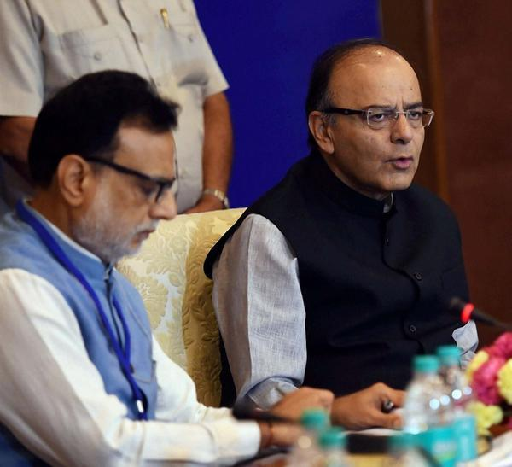
PTI
TAX NET: Union Finance Minister Arun Jaitley said consensus was also reached on jurisdiction over assessees.

Businesses in Northeastern, hill States with annual turnover below Rs.10 lakh out of net
The Goods & Services Tax (GST) Council has decided that businesses in the Northeastern and hill states with annual turnover below Rs.10 lakh would be out of the GST net, while the threshold for the exemption in the rest of India would be an annual turnover of Rs.20 lakh.
“For GST, the exemption threshold is fixed at Rs.20 lakh,” Council Chairman and Union Finance Minister Arun Jaitley said at a news conference at the conclusion of the panel’s first meeting here on Friday.
“So those with a turnover of below Rs.20 lakh annually will be exempted from GST. With the north-east States, the exemption threshold is Rs.10 lakh,” Mr. Jaitley said. The Constitutional Amendment paving the way for the GST has a provision to accord special status to the Northeastern and hill states.
‘Goodnews’
“A higher threshold of Rs.20 lakh [as against earlier proposed limit of Rs.10 lakh] is also a good news,” Rajeev Dimri, Leader, Indirect Tax, BMR Associates, said in an e-mailed statement. “Many small scale traders and service providers would be saved from undertaking GST compliances and it also reduces a substantial burden for tax authorities to assess small time dealers.”
Mr. Jaitley said the Council had also reached consensus on another contentious issue, that of administrative control over indirect tax assessees.
The States would have sole jurisdiction over assessees (currently in the Value Added Tax [VAT] net at present) having a turnover of Rs.1.5 crore or less, while the administrative control of businesses with a turnover exceeding that limit would be jointly with the Central and State governments, Mr. Jaitley said.
On Thursday, Abhishek Mishra, the Minister representing Uttar Pradesh, called for fixing the exemption threshold at Rs.10 lakh. He argued against a preliminary proposal for fixing it at Rs.25 lakh on the grounds that at that level the State could lose 7.1 per cent of its revenue.
Delhi Deputy Chief Minister Manish Sisodia, and members from Tamil Nadu and some other States supported the proposed threshold level of Rs.25 lakh.
The Council also decided that the existing 11 lakh service tax assessees will continue to be under the jurisdiction of the Centre. Since the GST will allow the States to also tax services, over time the revenue officials in the States will be trained after which they will begin assessing assessees in the services sector.
“Retention of administrative control over existing Service Tax assessees by Central authorities highlights an open mindset to facilitate smooth transition to GST,” Mr. Dimri said.
The Council would reconvene on September 30 to finalise the categories of goods and services that would be exempt from the GST. After that, it would meet on October 17, 18 and 19 to fix the slabs and rates at which the GST would be paid by consumers, Mr. Jaitley said.
Compensationformula
The compensation that the Centre would pay to the States for losses of revenue because of the transition to the new regime would be routinely, quarterly or bi-monthly, Mr. Jaitley said. The Council agreed to settle for 2015-16 as the base year for calculating the compensation.
On Thursday, Tamil Nadu called for ascertaining the quantum of compensation based on the average growth rate in the best three of the preceding six years. A formula would be set based on suggestions, Mr. Jaitley said.

GST Council Additional Secretary Appointed
Arun Goyal will take charge of the newly created post of Additional Secretary. (File Photo)

NEW DELHI: With the Goods and Services Tax (GST) Council slated to take vital decisions during its coming meets, the government on Saturday appointed Mr Arun Goyal as Additional Secretary of the pan India indirect levies' apex body.
According to the Appointments Committee of the Cabinet (ACC), Mr Goyal will take charge of the newly created post of Additional Secretary, GST Council, under the Central Staffing Scheme.
"Arun Goyal, lAS (UT:1985) Additional Secretary, Project Monitoring Group, Cabinet Secretariat on lateral shift as Additional Secretary, GST Council against Newly created post under Central Staffing Scheme," Ministry of Personnel, Public Grievances & Pensions said in a statement.
The Council on Friday fixed the turnover-based exemption limit from such levies at Rs. 20 lakh, but left the decision on fixing the actual tax rates and the finalisation of draft rules for later.
The council is scheduled to reconvene on September 30 and again from October 17-19.

Disclaimer : The news in the GST Corner is purely according to the information available in public domain and does not necessarily reflect the views of ICSI. Any person wishing to act on the basis of this document should do so only after cross checking with the original source.

