GST HEADLINES
August 26, 2016

GST Bill gets unanimous ratification in MP assembly

[Source : Times Of India]

Delhi Assembly nod for ratifying GST

[Source : The Indian Express]

GST Bill gets unanimous ratification in MP assembly
Suchandana Gupta| TNN | Aug 24, 2016, 10.49 PM IST
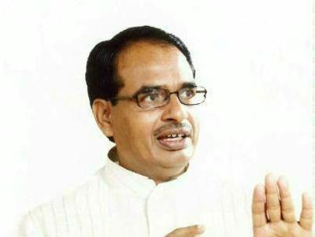Shivraj Singh Chouhan
BHOPAL: Madhya Pradesh on Wednesday became the seventh state to ratify the Goods and Services Tax (GST) Constitution 122 Amendment Bill. The bill was unanimously endorsed by voice-vote by both ruling BJP and Opposition parties in the state assembly after a two-hour long discussion. Addressing the House at the end of the debate, chief minister Shivraj Singh Chouhan said, "I am thankful to all Opposition members for unanimously supporting the GST. India displayed economic unity on August 8 when the bill was passed in the Lok Sabha and today we have contributed to it."
Assam, Bihar, Jharkhand, Himachal Pradesh, Chhattisgarh and Gujarat have already ratified the GST Constitution Amendment Bill. Perceived as the biggest tax reform initiative, the bill passed in both Lok Sabha and Rajya Sabha, requires ratification by at least 15 state assemblies before the President's assent.
Finance minister Jayant Malaiyya argued that GST and the concept of "one nation, one tax" will be beneficial for the state. "It will end the loss of tax from e-commerce. The system will be transparent, there will be much less tax evasion and easier for business establishments," the finance minister reasoned. He said seven indirect taxes including excise duty, service tax, custom duty, securities transaction tax, VAT, entry tax and Entertainment/luxury tax will merge into a common indirect tax which is GST.
Chief minister Chouhan and finance minister Malaiyya explained that opposition to the new tax system ended after the NDA-Centre decided to exempt petrol and alcohol from the purview of GST. This means that state government will continue to levy its tax on petrol, diesel and alcohol for its revenue. Hence, there will be no reprieve for consumers in Madhya Pradesh (state with highest taxation on petrol) from state government's high rate of taxation on petrol, diesel and liquor. Malaiyya also specified that whatever revenue loss is faced by the state government after implementation of GST will be borne by the Centre for the first five years.

Delhi Assembly nod for ratifying GST

Manish Sisodia says Bill is finally a step in right direction, expresses concern over implementation
Delhi | Published:August 25, 2016 5:45 am
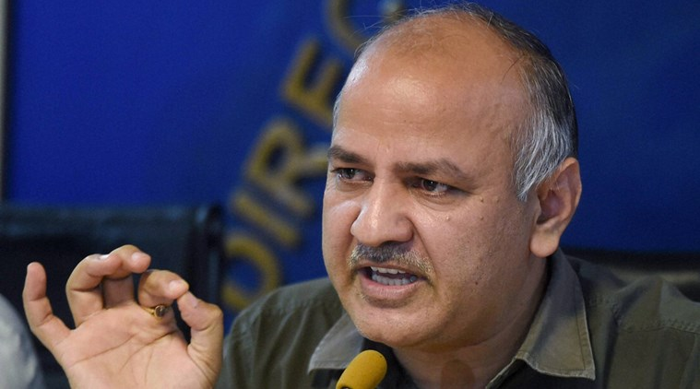Deputy Chief Minister Manish Sisodia. (File)
The Delhi Legislative Assembly on Wednesday passed a resolution to ratify the Constitution (122nd Amendment) Bill or the Goods and Services Tax Bill passed by the Parliament. Deputy Chief Minister Manish Sisodia who moved the resolution in the Assembly said, “We think the GST Bill is in the interest of Delhi. Delhi supports it. The more the tax system is unified and made easy, the better it will be.”
The GST bill had, for the first time, acknowledged Delhi as a state and sought the Delhi assembly’s ratification, Sisodia said. He later tweeted, “GST Bill for the first time recognises Delhi as a state under the new Constitutional amendment to Art 366 – step in right direction finally.” The BJP at the Centre and the AAP in Delhi have been locked in a bitter turf war since the Arvind Kejriwal government took charge in February 2015.
In a setback to the Delhi government, the Delhi High Court on August 4 held that Delhi continues to be a Union Territory under the authority of the Lieutenant Governor.
Although the legislative assembly passed the resolution to ratify the single indirect tax regime, Sisodia expressed ‘concerns’ over its implementation in the future. “This is a major tax reform. We support reform but we want our concerns to be addressed,” said Sisodia.
He said that the Delhi government had interacted with many small traders and felt that they need to be assured that the tax burden on them will not increase.
“The tax threshold for Value Added Tax is Rs 20 lakh. Businesses that make Rs 85,000 to Rs 1 lakh don’t need registration etc. But if this threshold is reduced to Rs 10 lakh then small businesses will feel burdened. I think this threshold should be made Rs 25 lakh,” said Sisodia.
He added that although these questions will arise only when the GST Bill is made into a law and rules under it are framed, it is important that states are consulted prior to that. He said that finance ministers of all states should meet to address their concerns over the GST Bill.

Disclaimer : The news in the GST Corner is purely according to the information available in public domain and does not necessarily reflect the views of ICSI. Any person wishing to act on the basis of this document should do so only after cross checking with the original source.

