GST HEADLINES
October 25, 2016

GST rollout: 80 lakh assessees may start migrating to GSTN portal from Nov 8

[Source: Firstpost]

Centre's proposals on GST rates find favour with Niti Aayog

[Source: Business Standard]

GST can be paid with debit, credit cards online, says Revenue secretary Hasmukh Adhia

[Source: Firstpost]

GST rollout: 80 lakh assessees may start migrating to GSTN portal from Nov 8

New Delhi: As many as 80 lakh assessees of excise as well as service tax and VAT can start migrating their registration to the Goods and Service Tax Network portal by November 8, GSTN Chief Executive Prakash Kumar said today.
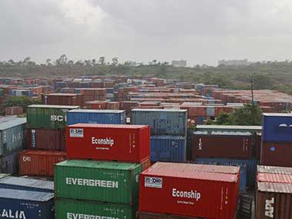
Reuters
"On this date (November 8), we are releasing enrolments. This means getting these existing eight million assessees on to our system," Kumar was quoted as saying by a PHDCCI release.
The GSTN, which is expected to provide common and shared IT infrastructure for GST implementation, will transfer on-board to its platform the details of about 80 lakh existing assessees of excise, value-added tax, customs and service tax.
Kumar said the migration of assessee details onto the GSTN platform will sort out inconsistencies and help industry get ready for GST implementation date of April 1, 2017.
"This move will help them do business without any hassle from April 1 next year, which is the likely GST implementation date," Kumar said.
GSTN, a not-for-profit entity incorporated in March 2013, has been set up primarily to provide IT infrastructure and services to the central and state governments, taxpayers and other stakeholders for implementation of GST. It has also been allowed to partner with other agencies for creating an efficient and user-friendly GST eco-system.
Kumar also said that GSTN will in the coming days obtain imports related data (Bill of Entry) from the Central Board of Excise Customs (CBEC). This will be useful for levy of IGST (GST levy on imports).
The GST will subsume excise, service tax and other local levies and will make India one market for seamless transfer of goods and services. The GST Council, consisting of Union Finance Minister and his state counterparts, is likely to decide on the tax rates in their November 3-4 meeting.

Centre's proposals on GST rates find favour with Niti Aayog

Arvind Panagariya on Monday defended the Centre's proposal of four-slab GST rates
Niti Aayog vice-chairman Arvind Panagariya on Monday defended the Centre’s proposal of a four-slab goods and services tax (GST) rate structure, beside a cess on luxury and ‘sin’ goods.
There is criticism in some quarters that the multiple rates would distort the structure of the proposed indirect tax regime.
Panagariya also said the April 1 target for rolling out a national GST was possible, though a race against time.
“The criticism that the relevance of GST would be lost due to the proposed four-slab structure is a bit overstated,'' Panagariya told reporters. One should note, he said, that while there might not be a single GST rate for all items, each item would have a single rate pan-India. No tax theory, he added, said two slabs were better than a bit more. If GST would have only one rate or two rates, items attracting a levy of three or eight per cent would see much higher inflation. It is so as rates on these items would have to be stretched much more in that case. Those attracting three to eight per cent now are proposed to come under a six per cent GST rate. The other rates are 12, 18 and 26 per cent, plus a cess.
Panagariya said this gave predictability to the tax structure, as rates were not altered too much as compared to the present one. This would not have been possible if there had been a twin or single rates.
GST, he added, was a process. Hopefully, later, there would be gradual movement towards a single rate.
Giving historical perspective, Panagariya said former finance minister Yashwant Sinha had converged 11 excise rates to three — of eight, 16 and 24 per cent — in 1999-2000. There were two additional non-VAT rates on luxury goods.
On the proposed move to impose a cess over 26 per cent on luxury and sin goods, he said if this was replaced with another tax, the rate would be much higher than the cess, as 42 per cent of it would go to states. Beside, a cess could be temporary and be done away with, once its purpose to compensate states for revenue loss in the first five years of GST roll-out, is over.
The GST Council could not decide on the rates on Thursday as discussion on cess was inconclusive. If cess is decided, then tax rates could be fixed, finance minister Arun Jaitley had said. The next Council meeting on November 3-4 would try to evolve a consensus on the rates.
Former Finance Secretary Vijay Kelkar, who headed the 13th Finance Commission (TFC) that gave recommendations on GST, recently said the proposed structure was disappointing, as it would rob the GST of efficiency enhancing potential. He'd also said the impact of the tax rate proposals on the economy would be only a fourth of the high potential impact the TFC had estimated.
Pratik Jain, partner with PwC, said multiple rates weren't desirable but were perhaps the only realistic way for a consensus. “In particular, a six per cent band is necessary as many products, including food items, currently attract an effective rate of five to six per cent, and having those at a 12 per cent slab could have been inflationary,” he said.
However, he said, a cess on products under the higher slab was not a good idea. It would complicate compliance for business and could lead to cascading of taxes. “Instead, it might be a better idea to increase the tax rate nominally, if needed. In any case, the government might not need to compensate the states if there is revenue buoyancy,” he said.

GST can be paid with debit, credit cards online, says Revenue secretary Hasmukh Adhia
Indore: Individuals and entities can pay taxes online using debit or credit cards once the Goods and Services Tax is rolled out, revenue secretary Hasmukh Adhia said.
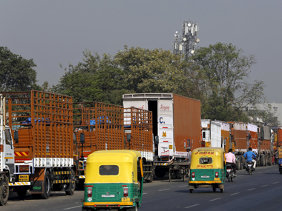
The government proposes to roll out the new indirect tax regime from April 1 next year and has made registration, refunds, returns filing and payment processes online.
"With regard to payments, the best thing that will happen is all payments will have to be made online. You can use any mode of payment, electronic, RTGS. You can do it through debit cards or credit cards of any bank.
"You need not open account in banks of government. Even if you have account in a private bank you can transfer money and it will reach the government," Adhia said while addressing the Global Investors Summit here.
He said GST will make it easier for traders and industry to access Input Tax Credit and also ease compliance burden as the entire country will become a single market.
"I would ask the states to focus on the services sector because industry will come on its own once demand increases," Adhia said.
He said India is now taking several reform measures and GST is the biggest tax reform since Independence. Adhia added that GST will also ensure that the taxes deducted by sellers reach the government.
Asked what will happen to excise duty benefits currently enjoyed by units in Jammu and Kashmir as well as Northeastern and hilly states, Adhia said they will be protected in a similar manner. "Instead of giving direct exemptions, we will take it through the Government of India's budgetary route," he said.

Disclaimer: The news in the GST Corner is purely according to the information available in public domain and does not necessarily reflect the views of ICSI. Any person wishing to act on the basis of this document should do so only after cross checking with the original source.

