GST HEADLINES
November 24, 2016

No Consensus on Draft Laws, GST Council Meet Postponed To Dec 2-3

[Source: The Indian Express]

No consensus on draft laws, GST Council meet postponed to Dec 2-3

This is the second time that the fifth meeting of the GST Council has been rescheduled. Earlier, the meeting was supposed to be held on November 9-10.

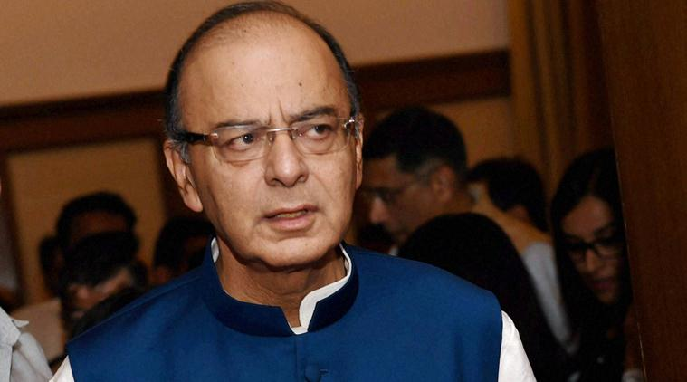
Union Finance Minister Arun Jaitley. PTI Photo

The fifth Goods and Services tax (GST) Council meeting, slated for Friday, has been deferred to December 2-3 as the committee of officers from states and the Centre failed to draw a consensus regarding the formulation of draft GST laws.

The officers, who met on November 21-22 to deliberate upon the three draft GST related laws – Model GST; Integrated (IGST) and GST (Compensation to the States for loss of Revenue), will now meet on November 25 to finalise the draft laws before being presented at the Council’s meeting next week.

“Number of issues was resolved during the two-day meeting (November 21-22). However, the states desired some more time to internally deliberate on revised draft of the laws within their respective states,” a finance ministry statement said.

This is the second time that the fifth meeting of the GST Council has been rescheduled. Earlier, the meeting was supposed to be held on November 9-10. Later, it was shifted to November 24-25 and then on Sunday it was decided to shorten the duration of the two-day meeting to only one day on November 25. States have raised certain concerns regarding the legal terminology in draft model GST law and draft GST compensation law, officials said, adding that the state government officials wanted to ensure that the draft law has provision for ‘full’ compensation to states. Government officials said that since the legal process for changes in the draft laws would take some time, it was decided to postpone the meeting.

“The states have suggested certain changes relating to returns procedures in model GST law. Also, they have asked for changes in wordings in compensation law. We will finalise the three draft laws at the November 25 meeting,” a government official said.

The deferment of the meeting, however, is unlikely to cause delay in the targeted rollout date of April 1, 2017, for the proposed indirect tax regime as the Centre proposes to introduce these legislations as money Bills to ensure a speedy passage in Parliament, officials said. The Indian Express had reported on Wednesday that the government plans to introduce all three GST-related Bills as money bills as these are required to be voted only in Lok Sabha where the ruling party has a clear majority. In the meeting of the officers committee, concerns were also raised regarding the legal space available for Centre to exercise jurisdictional and administrative control over tax assessees even beyond the threshold, officials said. A final decision on the issue of cross empowerment to avoid dual control, however, will only be taken at the ministerial level, they added.

Centre had on November 16 circulated the draft legislations among the states. These laws deal with returns, registration and refund process as well as where GST will be levied. The compensation law will list out how states will be compensated in the initial five years for revenue loss on account of GST rollout. Also, the states will draft their own State GST (SGST) based on the draft model law with changes incorporating state-based exemptions. At its last meeting, the GST Council had agreed on a four-slab structure — 5, 12, 18 and 28 per cent — along with a cess on luxury and ‘sin goods’ such as tobacco. Finance minister Arun Jaitley had called an informal meeting with states’ FMs on Sunday to find a solution to the issue of dual control over the tax assesses.

Disclaimer: The news in the GST Corner is purely according to the information available in public domain and does not necessarily reflect the views of ICSI. Any person wishing to act on the basis of this document should do so only after cross checking with the original source.

