GST HEADLINES
August 24, 2016

Gujarat Assembly ratifies GST Bill

[Source : The Indian Express]

GST rate at 18% will be revenue neutral: CII chief
[Source :Hindu Business Line]

Gujarat Assembly ratifies GST Bill

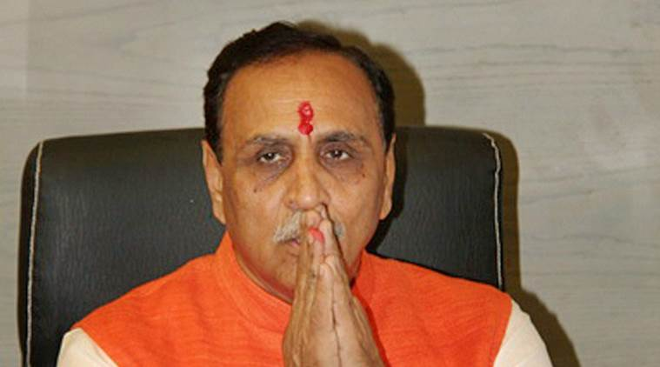

Gujarat Chief Minister Vijay Rupani. PTI Photo

The Gujarat Assembly on Tuesday passed the Goods and Service Tax (GST) Constitution Amendment Bill, becoming the sixth state to pass the bill.
The ratification of the bill comes in quick succession after the Chhattisgarh assembly passed it unanimously on Monday.
Himachal, Assam, Jharkhand and Bihar state assemblies have also passed the Bill.
The state assembly of Gujarat had convened a special session to ratify the Bill that was passed by Parliament earlier this month.
In New Delhi, the Aam Aadmi Party government only last week said it will place the GST Bill for ratification before the Delhi Assembly during its 4-day session beginning August 22 if it receives official communication about the Bill from the Centre.
The Constitution (122nd Amendment) Bill for the roll-out of the Goods and Sevices Tax (GST) was passed by the Lok Sabha earlier in August, with 443 members present in the House voting in favour of the legislation. Arun Jaitley had, earlier in August, announced that the deadline for the rollout of the bill was April 1, 2017.
The GST bill, seen as single biggest tax reform in a long time, needs to be ratified by at least 15 state legislatures before the President can notify the GST council which will decide the new tax rate and other issues.
The government had been working overtime to get states on board over the GST following the passage of the bill in Parliament. It is keen to bring two bills aimed at implementing the new tax regime in the winter session to meet the April 2017 deadline for its rollout.

GST rate at 18% will be revenue neutral: CII chief
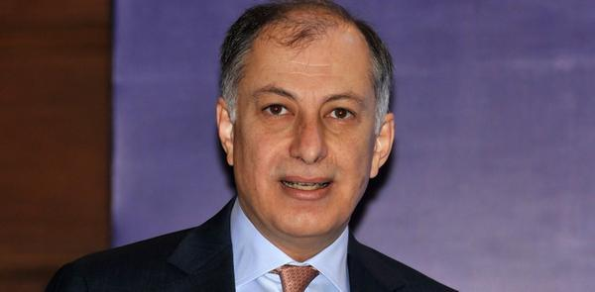
Looking ahead Naushad Forbes, CII President, addressing a press conference in Kolkata on Tuesday. - Ashoke Chakrabarty

‘Ensuring seamless implementation of the tax framework will be the next important step’
The ideal Goods and Services Tax (GST) rate should be around 18 per cent, Naushad Forbes, President, Confederation of Indian Industry (CII), said here on Tuesday.
Calling it a “revenue neutral rate”, Forbes pointed out that an 18 per cent rate will lead to “neither an increase nor a decrease” in taxes; immediate inflationary pressures on the economy are also not forseen (at that rate).
The rate is not “so high to damage the market” (for demand of goods).
Considered to be the country’s biggest ever indirect tax reform, the GST framework has already been passed by Parliament.
“A max rate of around 18 per cent would be fine. Beyond that, the first thing it will hit is demand. Supposing you had 22-23 per cent, it will directly hit demand. If you suddenly end up paying 5-8 (percentage point) more, then the immediate effect is you consume less,” Forbes reasoned.
In the long-run, a revenue neutral rate of GST will help bring in buoyancy and lead to widening of the tax net and increased collections.
Implementation of GST
Forbes pointed out that apart from the rate, the next most important step will be to ensure seamless implementation of GST. This requires clarity on several aspects, as well as aligning the various IT and other tax assessment / collection mechanisms of the Centre, States and companies together.
“The States passing the GST will not be an issue. But, seeing that the State government and Central government systems are in place, and the company IT systems should also be in place for all this tracking to take place and doing it all in a national unified way,” he told reporters during an interaction.
For smooth working of the GST regime, Forbes said it has to be ensured that the States are on the same page at least in terms of systems and procedures. For example, there should be a common GST form and not different ones across States.
“A common tax is okay. But you (States) can’t have your own form. If you have that, then there will be 29 different forms in 29 different States. That defeats the whole purpose.,” he reiterated.
The CII President also pointed out that clarifications regarding “deemed export sops” are awaited. “Some of the export sops that people are talking about are not exactly export sops; but rather deemed export sops. But I think they are working out in detail. The rules are still not clear,” Forbes said.

Disclaimer : The news in the GST Corner is purely according to the information available in public domain and does not necessarily reflect the views of ICSI. Any person wishing to act on the basis of this document should do so only after cross checking with the original source.

