GST HEADLINES
September 23, 2016

GST Council Meeting: No Consensus on Turnover Limit; Nod To April 1 Deadline
[Source : The Indian Express]

Centre, States Spar Over 3 Key Issues, Eye April GST Rollout
[Source : The Times Of India]

GST Council Meeting: No Consensus on Turnover Limit; Nod to April 1 Deadline

There will also be clarity regarding the selection of base year for purpose of calculation of compensation to states for loss suffered due to GST.

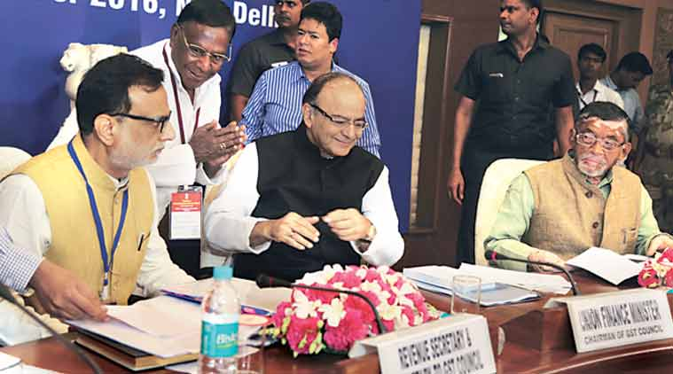Puducherry Chief Minister V Narayanasamy greets Finance Minister Arun Jaitley, Revenue Secretary Hasmukh Adhia and MoS for Finance Santosh Gangwar at the GST Council meeting in New Delhi on Thursday.(Express Photo: Renuka Puri)
Day one of the Goods and Services Tax (GST) Council meeting brought to the fore divergent views regarding threshold for annual turnover for the applicability of the indirect tax on Thursday. While 11 BJP-ruled and smaller states agreed for an annual turnover limit of Rs 10 lakh, 12-13 states agreed for a threshold limit of Rs 25 lakh. Delhi asked for a threshold limit higher than Rs 25 lakh, while 7-8 states, including Uttar Pradesh, had contentions regarding the two slabs of turnover limit for exclusion from levy of the GST.
Government officials indicated that a final view on the matter will be taken in subsequent meetings. “With regard to threshold for exemptions, there are two sets of suggestions which have come. We have to converge on both views, and both on officers and ministers track. We will continue the meeting tomorrow (Friday) and thereafter we will be able to converge to one particular figure as far as the exemptions are concerned,” finance minister Arun Jaitley said after the meeting.
Delhi’s finance minister and Deputy Chief Minister Manish Sisodia said the opinion regarding the turnover threshold for GST levy was divided and it will be taken up for discussion by the council when they meet later.
Currently, the threshold for Value Added Tax (VAT) is Rs 10 lakh in most states. A panel headed by Chief Economic Adviser Arvind Subramanian had last December suggested a higher annual turnover threshold of Rs 40 lakh, above which GST will be levied on traders.
Some states such as Tamil Nadu and Uttar Pradesh also demanded higher weightage from the existing one vote per state, citing higher population and contribution to the country’s GDP. The demand was overruled and the present voting structure with two-third votes of states and one-third vote of Centre will continue. To adopt a resolution, a three-fourths majority will be required.
The Centre and states, however, agreed on the timeline for GST to be rolled out from April 1, 2017, with the Union finance minister stating that the timetable has been set keeping the intended April 1 deadline in mind. “The target also involves the passage of CGST and IGST laws in Parliament and then by the state legislatures the state GST law in the winter session itself … Today, starting from September 22, we roughly have two months time till November 22 to resolve all outstanding issues and therefore a draft timetable was given which also has been adopted,” Jaitley said.
A consensus on compounding scheme for traders was arrived at the GST Council meeting, with a flat 1-2 per cent tax rate for traders with gross turnover cut-off of Rs 50 lakh, Revenue Secretary Hasmukh Adhia said. The composition scheme provides for easier method of calculating tax liability and it allows option for GST registration for dealers with turnover below the compounding cut-off to reduce the administration cost associated with collection of tax from small traders.
Also, states and Centre agreed on the continuation of the Empowered Committee of State Finance Ministers. Adhia, however, said that the committee will not discuss any issue related to GST but will focus on other state-related issues such as devolution of taxes to states and Plan finance. There was no decision regarding the selection of vice chairman for the newly constituted GST Council in Thursday’s meeting.
“If there is need of voting, then he will be selected by that process. Otherwise, if there is consensus for one candidate, then he will be elected as the vice chairman,” Adhia said.
There was no discussion on GST rates by the Council and it will be taken up in its subsequent meetings. “The GST Council at the end of its meeting tomorrow (Friday) will decide on the dates for the next meeting of the Council. The Council will meet for a number of days in quick succession so that other issues such as fixation of the rate etc, and whatever is outstanding from today’s meeting could be worked out,” Jaitley said.
The GST Council, at its meeting on Friday, will also discuss issues of dual control and compensation.
There will also be clarity regarding the selection of base year for purpose of calculation of compensation to states for loss suffered due to GST.

Centre, States Spar over 3 Key Issues, Eye April GST Rollout

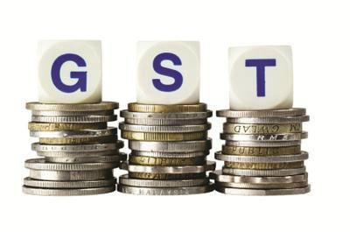
NEW DELHI: It is likely to be a stormy Friday at Vigyan Bhawan where the Centre and the states will tackle at least three contentious issues even as they agreed to try and roll out goods and services tax from April.
Already, deciding the threshold for imposing GST is proving to be a tough task, given that states such as Uttar Pradesh, Tamil Nadu and those from the North East believe that keeping units with a turnoverof under Rs 25 lakh outside the cap will result in massive revenue loss. For the north eastern states, this threshold would mean that 80-85% of the units would be out of the tax net. Uttar Pradesh, which said that around 8% of the units would go out of the net, also argued for keeping the threshold at Rs 10 lakh.
"With regard to composition (scheme) we have finalised our proposal which has been unanimously accepted by the members. With regard to threshold for exemptions, there are two sets of suggestions which have come. We have converged those two different views... we will continue the meeting tomorrow and thereafter, so that we are able to converge to one particular figure as far as the exemptions are concerned," finance minister Arun Jaitley told reporters.

Revenue secretary Hasmukh Adhia said a consensus on compounding or composition scheme was reached which decided that traders with gross turnover of up to Rs 50 lakh will pay 1-2% tax. The scheme provides for an easier method of calculating the tax liability by allowing option for GST registration for dealers with turnover below the cut-off to opt for compounding and avoid the "normal track", which comes with more paperwork.
While the other two controversial issues -the compensation formula and the demand for state control over units with turnover are yet to be decided -will be discussed on Friday, state finance ministers indicated that there was a wide gap in the Centre and the states' stand. For instance, the finance ministry has proposed that the average revenue growth for the previous three years be taken to calculate the compensation formula. Ministers from Kerala and Tamil Nadu instead want the average for the best three out the last six years to be taken to calculate the average growth. This will result in the possibility of the Centre having to shell out higher compensation, something that it is not keen on.
On the issue of cross-empowerment, several states led by West Bengal want that units with turnover of up to Rs 1.5 crore to be under the exclusive domain of states for audit and collection purposes. Again, this is not acceptable to the Centre.
Sources said that even some of the BJP states such as Gujarat want discussion on a few issues.

Disclaimer : The news in the GST Corner is purely according to the information available in public domain and does not necessarily reflect the views of ICSI. Any person wishing to act on the basis of this document should do so only after cross checking with the original source.

