**GST HEADLINES**

**August 23, 2016**

**More States Riding on GSTN Tech to Roll Out GST Reform**

**[Source : The Economic Times]**

**Chhattisgarh Assembly Passes GST Bill, Becomes Fifth State To Do So**

**[Source : The Indian Express]**

**Congress-Ruled Himachal Pradesh, Chhattisgarh Ratify GST Bill**

**[Source : Livemint]**

## 

**Chhattisgarh Assembly passes GST Bill, becomes fifth state to do so**

## Before Chhattisgarh, Himachal, Assam, Jharkhand and Bihar became the first four states to pass the bill.

|  |  |  |
| --- | --- | --- |
|  |  |  |

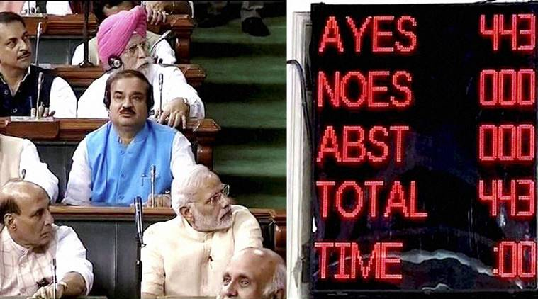Prime Minister Narendra Modi, Home Minister Rajnath Singh and Union Ministers during the voting on the GST Bill in the Lok Sabha during its Monsoon session in New Delhi. (Source: PTI Photo / TV GRAB)

The Chhattisgarh Assembly on Monday unanimously ratified the Goods and Service Tax (GST) Constitution Amendment Bill becoming the fifth state to pass the bill. Earlier today, Himachal Pradesh state assembly too passed the Bill unanimously.

Before Chhattisgarh, Himachal, Assam, Jharkhand and Bihar became the first four states to pass the bill. In New Delhi, the Aam Aadmi Party government only last week said it will place the GST Bill for ratification before the Delhi Assembly during its 4-day session beginning August 22 if it receives official communication about the Bill from the Centre.

Meanwhile, the state assembly of Gujarat convened special sessions to ratify the Bill that was passed by Parliament earlier this month.

The Constitution (122nd Amendment) Bill for the roll-out of the Goods and Sevices Tax (GST) was passed by the [Lok Sabha](http://indianexpress.com/tag/lok-sabha/) earlier in August, with 443 members present in the House voting in favour of the legislation. [Arun Jaitley](http://indianexpress.com/profile/politician/arun-jaitley/) had, earlier in August, announced that the deadline for the rollout of the bill was April 1, 2017.

The GST bill, seen as single biggest tax reform in a long time, needs to be ratified by at least 15 state legislatures before the President can notify the GST council which will decide the new tax rate and other issues.

The government had been working overtime to get states on board over the GST following the passage of the bill in Parliament. It is keen to bring two bills aimed at implementing the new tax regime in the winter session to meet the April 2017 deadline for its rollout.

**Congress-ruled Himachal Pradesh, Chhattisgarh ratify GST bill**

Himachal Pradesh and Chhattisgarh join Assam, Jharkhand and Bihar in endorsing the constitutional amendment bill for the goods and services tax

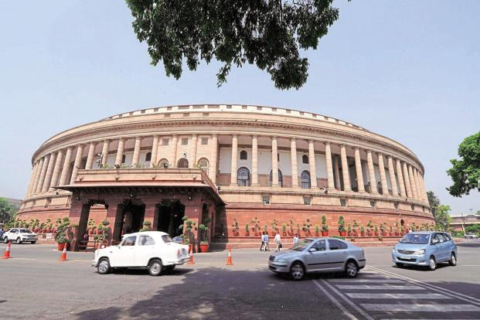

The GST bill received parliamentary approval earlier this month. The bill needs to be ratified by 50% of Indian states before it can be sent for presidential assent. Photo: AFP

Himachal Pradesh and Chhattisgarh on Monday ratified the constitutional amendment bill for the goods and services tax (GST), the former becoming the first Congress-ruled state to ratify the legislation.

“Himachal Vidhan Sabha has passed the GST bill. With this bill, it will ease the burden of crores of rupees on the state of Himachal,” chief minister Virbhadra Singh told reporters.

Himachal Pradesh and Chhattisgarh join Assam, Jharkhand and Bihar in endorsing the bill. While Assam and Jharkhand are ruled by the Bharatiya Janata Party (BJP), Bihar, led by the Janata Dal (United) government, became the first non-BJP-governed state to ratify the bill.

The Congress had initially opposed the bill, forcing nearly a year’s delay. It was only after the BJP-led central government conceded some of its demands that the party rallied behind the legislation.

“Today, Chhattisgarh assembly unanimously ratified the historic GST constitution amendment bill. I thank everyone for their support. Heralding of GST era will reinforce CG’s revenue, improve in ease of doing business & make taxation system more transparent,” Chhattisgarh chief minister Raman Singh tweeted.

The 122nd constitution amendment bill received parliamentary approval earlier this month. The bill needs to be ratified by 50% of Indian states before it can be sent for presidential assent.

*Mint* [**reported**](http://www.livemint.com/Politics/k7dQkHagy4EKfs666xBE9L/GST-Bill-likely-to-be-ratified-by-seven-more-states.html)last week that other states are in the process of calling a special sitting of legislative assemblies to ratify the GST bill. This includes the Trinamool Congress-led West Bengal assembly and the BJP-led governments in Gujarat, Haryana and Maharashtra.

GST is a far-reaching tax reform that aims to forge a common market and remove inter-state barriers to movement of trade in goods and services. It will subsume most indirect taxes levied by the centre and the states, including excise duty, service tax, value-added tax, luxury tax, entertainment tax and entry tax.

*Disclaimer : The news in the GST Corner is purely according to the information available in public domain and does not necessarily reflect the views of ICSI. Any person wishing to act on the basis of this document should do so only after cross checking with the original source.*