GST HEADLINES
December 22, 2016

Two-day meeting of GST Council begins today in Delhi

[Source: Hindustan Times]

Two-day meeting of GST Council begins today in Delhi
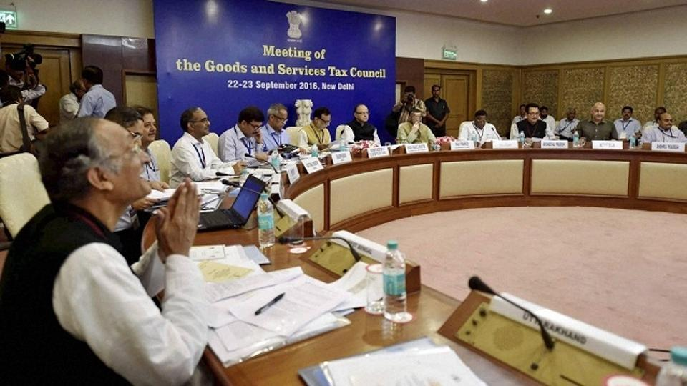

The Goods and Services Tax (GST) Council will begin its two-day meeting in New Delhi on Thursday. (PTI File Photo)

The Goods and Services Tax (GST) Council will begin its two-day meeting in New Delhi on Thursday to consider the model laws and iron out differences on the issue of jurisdiction over assesses in the new indirect tax regime.
This will be the seventh meeting of the Council and Union Finance Minister Arun Jaitley will chair the meeting.
GST Council in its last meeting had cleared 20 chapters of the model GST law and today they will discuss the remaining seven chapters.
Earlier, the council have taken several important decision.
The decision includes the threshold limit of 20 lakh rupees exemption from levy of GST for normal states and 10 lakhs for the Special Category States.
Besides, to compensate states for five years for loss of revenue due to implementation of GST, the base year for the revenue of the State would be 2015-16 and a fixed growth rate of 14% will be applied to it.
The government has time till September 16 next year to implement the GST Act as per the Constitution Amendment Bill passed by both the Houses with two-thirds majority and by half of the states.
Disclaimer: The news in the GST Corner is purely according to the information available in public domain and does not necessarily reflect the views of ICSI. Any person wishing to act on the basis of this document should do so only after cross checking with the original source.

