GST HEADLINES
November 22, 2016

Central, State Officials Discuss GST Rate on Goods, Services

[Source: Money Control]

IRS Officers Demand GST Assessments by Centre

[Source: The New Indian Express]

Central, State Officials Discuss GST Rate on Goods, Services

Tax officers of both central and state governments today discussed various aspects of draft GST laws, the tax rate on various goods and services and exempted ones under the indirect tax regime, which is likely to kick in from April next year. Revenue Secretary Hasmukh Adhia chaired the meeting to finalise the draft GST laws and the meeting would continue tomorrow. Officials said the report of the officers committee will be taken up by the GST Council, which is headed by Union Finance Minister and has state ministers as members, at its next meeting on November 25. At its last meeting, the Council agreed on a four-slab structure - 5, 12, 18 and 28 per cent - along with a cess on luxury and 'sin' goods, including tobacco. Under the structure, the clean energy cess and that of luxury items and demerit goods will be utilised to create an Rs 50,000 crore fund every year which will be utilised to compensate the states for first five years of GST rollout. With a view to safeguarding the interest of poor and keeping inflation in check, it has been decided that half the items in the CPI basket like foodgrains will not be taxed at all. However, the committee of state and central officers will have to together work out the final list of items for each tax bracket. There have been indications that soap, oil, shaving stick, toothpaste and such products will likely fall in the 18 per cent bracket, similar to most services. Finance Minister Arun Jaitley has already said the tax incidence on goods will be worked out in a manner such that the GST levy will be somewhere close to the current tax rate (excise duty plus VAT). The items and the tax bracket will form part of the Central GST (CGST) legislation, which the GST Council will take up for discussion at its meeting on Friday. The meeting will also approve the Integrated GST (IGST) and the draft compensation law. The GST Compensation Bill will provide a legal backing to the Centre's promise to compensate the states if their revenue growth rate falls below 14 per cent in the first five years of the GST rollout. The base year for calculating the revenue of a state has been decided as 2015-16.

IRS officers demand GST assessments by Centre
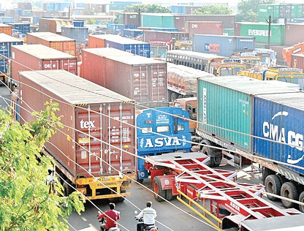

NEW DELHI: The Indian Revenue Service (Customs and Central Excise) officers’ association wants the centre to firmly control service tax assessees under the Goods and Services Tax (GST) having a turnover of less than 1.5 crore. This concern has been raised after a few states like Tamil Nadu demanded control over them.
In a letter to Finance Minister Arun Jaitley, they apprehended a rise in black money and tax evasion if states are given control over such assesses.
Other than West Bengal, Kerala, Tamil Nadu, Bihar, Delhi and Odisha, commercial tax officers all over the country working under the state government’s jurisdiction have supported demands for controlling service tax payers having lesser turnover than `1.5 crore.
The move towards GST is aimed at simplifying the tax structure, widening the tax base, reducing tax-evasion and incentivising the honest tax payers. It is supposed to be a win-win situation for all the stakeholders including the taxpayers, Central and state government.
The association representing 2000 IRS officers said that the very root and premise of the GST is in conflict with the proposal of state governments controlling assesses with a revenue turnover of less than 1.5 crore. Tax evasion will become rampant and there will be chaos and confusion amongst assesses due to different interpretations of issues.
The letter also states the despair and anguish of the 200 young IRS officers who were recruited every year since 2008 to implement GST.

Disclaimer: The news in the GST Corner is purely according to the information available in public domain and does not necessarily reflect the views of ICSI. Any person wishing to act on the basis of this document should do so only after cross checking with the original source.

