GST HEADLINES
November 21, 2016

GST: Consensus Eludes on Jurisdiction over Assessees

[Source: The Financial Express]

Positive Protest on GST: States Tax Officers work on Sunday

[Source: Business Standard]

GST: Consensus eludes on jurisdiction over assessees

The Centre and states today failed to reach a consensus on who will control which set of assessees under GST.
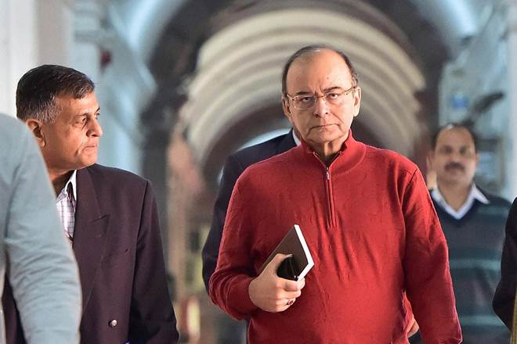
Today’s meeting, which came ahead of the formal meeting of the all powerful GST Council on November 25, was held after the Centre and states were deadlocked over the issue at two previous meetings.

The Centre and states today failed to reach a consensus on who will control which set of assessees under GST. The GST Council will meet again on November 25 to work out the modalities. The informal meeting of Union Finance Minister and his state counterparts was called to break the political deadlock on sharing of administrative control under the proposed goods and services tax (GST) regime. “The meeting has remained incomplete. Discussions will continue on November 25,” Finance Minister Arun Jaitley told reporters after the meeting.
Today’s meeting, which came ahead of the formal meeting of the all powerful GST Council on November 25, was held after the Centre and states were deadlocked over the issue at two previous meetings.
The government aims to roll out GST, which will subsume excise, service tax and local levies, from April next year
Officers of both central and state governments will meet tomorrow and try to workout a solution.
States like Uttarakhand, West Bengal, Uttar Pradesh, Tamil Nadu and Kerala have insisted on exclusive control over small businesses, which earn less than Rs 1.5 crore in annual revenue, for both goods and services.
They feel states have infrastructure deployment at grass root level and small taxpayers are familiar with state authorities.
The Centre, on the other hand, is unagreeable to the demand as it wants single registration mechanism for ease to service taxpayers.
Instead of horizontally splitting the taxpayers — tax payers with Rs 1.5 crore revenue with states and those above with Centre — it has proposed to divide entire taxpayer base vertically, wherein taxpayers are divided between the Centre and states in a fixed proportion.
As a compromise, it is willing to give states administrative power over 2/3rd of the taxpayer base, with service tax continuing to be administered by Centre.
An official said the informal meeting was held sans civil servants to arrive at a political solution.
Uttarakhand Finance Minister Indira Hridayesh said states demanded control over both goods and service tax assessees of Rs 1.5 crore and below.
At present, the estimated total indirect tax payer base, including value-added tax, service tax and excise, is around 10 million, of which around 0.4 million are common to the Centre and the states.
This leaves around 9.6 million taxpayers, of which around 6.6 million are value-added tax assessees, 2.6 million are active service tax assessees and around 0.4 million are registered under excise.
Under the new system, the states and Centre will collect identical rates of taxes on goods and services. For instance, if 18 percent is the GST rate on a good across the country, the states and the Centre will get 9 percent each, called the CGST and SGST rates.
The Centre will also levy and collect the Integrated Goods and Services Tax (IGST) on all inter-state supply of goods and services.
The IGST mechanism has been designed to ensure seamless flow of input tax credit from one state to another.
The dual control issue, which was deadlocked in the third and fourth GST Council meetings, has risen because multiple taxes levied by the Centre and the states at present will now be integrated into one tax under the GST regime, which is aimed at removing inter-state barriers to trade and integrating India into one common market.
The next GST Council meeting is to finalise four supplementary bills dealing with CGST, SGST, IGST and the compensation law.
At the last meeting, the Council agreed on a four-slab structure – 5, 12, 18 and 28 per cent — along with a cess on luxury and ‘sin’ goods such as tobacco.
Jaitley had earlier this month stated that the proposed GST needs to be rolled out by September 16, 2017, within one year of the Constitution (101st Amendment) Act, 2016 being brought into force.

Positive protest on GST: States tax officers work on Sunday

The All India Confederation of Commercial Taxes Association wants a fair share in the administration of taxes under the GST regime
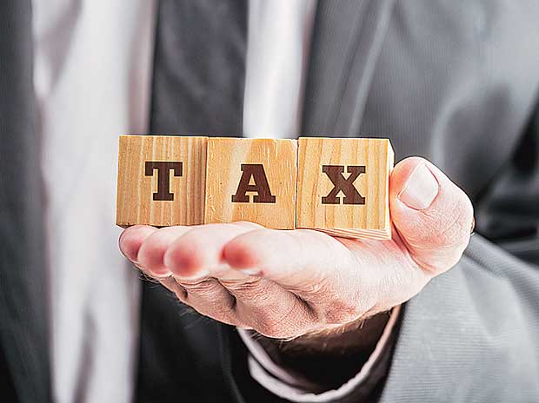

Adopting an innovative "positive form of protest", tax officers working with various state governments came to work today on a holiday to press for their demand of having a fair share in the administration of taxes under the GST regime.
The All India Confederation of Commercial Taxes Association (AICCTA), which claims to represent over 36,000 Gazetted officers and about two lakh employees of Class-III and IV categories, had given a call for this positive form of protest by working on Sunday.
The Uttarakhand Commercial Tax Service Association and similar associations of other states, following directions from AICCTA, joined this protest by coming to work on their weekly off day as a normal working day from 10 am to 5 pm.
Uttarakhand Commercial Tax Service Association president Yashpal Singh, who is also head of the NCR chapter of AICCTA, said a considerable number of employees across at least 15 states came to work today while details from other states were also pouring in.
An association representative said the move is part of continued protest of states commercial tax departments under AICCTA for their just rights in the GST regime.
The AICCTA has said its members will also go on day-long "pen down strike" on November 23 if their demands are not accepted by the government.
The confederation has sought complete authority relating to monitoring, audit, assessment and enforcement activities provided either under the GST Act or under the Integrated Goods and Services Tax -- to be levied on all inter-state supplies of goods and services.
"It is also demanded that the state authorities should also be empowered under IGST Act to administer matters relating to interstate transactions," as per a memorandum submitted to the Finance Ministry.
The officers' body has sought representation of officers from the states in GST council secretariat.
"It is demanded that the GST council provide sufficient funds to the states to establish a uniform infrastructural and networking system," it said.
The proposed GST is a single tax on supply of goods and services, right from the manufacturer to the consumer.
The 'positive protest' today took place on a day when Union Finance Minster Arun Jaitley had called an informal meeting of all the state finance ministers.
"This is also symbolic of the fact that the state tax departments are serious and sensitive towards their job of collection of tax.
"This also reflects the fact that the state tax administration is responsible towards its responsibilities," an association representative said.
The state tax departments, by working on a weekly off want to reiterate that they are neither against GST nor against state governments but want to protest against any bias in administration of the new GST regime, he added.

Disclaimer: The news in the GST Corner is purely according to the information available in public domain and does not necessarily reflect the views of ICSI. Any person wishing to act on the basis of this document should do so only after cross checking with the original source.

