GST HEADLINES
October 19, 2016

Four-Tier GST Structure Proposed: Low of 6 Per Cent to High of 26 per cent, Extra on Luxury Goods

[Source: The Indian Express]

Four-Tier GST Structure Proposed: Low of 6 Per Cent to High of 26 per cent, Extra on Luxury Goods

The GST Council finalised the compensation formula for states for potential revenue loss, converging at an assumption of 14 per cent revenue growth rate over the base year of 2015-16

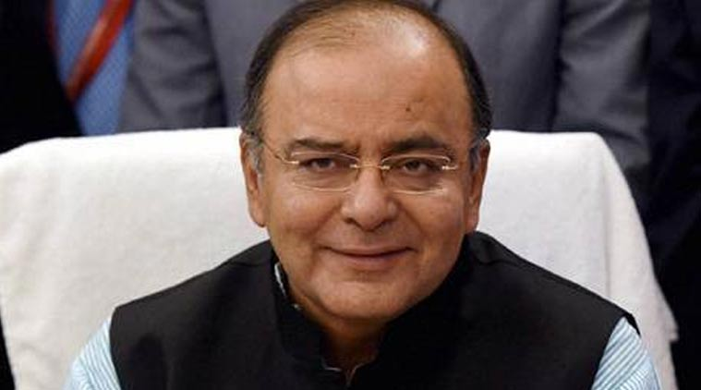

The Finance Minister said that all decisions of the GST Council are being taken with consensus.
A four-tier structure for Goods and Services Tax (GST) comprising a lower rate of 6 per cent, two standard rates of 12 per cent and 18 per cent, and a higher rate of 26 per cent with an additional cess for luxury and demerit goods were proposed in the third meeting of the GST Council Tuesday.
The higher rate for services under the indirect tax regime is proposed to be 18 per cent, while essential services such as transportation are proposed to be taxed at 6 per cent or 12 per cent.
Around 70 per cent of the taxable base is proposed to be taxed at either18 per cent, 12 per cent or 6 per cent, with more than 50 per cent of the items to be taxed at 12 per cent or 18 per cent. Ultra-luxury items like high-end cars and demerit goods like tobacco, cigarettes, pan masala and aerated drinks, comprising about 25 per cent of the taxable base, would attract an additional cess over and above the higher rate of 26 per cent, Revenue Secretary Hasmukh Adhia told reporters after the meeting.
Gold is proposed to be taxed at 4 per cent.
The collections from the proposed cess on luxury or demerit supplies over and above the higher tax slab are estimated to be around Rs 50,000 crore, out of which around Rs 26,000 crore will be collected through clean environment cess, Adhia said, adding that the cess collections will be exclusively used by the Centre to compensate states.
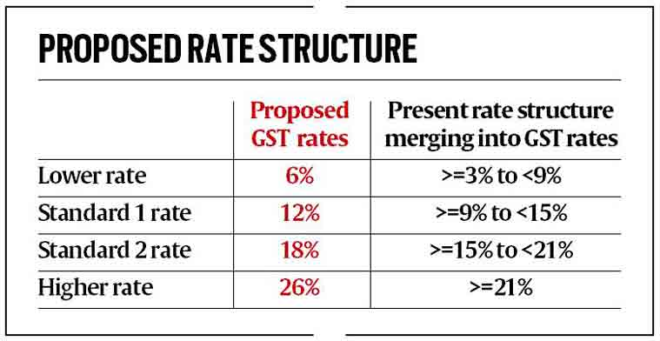
In its presentation at the meeting of the GST Council, which is headed by Finance Minister Arun Jaitley and has representatives of all states, it was said that the total impact of the proposed rate structure on Consumer Price Index (CPI)-based inflation rate will be (-) 0.06 per cent.
Under the proposed GST rate structure, the inflation impact on constituents of CPI such as health services, fuel and lighting and clothing is estimated to be 0.56 per cent, 0.05 per cent and 0.23 per cent, respectively, while for transport it is estimated at (-) 0.65 per cent, education at (-) 0.08 per cent and housing at (-) 0.09 per cent. Total revenue collection under the proposed GST structure is estimated at Rs 8.72 lakh crore (based on 2015-16 estimates).
During the meeting, it was discussed that the GST rate should not be regressive in nature and be such that the existing revenues of states and Centre are protected and the impact on CPI inflation is minimal. It was said that the items being consumed by upper middle class and rich, which are being taxed at higher rate presently, should not be taxed at a rate lower than their present tax incidence, while items of mass consumption should not be taxed at a higher rate.
It was discussed that the items which are exempt from excise (currently at 300) and are taxed at a lower VAT rate of 5-6 per cent can be taxed at 12 per cent, while items with at least 27 per cent tax incidence can be taxed at a standard rate of 18 per cent under the GST regime. Items presently being taxed at standard rate by both Centre and states are proposed to be kept in higher tax slab.
Jaitley said: “The broad approach has been that the rate structure should be such that it does not lead to any further CPI inflation, states should have adequate revenue and so also the Centre, so as to discharge their obligations, and this has to be blended with only the least possible burden which has to be put on the taxpayer. The revenue model should be such that it has some additional resources which could be used for revenue payment, for compensation payment to any losing state.”
Last year, a committee headed by Chief Economic Adviser Arvind Subramanian had recommended a revenue neutral rate (RNR) of 15-15.5 per cent and standard rate of 16.9-18.9 per cent for the proposed GST and a high rate of 40 per cent for luxury goods.
“There are five alternative options for rates that have been worked out. It will be discussed tomorrow,” Jaitley said, adding that after the decision on rates, the technical group of officers will decide which group of items will be put into which category of rate.
The GST Council finalised the compensation formula for states for potential revenue loss, converging at an assumption of 14 per cent revenue growth rate over the base year of 2015-16 for calculating compensation for states in the first five years of implementation of GST. States getting lower revenue than this would be compensated by the Centre.
The Finance Minister said that all decisions of the GST Council are being taken with consensus. “So far between the last two meetings and today, we have been, one by one, reaching a consensus on each issue and so far, all decisions have been taken by consensus. And the object is to keep on discussing and re-discussing even when there is no agreement on the first instance and takes as many decisions possible by consensus and, to the extent possible, avoid a situation where we have to put an issue to vote. So far, we have achieved that objective,” he said.

Disclaimer: The news in the GST Corner is purely according to the information available in public domain and does not necessarily reflect the views of ICSI. Any person wishing to act on the basis of this document should do so only after cross checking with the original source.

