**GST HEADLINES**

**September 19, 2016**

**Government Plans Rs. 4000- Crore Overhaul of 80 Check Posts for GST**

**GST may have Multiple Rates Initially, No RNR Too: Revenue Secretary Hasmukh Adhia**

***[Source : The Economic Times]***

# GST will have a Few Tax Slabs in ‘Transition Period’

***[Source : Business Line]***

**Government Plans Rs. 4000- Crore Overhaul of 80 Check Posts for GST**

**

**GST may have Multiple Rates Initially, No RNR Too : Revenue Secretary Hasmukh Adhia**

# 

# GST will have a few tax slabs in ‘transition period’

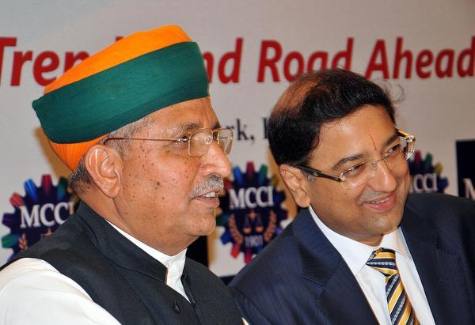

Arjun Ram Meghwal, Union Minister of State for Finance & Corporate Affairs, with Hemant Bangur, Senior V-P, MCCI, at a special session on ‘Indian Economy: Current Trends and Road Ahead’ in Kolkata - Photo: ASHOKE CHAKRABARTY

Differential rates needed to protect small manufacturers, says Minister

The Goods and Services Tax (GST) regime, which will usher in India’s biggest indirect tax reform measure, will have a few tax slabs and levy different rates in the “transition period” before migrating to a single tax structure.

According to Arjun Ram Meghwal, Union Minister of State for Finance, the tax slabs are necessary to protect sections of the manufacturing sector, which now figure in the low tax brackets.

The slab-based rates and the standard rate will be decided by the GST Council, which is expected to meet later this month.

“There are industries where the present tax rates are as low as 1 or 2 per cent. In such cases, rates cannot be at par with the standard GST one,” he said, during an interactive session organised by the MCCI Chamber of Commerce & Industry.

“Similarly, luxury goods cannot be taxed at the same standard rate. Hence, we will have different tax slabs,” he added.

Meghwal further assured city-based businessmen that GST will not lead to increased incidence of indirect taxation.

Some goods will be exempted from taxation, but the flip side was that the cost of services may move up post-imposition. Product and location-based exemptions will also be taken up by the GST Council.

“I can assure you that it (tax rate post-GST) will be not more than the present indirect taxes that you all are paying,” he clarified.

**Petro products in GST net**

Petroleum products, too, will come under GST, but at a later stage.

“Economists have told us that the purpose of introducing GST will be defeated if petroleum products are outside its ambit,” Meghwal said, while addressing a meeting at the Calcutta Chamber of Commerce.

Efforts will also be made to ensure that inflation does not cross 6 per cent after the implementation of GST.

“We have had detailed discussions with the Reserve Bank of India on the inflation issue. The inflation target is 4 per cent for the next 5 years, with plus-minus 2 percentage point swing. We will not allow inflation to go beyond this limit,” the Minister said.

*Disclaimer : The news in the GST Corner is purely according to the information available in public domain and does not necessarily reflect the views of ICSI. Any person wishing to act on the basis of this document should do so only after cross checking with the original source.*