GST HEADLINES
October 18, 2016

Rates, Compensation On GST Council Table Today

[Source :The Indian Express]

Assam Gets Off The Block With GST Registration

[Source :Livemint]

Doctors Seek 40% Sin Tax On Tobacco Under GST

[Source :Deccan Herald]

Rates, compensation on GST Council table today
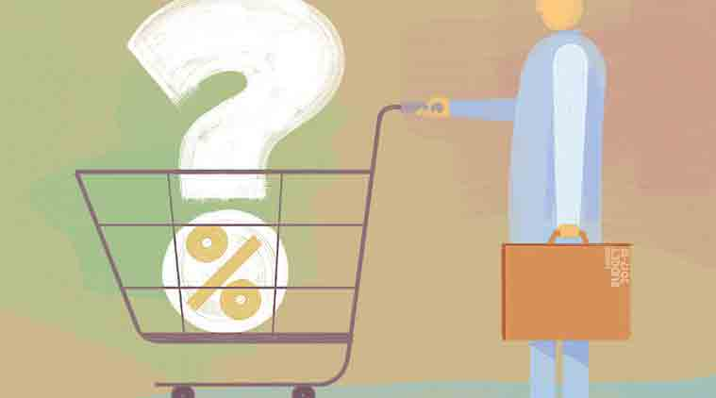
The Centre and the states are expected to take a decision on the most crucial aspect of tax rate that will have a bearing on the common man.
Finance Minister Arun Jaitley will chair the three-day meeting of the Goods and Services Tax Council starting Tuesday, which will deliberate on the issue of the likely GST rate and formula for compensating states against revenue losses under the new tax regime. To ensure that the GST dispensation starts functioning from April 1, 2017, across the country, the finance ministry has set November 22 as the deadline for building consensus on all the issues in the Council.
The Centre and the states are expected to take a decision on the most crucial aspect of tax rate that will have a bearing on the common man. Last year, a panel headed by Chief Economic Adviser Arvind Subramanian had suggested 17-18 per cent as the standard rate for bulk of goods and services while recommending 12 per cent for low-rate goods and 40 per cent for demerit ones like luxury cars, aerated beverages, pan masala and tobacco. For precious metal, it recommended a range of 2-6 per cent.
The GST Council will also deliberate on the vexed issue of the Centre retaining power to assess 11 lakh service tax filers under the new dispensation.
While a decision to this effect was taken at the first meeting of the GST Council, at least two states dithered on approving the minutes of the meeting, saying they are not in favour of losing power of assessment of these assessees.
The finance ministry will try and reach a consensus on the key issues so that the subsequent Central GST (CGST) and integrated GST (IGST) legislations can be introduced in the month-long Winter Session of Parliament beginning November 16.
At its previous meeting last month, the GST Council, which has all state finance ministers as members, had finalised area-based exemptions and how 11 states, mostly in the North-East and hilly regions, will be treated under the new tax regime.
Finance minister Arun Jaitley had last week said that the tax on environment-unfriendly products will be “distinct” from others in the GST framework. As for the formula for the Centre compensating loss of revenue to states, 3-4 alternatives were discussed at the first meet, but a decision could not be reached.
“The indirect tax regime that we are planning, the rate of taxation on such products which are going to be environment unfriendly would be distinct from the normal rate of taxation. This is one of the proposals being discussed,” Jaitley had said.
As per the proposals, a state can be compensated if the revenue under GST falls short of the average tax earnings in the best three years out of the past five years. Second, of the five years, two outliers are left out and an average is taken. If the revenue under GST is short of this, then states get compensated.
Third, a base year can be fixed and a particular growth rate decided for all states. If the revenue falls short of that, then the state gets compensated. The base year would be 2015-16.
Another suggestion was on a fixed rate of revenue growth and give compensation, he said. So far, as many as 6 issues have been settled by the GST Council, including finalisation of rules for registration, rules for payments, returns, refunds and invoices.
In the first meeting, the Centre and states had reached an agreement on keeping traders with annual revenue of up to Rs 20 lakh out of the new national sales tax ambit that will subsume all cesses.
It also resolved issues over dual control over small traders, and decided that states will have exclusive control over all dealers up to a revenue threshold of Rs 1.5 crore in a year. A mechanism will be worked out for traders above Rs 1.5 crore to ensure a dealer is regulated either by the central government or the state and not both.

Assam gets off the block with GST registration
The Assam tax department has asked goods and services taxpayers to furnish the mobile numbers and email IDs on or before 5 November, 2016
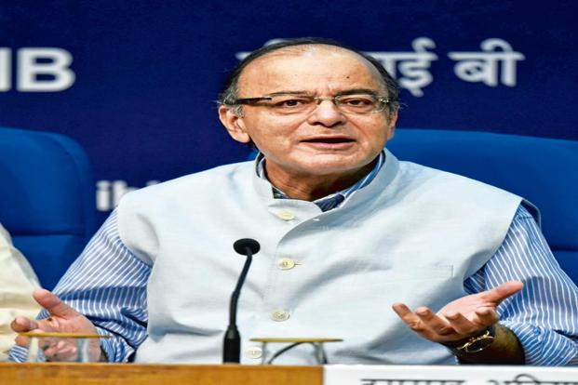
The crucial three-day meeting of GST Council starts on Tuesday.
New Delhi: Assam, the first state to ratify the Goods and Services Tax (GST) amendment bill has started the process for providing registration to taxpayers in the new indirect tax regime that is slated to kick in from April next year.
The state tax department has started collecting mobile numbers and e-mail IDs of registered dealers or taxpayers under Value Added Tax (VAT), Central Sales Tax(CST), entry tax, luxury tax and entertainment tax to provide goods and services identification number (GSTIN) on a provisional basis.
In order to facilitate communication of GST registration number to the existing registered entities, the Assam tax department has asked them to furnish the mobile number and email ID on or before November 5, 2016. Failing to submit details on time, the GST number will not be generated. Moreover, such dealers will be disabled to upload their tax returns and apply for statutory forms under the existing acts,” the department said.
It has asked the taxpayers to log into the tax department website of the Assam government and after feeding the mobile number, PAN and e-mail ID, the provisional GSTIN will be sent.
The government plans to roll out GST, which will subsume excise, service tax and other local levies, from April 2017. In the run-up to the biggest indirect tax reform, the states have to get their taxpayers registered with the pan-India GST Network, which will help in seamless movement of goods and services throughout the country. After the GST constitutional amendment bill was passed by Parliament on 8 August, Assam was the first state to ratify it on 12 August.
A constitution amendment requires ratification by 50% of state assemblies before presidential assent. With the President approving it last month, GST is now a law and the GST Council, chaired by union finance minister Arun Jaitley, will decide on the crucial tax rate in its three-day meeting beginning on Tuesday.

Doctors seek 40% sin tax on tobacco under GST

Ahead of a crucial meeting of the Good and Service Tax Council, doctors and public health campaigners asked the council to tax tobacco products uniformly at the highest GST rate of 40% in order to save millions of Indians from death.

Over the next three days, the council headed by Finance Minister Arun Jaitley is likely to decide on the GST rates for a large number of items as the Finance Ministry set up a deadline of November 22 to build consensus on contentious issues.

Doctors, public health advocates and few political leaders on Monday asked the council to accept 40% GST rate on tobacco products, including bidi and chewing tobacco, to discourage their use. “With the current tax pattern on bidi, consumers and the nation are losers whereas bidi industry owners are making profits. It is shocking that there is no tax on bidis in many states. All tobacco products should be taxed very high in the GST era”, said Pankaj Chaturvedi, oncologist, Tata Memorial Hospital, Mumbai. The anti-tobacco campaigners pin their hopes on a 2015 report made by a high-level panel chaired by Chief Economic Adviser Arvind Subramanian. The committee recommended 40% GST for tobacco and tobacco products by putting them on the demerit list.

The panel recommended to have a demerit goods rate, which would be higher than the standard rates for discouraging their use. Luxury cars, aerated beverages, paan masala, tobacco and tobacco products were recommended to be on the demerit list for 40% GST.

“The government should make tobacco prohibitively expensive in the GST era. There is no justification for giving any subsidy to a product that kills every second user prematurely,” said Trinamool Congress MP Dinesh Trivedi, a former minister of state for health.

A senior BJP leader from Bihar too supported the public health advocates. “As a health minister of Bihar I had banned gutka and raised taxes on tobacco products including bidi. I am sure the GST council will put tobacco in highest tax category. It will save millions of lives,” said Ashwini Kumar Chaube, former health minister of Bihar and BJP MP. Activists stepped up the campaign because of the health and economical burden imposed by tobacco. Each year, almost a million Indians die from tobacco-related diseases in India, while the total direct and indirect cost of diseases attributable to tobacco use was Rs 1.04 lakh crore ($17 billion) in 2011, which comes to 1.16% of GDP.

Disclaimer : The news in the GST Corner is purely according to the information available in public domain and does not necessarily reflect the views of ICSI. Any person wishing to act on the basis of this document should do so only after cross checking with the original source.

