**GST HEADLINES**

**August18, 2016**

**India Inc wants states to migrate to GST at one go**

# *[Source: Business Standard]*

# After Assam and Bihar, Jharkhand ratifies GST Bill

# *[Source: The Indian Express]*



# After Assam and Bihar, Jharkhand ratifies GST Bill

## The GST Bill, described as India's biggest tax reform, needs to be ratified by at least 15 state legislatures before the President can notify the GST Council which will decide the tax rate.

Ranchi | Updated: August 18, 2016 1:40 am

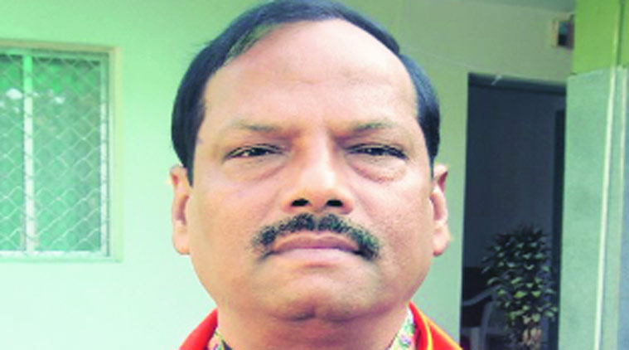Jharkhand CM Raghubar Das.

Jharkhand on Wednesday became the third state after Assam and Bihar to ratify the Goods and Services Tax (GST) Bill that was recently passed by Parliament. The Bill was ratified unanimously during the one-day extension of the Monsoon Session convened to discuss and ratify it.

*Disclaimer: The news in the GST Corner is purely according to the information available in public domain and does not necessarily reflect the views of ICSI. Any person wishing to act on the basis of this document should do so only after cross checking with the originalsource.*