GST HEADLINES
November 17, 2016

No Rates in Draft GST Bills That Centre Circulates With States

[Source: Business Standard]

Government Unlikely To Bring GST Bills Soon

[Source: Business Standard]

No rates in draft GST Bills that Centre circulates with states

Bills likely to be introduced as money Bills

21
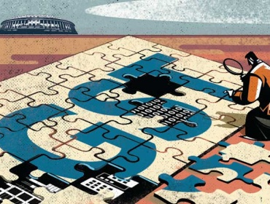

The Centre has circulated the draft goods and services tax (GST) Bills with the states, but it does not contain the four-slab rates agreed to by the GST Council earlier. The Union government has also circulated the draft compensation Bill with states.

With a heated debate on in Parliament over the government’s demonetisation move, the Centre is likely to introduce the Central GST and integrated GST Bills in late November or early December in the ongoing session in the form of money Bills, a move that may draw flak from the Opposition.

The GST Council, a body having representation from the Centre and states, will discuss these Bills on November 24 and 25.

While the Centre and the states have already decided on four-tier GST rates – five%, 12%, 18% and 28% – these rates did not find mention in the GST Bills, sources said.

“Rates are not a part of the Bills at the moment. Most probably, powers will be taken to notify exemptions and rates. Even today, the Central Board of Excise and Customs notifies these,” one of the sources said.

It has also not yet been decided how to ring-fence these rates, one of the crucial demands of the Congress, sources added. “There is no finality as of now on how rates will be ring fenced.”

The Centre will have to clear CGST, IGST and compensation Bills in Parliament and states SGST Bill in their respective assemblies before GST could be rolled out from April 1, 2017.

States will be given seven days to suggest changes or improvement to the draft laws for GST, after which these will be taken up by the GST council, sources said.

The Centre is likely to introduce the CGST and IGST Bills in the second half of the winter session – November-end or early-December. With the Opposition attacking the ruling dispensation in Parliament over the demonetisation issue, the government is unlikely to bring three Bills related to GST in the coming days.

CGST and IGST Bills are likely to be money Bills, a source in the Parliamentary Affairs Ministry said. This might draw criticism from the Opposition, which wants it to be tabled as finance Bill because the Rajya Sabha, where they have an upper hand, does not have the power to shoot down money Bills.

The GST Compensation Bill will provide legal backing to the Centre’s promise to compensate states if their revenue growth rate falls below 14% in the first five years of the GST rollout. The base year for calculating the revenue of a state has been decided as 2015-16.

The compensation law would have the taxes subsumed and the revenue forgone by each state on account of GST rollout.

It will give the details on how the Centre plans to raise funds for compensating the revenue loss. The Centre and states had earlier agreed on around 28% tax on high-end cars, tobacco, pan masala and aerated drinks to compensate states. Also, clean energy cess would not be subsumed into GST and would be used for funding compensation. Once the requirement of compensation is over in five years of the GST rollout, these cesses would cease to exist.

The Bill would also specify how much revenue is being raised from which item by way of levy of cess and also the way it is reimbursed to the states, leaving no room for ambiguity.

It would also specify at the end of five years if there is a surplus in the cess pool and in what proportion it should be allocated between the Centre and states.

Government Unlikely to Bring GST Bills Soon

With the united opposition attacking the ruling dispensation in Parliament over the demonetisation issue, the government is unlikely to bring three bills related to GST in the coming days and hopeful of pushing them in latter half of the winter session which began today.

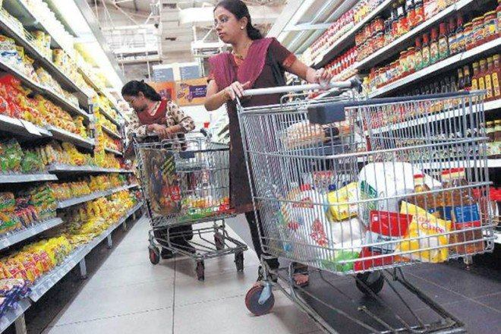
The government is keen to push the passage of three legislations related to the main GST bill in the ongoing winter session, as Parliamentary nod for these bills is must for rolling out GST from the target date of April 1, 2017. (Reuters)

With the united opposition attacking the ruling dispensation in Parliament over the demonetisation issue, the government is unlikely to bring three bills related to GST in the coming days and hopeful of pushing them in latter half of the winter session which began today.
The government is keen to push the passage of three legislations related to the main GST bill in the ongoing winter session, as Parliamentary nod for these bills is must for rolling out GST from the target date of April 1, 2017.
The three bills related to GST are–the Central Goods and Services Tax Bill, the Integrated Goods and Services Tax Bill, the Goods and Services Tax (Compensation for Loss of Revenue) Bill.
The government is hopeful of passage of the three GST bills in the winter session, which are likely to be introduced in either third or fourth week of the session, a source said.
As per the GST Constitution Amendment Bill, which was notified on September 17, 2016, the government is required to complete the process of implementation of GST within a year.
The all powerful GST Council, which is chaired by the Finance Minister and has representations from state, had already decided on a four-tier rate structure–5, 12, 18 and 28 per cent–with a cess over and above the peak rate for luxury and demerit goods.
The issue of dual control, which deals with who will control which set of assessees under GST, has been holding back the negotiations between the Centre and the states.

Disclaimer: The news in the GST Corner is purely according to the information available in public domain and does not necessarily reflect the views of ICSI. Any person wishing to act on the basis of this document should do so only after cross checking with the original source.

