GST HEADLINES
November 16, 2016

Parliament Winter Session Agenda: From GST to Corruption, Govt Looks to Get Key Bills Cleared
[Source: The Financial Express]

Gujarat Begins Migration Process under GST
[Source: Business Standard]

Parliament Winter Session Agenda: From GST to Corruption, Govt Looks to Get Key Bills Cleared

Even as the demonetisation move threatens to swamp the winter session of Parliament beginning on Wednesday, the Centre has lined up three key goods and service tax (GST) Bills for approval to roll out the new tax from April 1 next year.
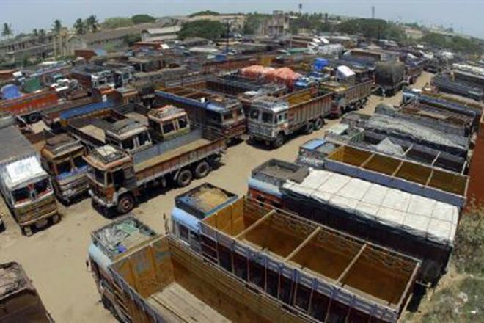

Parliament would meet for 22 sittings between November 16 and December 16. The legislative agenda included nine Bills for introduction and approval, 10 pending Bills for passing. Two Bills are listed for withdrawal. (Reuters)

Even as the demonetisation move threatens to swamp the winter session of Parliament beginning on Wednesday, the Centre has lined up three key goods and service tax (GST) Bills for approval to roll out the new tax from April 1 next year.

Parliament would meet for 22 sittings between November 16 and December 16. The legislative agenda included nine Bills for introduction and approval, 10 pending Bills for passing. Two Bills are listed for withdrawal.

It would introduce the CGST Bill, 2016, to facilitate levy of tax on supply of goods or services, the Integrated GST Bill, 2016, to levy of tax on inter-state supply of goods or services and the GST (Compensation for Loss of Revenue) Bill, 2016, to facilitates payment of compensation to states for any loss of revenue arising under the GST regime.

The Centre aims to get Parliament’s nod to these three Bills during the session. While most political parties have broadly supported and made considerable progress in addressing issues such as GST rates, a few sticky issues such as on jurisdiction of assessees between the Centre and states, needed to be sorted out. The GST Council, the apex decision making body on the matter, is expected to sort out all issues by November 24-25.

Among others, the Centre would push the Prevention of Corruption (Amendment) Bill that primarily seeks to protect officers who have taken honest decisions that could go wrong later on. It requires prior sanction to prosecute former officials, makes giving a bribe an offence and modifies the definition of taking a bribe.

Three Bills for reforms in labour laws, pending in either House of Parliament, would also be taken up. The Factories (Amendment) Bill, 2016 seeks to enhance the limit of overtime work hours and empowers central government to make exempting rules related to overtime hours. It was approved by the Lok Sabha in August this year, but pending in the Rajya Sabha. The Employee’s Compensation (Amendment) Bill, 2016 requires an employer to inform the employee of his right to compensation under the 1923 Act and imposes a penalty for failure to inform. It is pending in the Rajya Sabha.

Gujarat begins Migration Process under GST

State will enroll about 466,000 traders on Goods and Services Taxpayer Identification Number
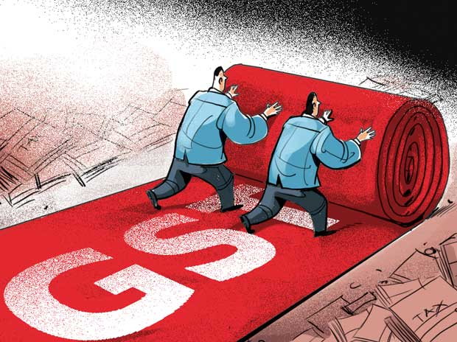
Gujarat government on Tuesday began migrating commercial tax payers from existing tax platform such as value added tax (VAT) to the new goods and service tax (GST) platform.

According to deputy chief minister of Gujarat, Nitin Patel, the state will enroll about 466,000 traders on Goods and Services Taxpayer Identification Number.

"We are well prepared to implement GST on April 1, 2017 and as part of it the state government has started migration process for commercial taxpayers. As of now businesses registered till August 31, 2016 will migrate on GST platform while the rest can be migrated from January 2017," said Nitin Patel, deputy chief minister of Gujarat.

The state government claimed that the trading community need not engage in any physical transaction for migration on GST platform. Once user login into the VAT portal, a popup window with one time login and password will appear and it will direct the user to the GST portal where the user can fill required fields and submit scanned documents.

"Union finance department has been providing technical guidance to the states and we are also providing guidance to the traders. Moreover, we will jointly work with various trade associations to assist small traders and businessmen for the migration. Commercial tax department has started special help desk for this purpose," said Patel.

With provision of special incentives to industries being disabled after GST implementation, the state government may make special provisions to give incentives to the industries in the state budget. Moreover, it is also planning to rework existing policies for the same, Patel said, without divulging further details on the move.

After implementation of GST, government will audit 5% of registered traders every year. Currently VAT department's audit ratio is 7%.

To formalise division of work between state government and central government, the GST council will meet on November 20 in which finance ministers of all the states will be present.

Disclaimer: The news in the GST Corner is purely according to the information available in public domain and does not necessarily reflect the views of ICSI. Any person wishing to act on the basis of this document should do so only after cross checking with the original source.

