GST HEADLINES
November 15, 2016

Centre to Share Model GST Law with States Today
[Source: NDTV]

GST Meet: States to Press for Exclusive Control on Small Biz
[Source: The Indian Express]

Centre to Share Model GST Law with States Today

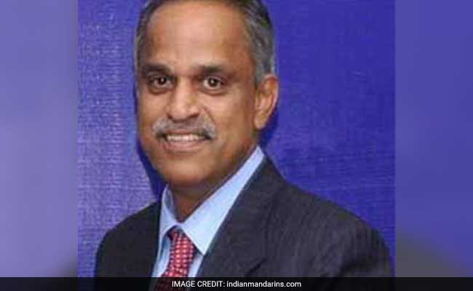
Najib Shah is the chairman of Central Board of Excise and Customs (CBEC).

NEW DELHI: The Centre will share the draft model GST law with the states today as it prepares for the rollout of Goods and Services Tax (GST) from April 1 next year, CBEC Chairman Najib Shah said on Monday.
The Centre is also working on multiple options apart from 'horizontal' and 'vertical' division for deciding on jurisdiction over tax assessees, he said.
"We are very hopeful of GST implementation from April 1, 2017. By today we will share the model GST law with the states which has been redrafted after taking into account the comments of stakeholders," Mr. Shah said while inaugurating the CBEC pavilion at the IITF.
He said the Compensation law will be shared with the states on November 16 detailing the procedure for making good revenue loss of states in the first five years of GST rollout.
The Central Board of Excise and Customs (CBEC) has taken up Goods and Services Tax as the theme for its IITF pavilion and it tries to educate people about the new taxation regime which is expected to roll out from April next year.
The GST will subsume excise, service tax, VAT and other local levies and will help in smooth movement of goods and services across the country.

The Centre and states have already decided on a four-tier GST rates-- 5, 12, 18 and 28 per cent-- but is yet to decide on the issue of cross empowerment to avoid dual control.
Differences arose with the states demanding control over 11 lakh service tax assessees, and the Centre proposing to do away with the states having exclusive control over all dealers up to an annual revenue threshold of Rs. 1.5 crore -- an issue which was settled in the first meeting of the GST Council.
The Council has arrived at an option of two proposals -- horizontal division and vertical division.
'Horizontal division' would mean taxpayers would be divided both for administrative and audit purposes based on a cut off turnover.
Those with a turnover over Rs. 1.5 crore would be administered both by the Centre and states, while those with below Rs. 1.5 crore would be administered solely by the states.
Under the 'vertical division', taxpayers could be divided in a ratio which would balance the interest of the Centre and the state, both with respect to revenue and spread of numbers.

GST Meet: States to Press for Exclusive Control on Small Biz

Jaitley has called for a political meeting on November 20 to discuss two options — horizontal and vertical division of taxpayers.

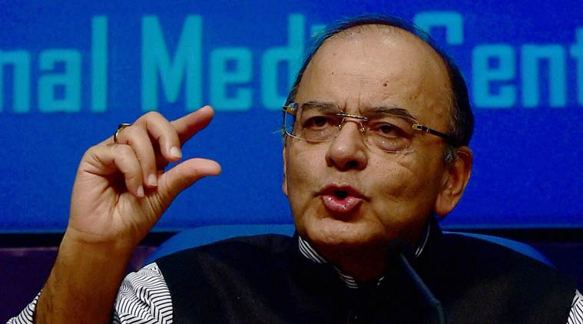
Union Finance Minister Arun Jaitley. (PTI Photo)

With a crucial informal meeting of Union finance minister Arun Jaitley with state finance ministers on GST slated for Sunday, several states including Kerala, West Bengal, Bihar, Odisha and Delhi are likely to press hard to get control over businesses with turnover up to Rs 1.5 crore.
“Kerala, Bengal, Tamil Nadu, Bihar, Delhi, Odisha … majority of states want a combination of vertical and horizontal (dual control structure). Below Rs 1.5 (crore turnover), states should tax, above Rs 1.5 crore, it can be vertical division,” Thomas Isaac, finance minister of Kerala, said.
Jaitley has called for a political meeting on November 20 to discuss two options — horizontal and vertical division of taxpayers. Division based on turnover and nature of business, which was considered in the GST Council meeting on September 22 and 23, remained inconclusive.
Under this option, it was proposed that taxpayers dealing in goods below the turnover of Rs 1.5 crore shall be dealt only by states and those with turnover above Rs 1.5 crore, by both states and the Centre. Also, the proposal was that to begin with, service tax would be administered by the Centre alone as the state officials needed training in this field.
However, it was later recognized that this arrangement causes a divide between goods and services and also created jurisdictional problems for those suppliers who had a substantial mix of supply of both goods and services.
Also, with fresh data, it came to the states’ notice that the number of service tax assessees over 30 lakh, compared with 11 lakh flagged by the Centre.
The next meeting of the GST Council headed by Jaitley is scheduled for November 24-25. The Centre prefers to have in place a vertical division. It feels that horizontal division would be lopsided as 93 per cent of service tax assessees and 85 per cent of VAT taxpayers have a turnover below Rs 1.5 crore.

Disclaimer: The news in the GST Corner is purely according to the information available in public domain and does not necessarily reflect the views of ICSI. Any person wishing to act on the basis of this document should do so only after cross checking with the original source.

