GST HEADLINES
September 15, 2016

GST: Government Works On 4-Slab Rate, Exemption For 50 Per Cent Goods And Services

[Source :The Indian Express]

Arun Jaitley, Officials Brief Narendra Modi On GST Roll-Out Preparation

[Source : Livemint]

GST: Government Works On 4-Slab Rate, Exemption For 50 Per Cent Goods And Services

The tax exclusion to nearly half the goods and services, an official said, would be “optically and politically correct” for the NDA government as already 300 items in the Centre and nearly 80 items in the states have this exemption.
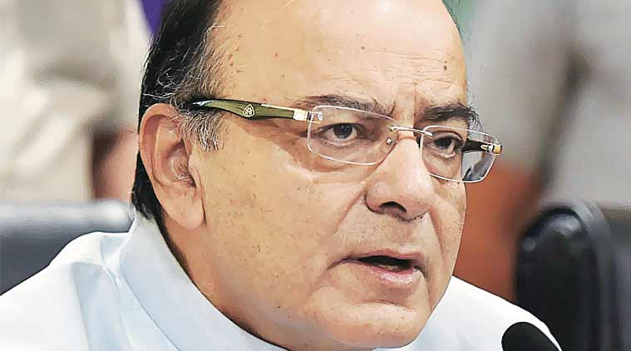
Finance Minister Arun Jaitley in Delhi, Wednesday. (Source: PTI)

AHEAD of the first meeting of the Goods and Services Tax (GST) Council on September 22-23, the Government is of the view that the basic tenet of the GST regime would be that it is “pro-poor” with 50 per cent of essential goods and services exempted from any tax.
The tax exclusion to nearly half the goods and services, an official said, would be “optically and politically correct” for the NDA government as already 300 items in the Centre and nearly 80 items in the states have this exemption.
At a review meeting Wednesday that discussed the run-up to the rollout, the consensus seemed to be that the new tax regime should not put fresh inflationary pressure and backed Revenue Secretary Hasmukh Adhia’s proposal of a tax band of 8 to 26 per cent with four rate slabs.
Sources said it was suggested that proposed slab rates of 8, 10, 18 and 26 per cent be tweaked to 10, 12, 16 and 25 per cent so that it did not affect revenue earnings and kept states on board as the final call has to be taken by the GST Council comprising state Finance Ministers and headed by Finance Minister Arun Jaitley.
Adhia was asked to rework the rates and their revenue implications for both Centre and the states and present the data at the next review meeting likely this week.
There is a widespread demand for keeping the GST rate low with the Congress calling for a cap of 18 per cent. The Arvind Subramanian panel had recommended a three-rate structure with essential goods at 13 per cent, demerit goods at 40 per cent and the remainder at a standard rate of 17-18 per cent. It had estimated the revenue-neutral rate at 15-15.5 per cent.
Finance Secretary Ashok Lavasa made a presentation on the state of readiness for the creation of a national sales tax and the next steps, including the timetable, to get the supporting legislation approved.

Arun Jaitley, Officials Brief Narendra Modi On GST Roll-Out Preparation

According to officials, Modi sought an update on the revenue neutral rate, information technology backbone for GST and concerns of the states.
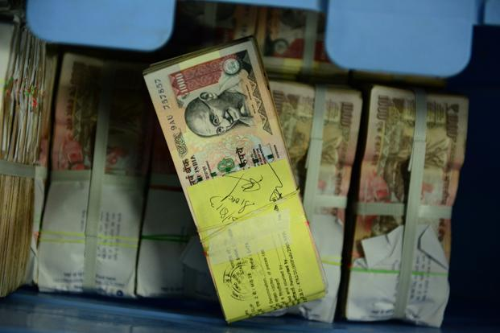
The first meeting of the goods and services tax (GST) council will be held on 22-23 September.
New Delhi: Prime Minister Narendra Modi on Wednesday reviewed preparations for the roll-out of the goods and services tax (GST) regime, possibly from 1 April 2017, with finance minister Arun Jaitley and his team making a presentation on the milestones achieved and the road ahead.
Jaitley along with finance secretary Ashok Lavasa and revenue secretary Hasmukh Adhia made a presentation to Modi on the state of readiness for creating the GST framework—India’s biggest tax reform since independence.
The presentation came within days of the cabinet approving setting up of the powerful GST council, which will decide on the tax rate, exempted goods and the threshold.
People familiar with the matter said that besides listing milestones achieved so far, the presentation detailed the steps to follow including the timetable to get the supporting legislations approved.
They said Modi wanted to understand the main areas where he should focus. He also wanted an update on the revenue neutral rate, information technology backbone being developed and concerns of the states, the people said.
The first meeting of the GST council, which will be headed by finance minister, will be held on 22-23 September, and the panel is to give its recommendations on the tax rate and other provisions within 60 days.
The prime minister was also briefed about the widespread demand for keeping GST rate at 18-19%, expectations of the states from the new regime and the impact of different tax slabs on the centre in terms of compensation it has to pay the states for loss of revenue.
The government is keen to implement the new tax regime from 1 April to ensure a smooth rollover to the changed tax structure from the beginning of the new fiscal, and avoid mid-year alterations.
People familiar with the matter said GST implementation is running ahead of schedule, with more than the anticipated number of states ratifying the constitutional amendment within the 30-day timeline set by the centre.
The focus now shifts to creating the IT infrastructure and preparing traders, businessmen and companies to smoothly shift to the new taxation regime that will subsume an array of central and state levies, including central excise duty, service tax, value-added and entry tax.
The supporting legislations—central GST and integrated GST—which detail the tax rates and exempted goods and bands are planned to be approved in the winter session of Parliament in November, the people said.

Disclaimer : The news in the GST Corner is purely according to the information available in public domain and does not necessarily reflect the views of ICSI. Any person wishing to act on the basis of this document should do so only after cross checking with the original source.

