GST HEADLINES
December 14, 2016

Workshop for Traders Ahead of GST Rollout

[Source: Times Of India]

Migration of Traders to GST Sluggish

[Source: The Hindu]

Workshop for Traders Ahead of GST Rollout
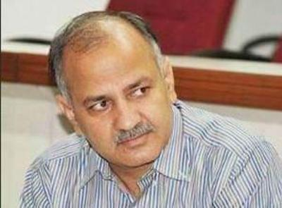
Manish Sisodia
NEW DELHI: Starting December 16, all traders registered with the value-added tax (VAT) department of the Delhi government will have to start enrolling on the GST portal as part of the process to migrate to the new tax regime. All dealers have to register on this portal by December 31. There are around 3.5 lakh dealers registered with the VAT department as of now.
A workshop to help dealers in the migration process will be held at the Delhi Secretariat on Wednesday. Deputy CM Manish Sisodia, who holds the finance portfolio, and senior VAT department officials will also be present.
An order was issued by the department of trade and taxes on December 9 in this regard. The theme of the workshop is "Front-end business on GST portal". The presentation will be given by Prakash Kumar, CEO, Goods and Services Tax Network (GSTN). Around 80 trade associations and networks from across Delhi have been invited to participate in the workshop. It is estimated that around 150 members from various trade associations will attend it.

It is learnt that the GSTN is organising these workshops across the country, according to the schedule for a rollout of GST wherein states have been clubbed under different categories.
"The representatives will be expected to pass on the information and the process for enrollment to other trades and assist in the migration process from VAT to GST," an official said. The GST portal seeks to empower the dealers with a complete online experience with no manual interface. Starting from registration, uploading of bills, filing of returns and online tax payment, the entire process will be online.
Once GST comes into effect, VAT will cease to exist except in the case of liquor and five petroleum products, including diesel and petrol. The luxury tax and entertainment tax will be merged under GST. The excise on liquor will continue, along with VAT, even after the GST rollout.
Aam Aadmi Party Trade Wing convener Brijesh Goyal said the workshop was very important as it would facilitate a smooth transition to GST. "For small traders who are still not comfortable with online processes, this training is critical to enable effective transition," Goyal added.

Migration of Traders to GST Sluggish

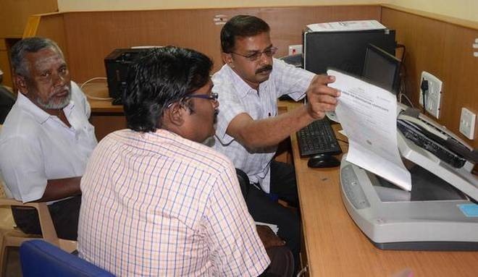
Few takers: The details of traders being scanned and updated on the Goods and Service Tax (GST) portal ate Commercial Taxes office in P

Despite a portal for the process opening last month, only 3,000 of 15,000 merchants have shifted
Despite Puducherry being the first State in the country to launch the Goods and Service Tax Network (GSTN) portal, the migration of traders and merchants registered under various State and Central tax regimes to the GST remains slow.
The portal was launched on November 8 to facilitate the migration of traders registered under Value Added Tax (VAT), Service Tax and Central Excise to GST.
According to K. Sridhar, Deputy Commissioner of Commercial Taxes, as many as 15,000 traders in the Union Territory are currently registered with VAT and other tax regimes such as Central Excise. Of them, about 3,000 have enrolled themselves with the GST.
The Commercial Taxes Department has also started validation of PAN data of the dealers and has communicated the provisional ID and password for GST migration. Traders who have enrolled themselves with the portal have been allotted a GSTN number. The Commercial Taxes Department will soon be enabling Aadhaar based e-signature to digitally sign documents on the GST portal, he said.
After the launch of the GST portal, the Department organised special camps at all the seven divisions in the UT for registration. However, merchants are yet to come forward to migrate from the present tax regime to the GST. Sources on condition of anonymity said that the enrolment process was slow across the country, except for Gujarat, which has registered a good response so far. Traders are not coming forward as they are unsure about the legal status of the GST. The delay may also be due to the transition time as April 1, 2016 is the date of implementation of GST.
Mr. Sridhar said the special camp at the Commercial Taxes Department will continue till December 15. The department will also be holding a special camp in association with the Puducherry Traders Federation this week to help traders get enrolled in the new tax regime.

Disclaimer: The news in the GST Corner is purely according to the information available in public domain and does not necessarily reflect the views of ICSI. Any person wishing to act on the basis of this document should do so only after cross checking with the original source.

