GST HEADLINES
October 14, 2016

Parliament's Month-Long Winter Session to Start Early on November 16

[Source : India Today]

]

Parliament's Month-Long Winter Session to Start Early on November 16

The winter session, which generally began towards the end of November, has been advanced to ensure the government gets adequate time for parliamentary nod to bills supporting the GST. By the first week of December, the government wants to clear the legislative works.
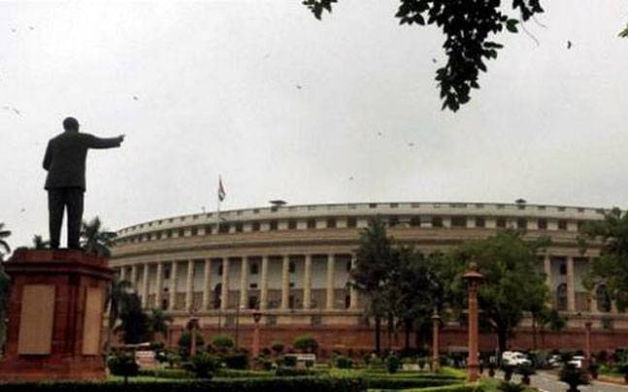

Parliament's winter session will be held from November 16 to December 16, the government announced today. The early start of the month-long session has been done to facilitate the rollout of the landmark Goods and Services Tax (GST) by April 1 next year.
The winter session, which generally began towards the end of November, has been advanced to ensure the government gets adequate time for parliamentary nod to bills supporting the GST. By the first week of December, the government wants to clear the legislative works.
GOVT MAY ISSUE CIRCULAR ON ADVANCING BUDGET SESSION
The government is also likely to issue a circular on advancing the Budget session. The dates would be finalised after the poll dates for Assembly elections in Uttar Pradesh, Uttarakhand, Manipur, Punjab and Goa are announced.
There are indications that the Budget session, which normally starts in February, may now be held towards the end of January. The merger of the Railway Budget with the General Budget from next year has already been announced.
According to the new proposals, the integrated Budget may now be presented to both houses of Parliament on January 31 next year.

Disclaimer : The news in the GST Corner is purely according to the information available in public domain and does not necessarily reflect the views of ICSI. Any person wishing to act on the basis of this document should do so only after cross checking with the original source.

