GST HEADLINES
September 14, 2016

GST Council Gets Cabinet Nod, First Meet On Sept 22

[Source :The New Indian Express]

GST Network Assists Corporate Sector To Be GST-Ready

[Source :Business Standard]

GST Council gets Cabinet nod, first meet on Sept 22
NEW DELHI: In its attempt to meet the stiff deadline of April 1, 2017 for the implementation of the most ambitious tax reform of Goods and Services Tax Bill, the Cabinet on Monday approved the setting up of a GST Council which will replace a slew of indirect taxes across the country.
The first meeting of the newly constituted GST Council, which will decide on rates, exemption and threshold, will be held on September 22 and 23, said Hasmukh Adhia, Revenue Secretary.
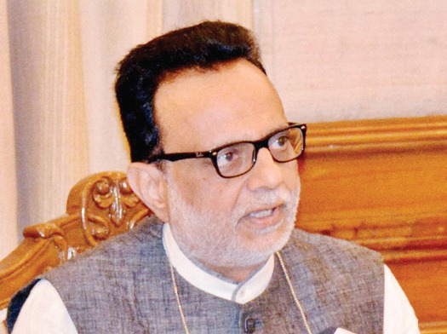

Right now we are all geared up for April 1, 2017 deadline. We will have to see how things proceed Hasmukh Adhia, Revenue Secretary. The council will, which will comprise Union finance minister, minister of state for finance in charge of revenue, state finance ministers or any other minister nominated by states, recommend on draft model GST Bill. Only after its recommendations will the Central GST and integrated GST Bills be taken up by Parliament and state GST Bills by respective states.
“As far as the administrative requirement is concerned, we are fully geared up for that. The Government is also monitoring IT implementation at the state level. As far as IT preparedness is concerned, we are fully on track,” Adhia said.
Since there has been no consensus so far between states and the Centre, the council will do the detail discussions on a particular GST rate.
Adhia said, “We are ahead of the time schedule. The main thing to be done now is to try and sort out all the major issues so that we are ready with the draft law completely and the industry can get itself ready.”
Rajat Mohan, director - indirect taxes, Nangia and Company said, “Keeping in view the leap taken by government in completing the legal formalities, the target date of 1 April, 2017 now seems achievable.”

GST Network Assists Corporate Sector To Be GST-Ready

Pvt body working closely with BPM software firms like SAP, Tally and Oracle to facilitate timely preparedness for the transition.
New Delhi September 14, 2016 Last Updated at 00:38 IST

In a race against time to roll-out the goods and services tax (GST) from April 1, 2017, the GST Network (GSTN) - developing the information technology backbone for the new tax regime - is working closely with business process management (BPM) software firms like SAP, Tally and Oracle, among others, to facilitate timely preparedness of the corporate sector for the transition.

This comes amid the industry requesting six months time for the roll-out - from the time laws and rules are finalised in order to align their systems with the new law. The GST laws are expected to be finalised by November-December this year.

However, the GSTN is planning to meet about 100-150 BPM software firms by September-end and hand over the application programming interface (API) to develop the enterprise resource planning (ERP) software, which will act as an interface between their clients and GSTN.

“We don’t need to assist all companies, but just 100-150, which will, in turn, help the corporate sector become GST-ready. We are working closely with these tax accounting software firms and will hand over the APIs by the month-end,” said a GSTN official.

A private body like the GSTN is also working with firms like Cleartax and Makemyreturns to facilitate corporate sector transition to the new indirect tax regime.

An API is a set of sub-routine definitions, protocols and tools for building software and applications.

However, experts point out that handing over API will just be 30-40 per cent of the work that will need to be done to prepare for GST, as the software will need to be tweaked, according to the final rules and law, besides customisation, according to the requirement of each company.

The GST Council, which was approved by the Cabinet on Monday, will prepare the model GST law and decide rates by November 22. The council, chaired by the finance minister, will have its first meeting on September 22 and 23.

While the draft law is in public domain, comments and suggestions will need to be accommodated before it is finalised by the GST Council and tabled in the winter session of Parliament.

“It is important for companies to get adequate time to plan operations once the final law is in place. The common software by SAP and Oracle cannot cater to the needs of every business and it will require significant customisation. The multinational companies will also need to get the ERPs tested with their other teams across the globe, which will require time,” said Saloni Roy, senior partner, Deloitte.

Pratik Jain, leader, indirect tax, PwC, said besides API, corporates will need to do various things to be GST-ready, from customisation to master data management. “API is just one part of it, which will take care of just 30-40 per cent requirement of companies. They will need to get the standard ERPs customised, based on their requirements, which will take anywhere between three to six months. Companies will need to start preparing immediately towards that,” he said.
USHERING IN NEW REGIME
- GSTN is planning to meet about 100-150 business process management software firms by September end and hand over the Application Programming Interface (API) to develop the enterprise resource planning software
- Handing over API will just be 30-40 per cent of the work that will need to be done to prepare for GST
- The GST laws are expected to be finalised by November-December this year

Disclaimer : The news in the GST Corner is purely according to the information available in public domain and does not necessarily reflect the views of ICSI. Any person wishing to act on the basis of this document should do so only after cross checking with the original source.

