GST HEADLINES
November 11, 2016

GST Implementation can’t be delayed Beyond Sept 16, 2017: Arun Jaitley

[Source: The Indian Express]

GST Implementation can’t be delayed Beyond Sept 16, 2017: Arun Jaitley

Arun Jaitley was referring to the GST Constitutional Amendment, which has a provision in this regard.
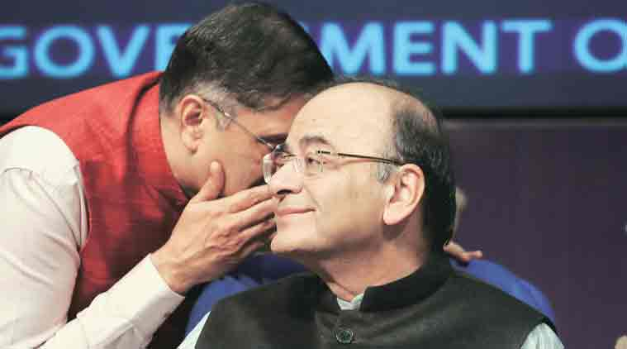
Finance Minister Arun Jaitley with Chief Economic Adviser Arvind Subramanian. (Express Photo: Anil Sharma)

Finance minister Arun Jaitley on Thursday said the Centre was trying earnestly to build a consensus with the states on the sticky issue of sharing of administrative control on assessees to ensure that the April 1 deadline for rolling out the goods and service tax (GST) was met.

“We are making all efforts to introduce GST from April 1, 2017. GST has to be implemented latest by September 16, 2017, and if it is not implemented by then, states will not be able to collect their share of taxes, and hence, there is not enough scope to further delay the decision,” Jaitley said at an economic editors’ conference here.

The minister was referring to the GST Constitutional Amendment, which has a provision in this regard. After deciding the GST rate structure a day earlier, the Centre and states hit a speed breaker on November 4 as they could not decide on how the audit and enforcement powers would be shared between them in the GST regime.

The Union and state finance ministers would meet informally on November 20 to solve the issue politically and suggest their formula to the GST Council meeting on November 24-25 for endorsement. In the meantime, officials from both sides are deliberating to finalise the four draft laws — those on central GST (CGST), integrated GST (IGST), compensation and state GST (SGST) — by November 15. The Centre is trying to introduce CGST, IGST and compensation Bills in the winter session of Parliament later this month.

“Only the last stages (of decision-making) remain and I do hope we (GST Council) are able to resolve that too, through a larger consensus,” Jaitley said.

The government has covered a lot of distance for implementation of comprehensive indirect tax and it was not in favour of resorting to voting to decide on any issue at the GST Council meeting. “We have already sorted out 10 issues. The issue of dual control still remains, there is no reason why we will not be able to work out a reasonable solution on this,” he said.

Disclaimer: The news in the GST Corner is purely according to the information available in public domain and does not necessarily reflect the views of ICSI. Any person wishing to act on the basis of this document should do so only after cross checking with the original source.

