**GST HEADLINES**

**November 9, 2016**

**Puducherry to Join GST Regime Today**

***[Source: The Hindu]***

**GST Portal Goes Live, GSTN Software Almost Ready: GSTN Chairman Navin Kumar**

***[Source: The Economic Times]***

# Puducherry to Join GST Regime Today

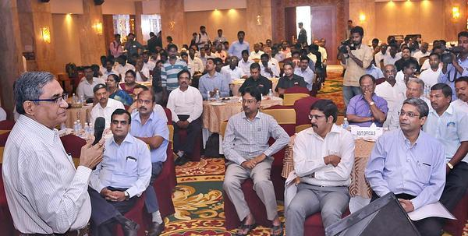

Navin Kumar, Chairman of Goods and Services Tax Network (GSTN), at the GST Portal curtain raiser organised by CII on Monday. —Photo: S.S. Kumar

## *It will be the first in the country to migrate to the new tax system*

The data of 88 per cent of active tax payers in the country had been verified and they will be enrolled on the Goods and Service Tax portal, said Navin Kumar, Chairman, Goods and Service Tax Network (GSTN).

Addressing an interactive session organised by the Confederation of Indian Industry (CII), Puducherry, in association with GSTN here on Monday, Mr. Kumar said that in the first phase, existing taxpayers of VAT will migrate to GSTN followed by Service Tax and Central Excise.

Puducherry will be the first State in the country to migrate to the new GST system from November 8, he said. A schedule had been drawn up for all States and Union Territories, he added.

GSTN will be generating ID numbers and passwords for the taxpayers and they can log on to the GST portal and familiarise themselves.

GST is an initiative by which the tax regime is embarking on an exercise that would bring together all the major indirect tax payers under one umbrella. It will subsume excise, service tax and other local levies and will make India a market for seamless transfer of goods and services, he said.

Infosys has been awarded the contract and will be operating the GST system for a period of five years.

Mr. Kumar pointed out that GSTN was initially working for the preparation of the back-end IT infrastructure for 12 States and Union territories. As of now GSTN is working on the back-end IT infrastructure for 20 States and with more states approaching GSTN since February 2015.

G. Srinivas, Commissioner, Commercial Taxes appreciated the good response from dealers and traders in Puducherry to shift to the new GST regime. The Government has started validation of PAN data of the dealers and they can log into the GST portal which would be launched on Tuesday. The Commercial Taxes department will help the traders in getting enrolled in the new tax regime, he said. Srikanth Sivaraman, Chairman, CII Puducherry State council and R.D. Shrikanth, Vice-Chairman, CII Puducherry also spoke.

**

*Disclaimer: The news in the GST Corner is purely according to the information available in public domain and does not necessarily reflect the views of ICSI. Any person wishing to act on the basis of this document should do so only after cross checking with the original source.*