**GST HEADLINES**

**September 09, 2016**

# Prez Nod to Constitution Amendment Bill On GST

# Andhra Pradesh Assembly Ratifies GST Bill

# GSTN To Take Rs. 550 cr. Loan From IDFC Bank

# GST Bringing Realty Shake Up

# *[Source :Business Standard]*

# 

# Andhra Pradesh assembly ratifies GST Bill

## The state govt has convened the session to seek the house approval for the GST Bill

**1**



[Andhra Pradesh](http://www.business-standard.com/search?type=news&q=Andhra+Pradesh)(AP) legislative assembly has ratified the[GST Bill](http://www.business-standard.com/search?type=news&q=Gst+Bill)on the opening day of the three-day session on Thursday.

The state government has convened the session to seek the house approval for the GST Bill.

The house witnessed noisy scenes earlier in the day with the opposition members trying to disrupt the proceedings as the protested against the financial package announced by the Centre.

During his reply, AP Chief Minister [N Chandrababu Naidu](http://www.business-standard.com/search?type=news&q=N+Chandrababu+Naidu) defended his government's efforts in securing the financial package from the Centre.

Explaining the measures incorporated in the financial package, the chief minister said he has requested the Centre to provide legal status for all the promises given to the state and also sought deadlines for each of these measures to ensure their time-bound implementation

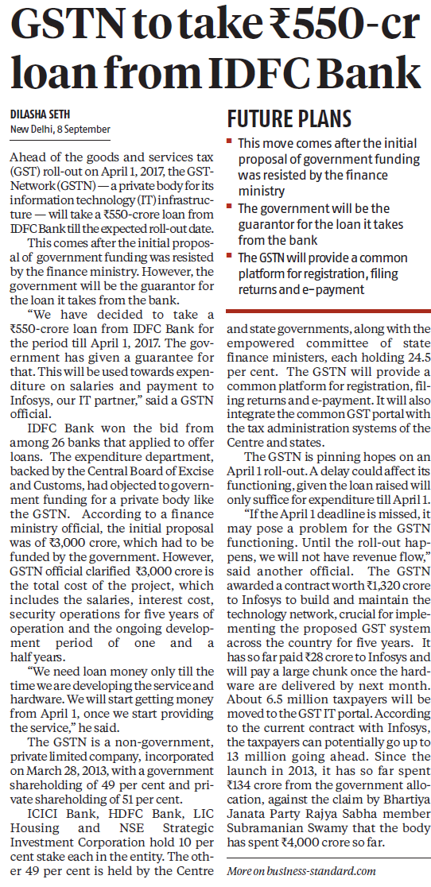



*Disclaimer : The news in the GST Corner is purely according to the information available in public domain and does not necessarily reflect the views of ICSI. Any person wishing to act on the basis of this document should do so only after cross checking with the original source.*