GST HEADLINES
September 8, 2016

It is a Race against Time to Implement GST, Says Jaitley

[Source : The Hindu]

GST Top Priority, Tax Rates to Come Down: Arun Jaitley

[Source : The Indian Express]

It is a race against time to implement GST, says Jaitley
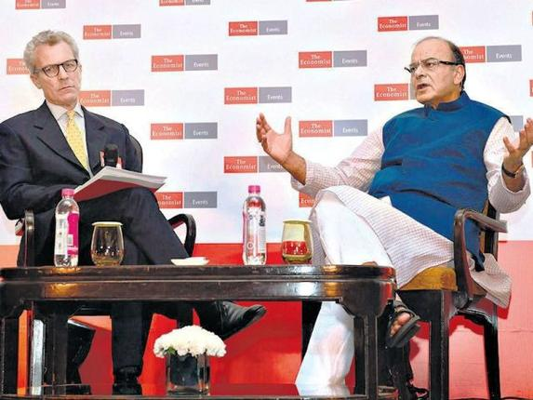

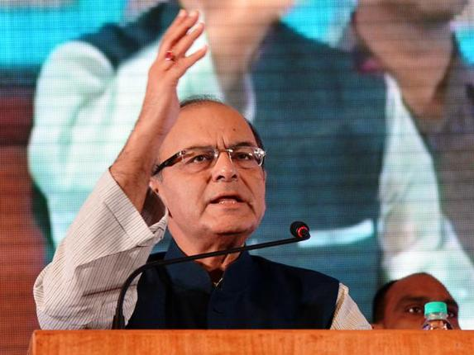
The Hindu
“We have kept a very stiff target and the reason is that there is a great national aspiration in support of a reform that GST is,” Finance Minister Arun Jaitley said at the Economist India Summit, in New Delhi on Wednesday.

The Centre is running against time to meet the ‘stiff’ target rollout date of April 1, 2017 for a new indirect tax regime, Finance Minister Arun Jaitley said on Wednesday.
Still, the government will strive to meet the deadline and introduce the necessary central legislation for the Goods and Services Tax in the winter session of Parliament, Mr. Jaitley said.
He cited the agility with which state governments had already ratified the Constitutional amendments.
“We have kept a very stiff target (for GST) and the reason is that there is a great national aspiration in support of the reform.And this is adequately exhibited by the fact that both Houses of Parliament have unanimously approved the legislation which is very rare,” Mr. Jaitley told Economist India Summit on Wednesday.
“Secondly, state after state, within a period of 20-25 days, have kept on ratifying it,” he said adding enough states have now okayed the Constitutional amendments for them to be taken up for Presidential assent.
The Finance Minister said that the long-pending tax reform will not just create a common nationwide market making seamless transfer of goods and services possible but also plug leakages and lead to lower tax rates, once effectively implemented.
The Minister said that the Lok Sabha Secretariat is in the process of collecting the legislative proceedings of all the 17 states that have cleared the Bill so that they may be sent to the President for ratification.
An official said that these proceedings have so far been procured from 11 out of the 15 states needed for moving forward with this procedural formality.
“Once the assent is granted by the President, the Constitutional amendment will be notified and the GST council will be constituted,” he said.
“There are obviously some pending issues which the council will have to resolve,” he said, referring to the need to arrive at a consensus on the GST rate and treatment of sectoral and geographical tax exemptions, among other things.
“So we have the months of September and October and parts of November to do that… there is a lot of work to do and if you are able to successfully transact those issues, then, in the winter session of Parliament, the central legislation with some drafts there in public domain, will have to be brought in,” he said.
“The states will have to pass their own legislations. Now if we look ahead it’s a very stiff target, we are running against time. But I would certainly like to give it a try,” the Minister said.

GST top priority, tax rates to come down: Arun Jaitley

About the implementation of Goods and Services Tax from April next year, Arun Jaitley said, "We look ahead, it's a very stiff target, we are running against time. I would certainly like to give it a try."
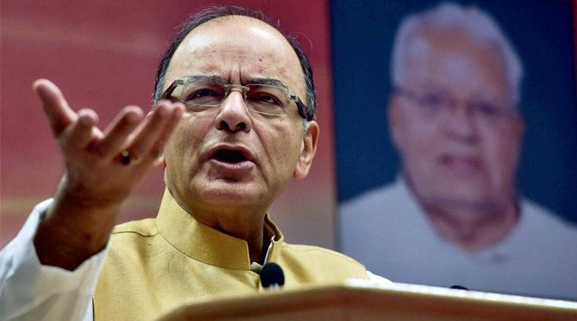
Finance Minister Arun Jaitley sounded confident on the tax rates coming down once the indirect taxation regime is put in place.
According top priority to the implementation of GST, Finance Minister Arun Jaitleyon Wednesday sounded confident on the tax rates coming down once the indirect taxation regime is put in place.
The challenges before the government, he said, is to put public sector banks back on track and continue to operationalise stalled infrastructure projects to further boost economic activity.
As regards the implementation of Goods and Services Tax from April next year, the Finance Minister said, “We look ahead, it’s a very stiff target, we are running against time. I would certainly like to give it a try.”

“It (GST) will the plug the leakages. In the long run it will probably stabilise the tax rate and move them down once effectively implemented,” he added.
Speaking at the event, ‘The Economist – India Summit 2016’, Jaitley said the procedural formalities of collecting proceedings of all the states and sending it to the President for ratification are on.
Once the assent is granted by President Pranab Mukherjee, the constitution amendment bill will have to be notified.
After notification and constitution of the GST Council, he said, there are obviously some pending issues, which the council will have to resolve.
“If you ask me in terms of economic priorities even outside Parliament, I would say that certainly implementation of GST is the top priority, putting the bank on track is a very important priority and the stalled projects, a lot of them have been cleared and this process must continuously go on… I think these are the obvious priorities,” Jaitley said.
Talking about state-owned banks, he said, India is not ready for their privatisation and present characteristics of PSU banks will continue except for IDBI Bank.
“We are trying to consolidate some of the banks, which may otherwise find it difficult in a competitive environment,” he said.
Asked why privatisation in financial space is not taking place, Jaitley said, “In order to reach a particular level of reform you have to evolve into that stage of public opinion… in funding large part of social sector in India, public sector banks, despite competition had a far larger contribution.”
According to Jaitley, the public or political opinion is still to converge to a point where one can start thinking in terms of any form of privatisation in the sector.
“Some selective reforms do take place, for instance, we have announced a policy that government holdings (in banks) to be brought down to 52 per cent,” he added.
On stressed assets, he said the Centre has initiated a large number of steps to reduce NPAs.
“There is not a single sector that we have left out in terms of resolving issues… if you were to ask me after the passage and may be possible implementation of GST, while that process is on what would be my priority at the moment, it is certainly the health of public sector banks,” he said.
He also hinted that the government is ready to provide an additional capital over and above Rs 25,000-crore amount announced in the Budget.
“This is over and above whatever assistance from the Budget we are giving towards the capitalisation of banks,” he said.

Disclaimer : The news in the GST Corner is purely according to the information available in public domain and does not necessarily reflect the views of ICSI. Any person wishing to act on the basis of this document should do so only after cross checking with the original source.

