GST HEADLINES
November 07, 2016

The Bumpy Road to GST Implementation
[Source: Livemint]

Knitwear Manufacturers Look Beyond Tax Structure in GST
[Source: The Hindu]

The Bumpy Road to GST Implementation

It could take more than two years for benefits of GST to start reflecting in India’s GDP, the caveat being successful integration
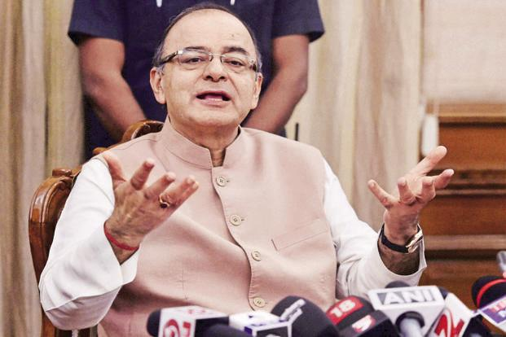
Finance Minister Arun Jaitley. While the aim of multiple tax rates is to minimize the impact on inflation and government revenues, growth could take a hit in the near term. Photo: PTI

After much to-ing and fro-ing, the centre and states have agreed on the rates of the goods and service tax (GST). A five-slab structure of 0%, 5%, 12%, 18% and 28% has been finalized, with some demerit goods taxed above 28% and cess on them has been retained.
The issue of administrative control over assesses is still to be thrashed out. The rates at which individual items are to be taxed are yet to be decided, which could explain the lack of enthusiasm in the market, which is anyway nervous at the prospect of a Trump win in the US presidential elections.
Given the long run-up to the GST agreement, part of the macro benefits such as the formation of a unified market for the country and supply-chain benefits should have been priced into the markets by now. But analysts say the impact of GST-related developments on individual stocks will be felt only after product-wise tax rates are fixed. Also, the multiplicity of rates may lead to a whole lot of litigation by firms, so the uncertainty may persist.
Coming to the macro-level impact, economists highlight that the multi-tier rate structure mirrors the current indirect tax regime; it seeks to ensure that prices do not vary significantly from where they are and almost 50% of the Consumer Price Index (CPI) basket is exempted from tax, hence a marginal surge of 15-20 basis points is foreseen in CPI inflation. A basis point is 0.01%. But service tax is expected to inch higher—HDFC Bank Ltd said in a note that it sees service tax going up from 15% to 18%.
While the aim of multiple tax slabs is to minimize the impact on inflation and government revenues, growth could take a hit in the near term. “The perception that goods will become cheaper after the GST could prompt consumers to postpone purchases of high-value consumer goods. Therefore, if the GST is implemented from April 2017, there could be a slightly negative impact on consumer demand in the run up to its implementation (i.e., in Q1 2017),” said a Nomura report. That is apart from the adverse impact it may have on the unorganized sector.
Also, for benefits of GST to start reflecting in India’s gross domestic product (GDP) it could take more than two years, the caveat being successful integration. “The bump-up in GDP on GST implementation would not be more than 0.5%,” said Madan Sabnavis, chief economist at CARE Ratings.
The multiple rates will make things complicated from a compliance perspective and could dilute some benefits of the GST system. Given the prevailing ambiguity on many aspects, a Religare Institutional Research report calls GST a leap of faith, adding that even though the structure scores high on progressivity and inflation neutrality, it is against the very essence of a simplified tax regime. There are also challenges such as getting the IT infrastructure in place followed by training of tax officers for a smooth integration.
In short, while GST is now likely to be a reality soon, much depends on its implementation.

Knitwear Manufacturers Look Beyond Tax Structure in GST
Knitwear manufacturers here are not ‘much’ concerned about the ‘mere rate structures’ of Goods and Services Tax (GST) but eagerly been looking at the macro approach that would be adopted for fixing various raw materials in the production chain into different slab categories.
According to the consensus reached, the GST rates have been fixed at 5 per cent for items of mass consumption or essential use, at 12 and 18 per cent for ‘standard items’ and at 28 per cent for ‘de-merit goods’.
Garment manufacturers feel that apparels should have been considered on the 5 per cent slab because clothing was considered an essential thing as in the class of food and water.
Raw materials
“Rate structures overall looks o.k. But, unless the classification of items is done properly, the real benefits cannot be obtained.
For example, the situation could become complex even if the textile products are classified at lowest slab but some of the key raw materials been taxed at 18 per cent.
“Moreover, the cumulative tax on the textile products presently comes to around only 7 to 8 per cent so any categorisation beyond the lowest slab could make the products from the cluster not gain much under the Goods and Services Tax regime except for logistical benefits”, said Tirupur Exporters Association president Raja Shanmugam.
R.M. Senthil Kumar, former chairman of Institute of Chartered Accountants of India (Tirupur chapter), cautioned that the tax refund rates should have be to proportionally raised if the rates under GST was fixed at higher slabs.
‘Apparels should have been considered on the 5 per cent slab because clothing is an essential item’

Disclaimer: The news in the GST Corner is purely according to the information available in public domain and does not necessarily reflect the views of ICSI. Any person wishing to act on the basis of this document should do so only after cross checking with the original source.

