**GST HEADLINES**

**October 7, 2016**

**Adoption of GST Poised to Boost India’s Medium Term Growth - IMF**

***[Source : The Economic Times]***

# GST Network Operating Expenses to be Funded by User Fee

***[Source : The Financial Express]***

# Auto Industry Demands Two Rates under GST

***[Source : The Hindu]***

# 

# GST Network Operating Expenses to be Funded by User Fee

|  |  |
| --- | --- |
|  | FacebookTwittoogle+LinkedInEmail |

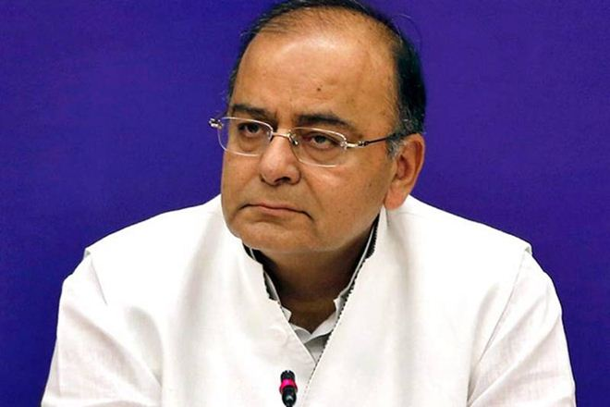

The GST Council, chaired by Union finance minister Arun Jaitley, is already working towards finalising the structure of the new tax law and two rounds of meetings are already concluded. (Reuters)

Clearing the ambiguity over the funding of operating costs of the Goods and Services Tax Network (GSTN), the government has decided that an ‘assessee-based user fee’ would make up for the bill.

GSTN, a not-for-profit, non-government firm, would provide IT infrastructure and services to the central and state governments, taxpayers and other stakeholders for implementation of the Goods and Services Tax (GST).

“The Centre and states will pay user fees based on the number of assessees registered with each of them to meet the running expenses of the GSTN. It will work on a no-profit-no-loss basis,” a senior finance ministry official told FE.

Currently, the Centre has over 16 lakh indirect tax assessees, while states such as Gujarat, Karnataka, Maharashtra, Tamil Nadu, Uttar Pradesh and Delhi have more than one lakh assessees. With the implementation of GST, the government expects the number of taxpayers under indirect tax laws to increase from 36 lakh currently to about 65 lakh.

The [Narendra Modi](http://www.financialexpress.com/tag/narendra-modi/) government’s plans to roll out GST from April 1, 2017 . The GST Council, chaired by Union finance minister [Arun Jaitley](http://www.financialexpress.com/tag/arun-jaitley/), is already working towards finalising the structure of the new tax law and two rounds of meetings are already concluded.

GSTN has hired Bengaluru-based [Infosys](http://www.financialexpress.com/tag/infosys/) on a project worth Rs 1,380 crore to buy and instal the IT infrastructure required for the network to function and to maintain it for five years. Of this, Rs 550 crore is towards capital cost. GSTN will reportedly subscribe to a loan to fund the expenses, and the repayment liability will be synced with the user charge. GSTN was incorporated on March 28, 2013. At present, the central government holds 24.5% equity in GSTN and all states hold another 24.5%. Balance 51% equity is with non-government financial institutions, including LIC Housing Finance, ICICI Bank, HDFC, HDFC Bank and NSE Strategic Investment Corporation.

GSTN has been initially funded through a one-time non-recurring grant in-aid of Rs 315 crore from the Centre towards expenditure for the initial setting up and functioning of the SPV for a three-year period after incorporation. After rolling out of GST, the revenue model of GSTN shall consist of user charge to be paid by stakeholders who will use the system and thus, it will be a self-sustaining organisation.

# Auto Industry Demands Two Rates under GST

With the government looking at rolling out GST from the next financial year, Society of Indian Automobile Manufacturers (SIAM) on Thursday said there should be only two rates for passenger vehicles instead of the four at present. The industry body said standard rates must apply on small cars, two-wheelers, three-wheelers and commercial vehicles, while bigger cars should attract 8 per cent more than the standard rate. “There should be only two rates for conventional vehicles,” a statement from SIAM said. “While for a long time there were only two rates of excise duties on passenger cars, in recent years, the bigger car rates have fragmented and today we have four rates for passenger cars excluding electric vehicles and hybrid electric for which lower rates are applicable,” the statement said. It also pitched for a lower GST rate for electric vehicles, hybrid electric vehicles and other alternative fuel vehicles, which should be at least 8 per cent less than the standard rate. “In view of the current scenario, there is a need to look at GST rate for automobiles sensitively,” SIAM said.

SIAM said its “members have committed to building the nation responsibly and as such no automotive product should be clubbed with goods that are health hazard, like cigarettes, pan masala, liquor, etc.”

It added that the automobile industry hads been looking forward to the GST as for manufacturing the industry accumulates a lot of embedded taxes and duties which make manufacturing in the country less competitive.

Further, it pointed out that its members have made large huge investments in locations falling under Area-Based Exemption scheme in places such as like Uttarakhand and Himachal Pradesh. “The period of the scheme is still not over and as such there is a need to protect the benefits to those units under GST regime till the end of the scheme,” it said.

In addition, the industry body said, the road tax and registration tax still remain outside the GST framework. This will further burden the consumer and Road Taxes needs to be subsumed in GST.

The industry body said it hads given a detailed feedback for the consideration of the government. “Some of the transition issues may have serious short-term implications for the economy, if not addressed now, though in the longer run the GST framework currently contemplated will be best for the economy,” it said.

*Disclaimer : The news in the GST Corner is purely according to the information available in public domain and does not necessarily reflect the views of ICSI. Any person wishing to act on the basis of this document should do so only after cross checking with the original source.*